Turning on and Off a PC correctly.
Make sure students understand how to correctly Shutdown a PC.
Click once on START, then SHUTDOWN and check SHUT DOWN is selected, then press OK.

Navigating the Start Menu and Windows.
The Menu is the normal route to opening programs.
e.g. 1: Calculator:- Click START with Left Mouse Button, move mouse up to move cursor to PROGRAMS, Move cursor to the right to move onto the programs menu, then move mouse up to ACCESSORIES and then move cursor to right to move onto the Accessories menu, move cursor onto CALCULATOR and click once with LMB to open Program. Click once with LMB on to close the calculator.

e.g. 2: Windows Explorer: Click START with Left Mouse Button, move mouse up to move cursor to PROGRAMS, Move cursor to the right to move onto the programs menu, and move cursor onto WINDOWS EXPLORER and click with LMB to open.
Closes the Program
You now have three icons in the top right of the open program.
Maximises/Reduces the Window.
Minimizes the Window to the Taskbar.

Open MS Word and Paint.
The Taskbar will show the two open programs. The one pressed in is the open Program. To swap to MS Word, press the Button on the Taskbar. This is called Multitasking.

Basic File Management.
Close all open Programs using the to Return to the desktop. Open WINDOWS EXLORER in the PROGRAMS MENU.
The following drives are listed in the window on the left. The C:\ is normally selected and open in the right window. You can select other drives by clicking on the icons on the left.
A:\ is the drive that can contain a Floppy Disk
C:\ is your hard drive, basically a large Floppy disk, fixed into the computer.
D:\ is the drive that can contain a CD ROM or Music CD.

With C:\ selected you will see a list of FOLDERS () and FILES on the C:\ in the right window.
Folders can contain more folders. e.g. D2 on PROGRAM FILES icon to see the sub folders for this Folder.
The purpose of a Folder is the same as a Filing Cabinet – to store files. Appropriately Named folders will make finding you computer files a lot easier.

Creating Folders.
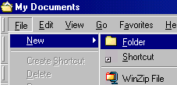
Close any open Windows. Open WINDOWS EXPLORER, C:\ and MY DOCUMENTS. The menu bar at the Top or the Taskbar will tell you what folder you are in.
Select FILE,
NEW
and FOLDER to Create a New Folder.

A new folder will be created. If the Text is highlighted you can
type in a new name for it (SIP Night Course 2002) otherwise,
make sure the folder is selected and select FILE and RENAME and enter the name.

D2 on folder icon in the RIGHT WINDOW to open you new folder.
Create four new subfolders in here and call them TEMP, MS WORD, MS PUBLISHER and SCANNING.
Saving Files.
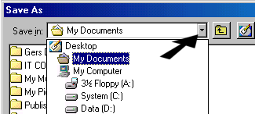
Open PAINT. Draw a circle on the drawing sheet.
To save the drawing, click FILE, SAVEAS and
select the indicated down arrow. Select C:\, D2 on MY
DOCUMENTS and D2 on SIP NIGHT COURSE 2002,
And D2 on TEMP. Then select the FILE NAME by
double clicking on it and type in circle. Select SAVE.
The file called circle.bmp is saved in the folder
Temp, and can be accessed at any later time.

e.g. 1:- Open a Notepad file, and type in your name, and save it into the folder TEMP as NAME.

e.g. 2:- Open MS Word and type in your school address and save it into the folder MS PUBLISHER as SCHOOL ADDRESS.

Copying/Cutting and Pasting Files.
If you decide that you want to change the folder a file is in, you can CUT it and PASTE it into another folder.
If you decide that you want to have a duplicate of a file then you can COPY it and PASTE it elsewhere. (This can also be done with FOLDERS.)

e.g.: - To move the file SCHOOL ADDRESS from the folder ‘MS Publisher’ to the folder ‘MS Word’.
Open WINDOWS EXPLORER, then D2 on the folder ‘MY DOCUMENTS’, then D2 on the folder ‘SIP Night COURSE 2002’ and then D2 on the folder ‘MS PUBLISHER’ in the left window, you should see you file called School Address in the right window.
Click once on it to select it.
Go to the EDIT Menu and select CUT (we want to move it, not duplicate it.)
Change to the directory MS Word, select EDIT and PASTE.

You can also drag the file from the right window to the folder in the left window. The normal setting for this is CUT. If you hold the SHIFT key down it will only copy the file to the new directory. (Be careful with this as you could accidentally move a folder that shouldn’t be moved.)

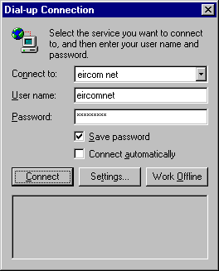
Accessing the Internet.
D2 on the icon. You will be prompted with a Dial Up Connection.
Click OK. Don’t change these settings. Eircomnet automatically sets the password
on free accounts. In the schools you use your username and password. (This applies
to Modem connections only. In Dunmore we use a Network)

The first page that opens is called your homepage, this can be set by the user,
more on this later. When the Explorer windows open we click on the address
box, the text goes blue and we type in the address that we wish to go to.
Favourites – Links to websites you have saved.

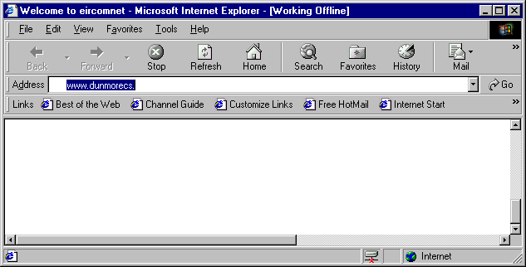
This is the main display area, web pages will be shown here.
Click here to highlight text, type new web address and press enter.
Back and Forward Buttons.

If Icon is spinning then a page is still loading.

Accessing Websites.
Once entered we press the ENTER key and the website will hopefully open, if we entered the address correctly. Format is vital, we can omit the http:// but the rest of the address must have no spaces or commas.
www.eircom.net is not the same as www . eircom . net. Also there is no full stop at the end of the address.

Some suggested websites are
www.scoilnet.ie WWW stands for world wide web.
www.doras.ie The second part of the address is the domain name.
www.iol.ie The final part is the country the website is in.
homepage.eircom.net/~dunmorecap This is a link to a personal website in a website.
homepage.eircom.net/~dunmorecap/links.htm This is a link to a specific file in a website.
www.ireland.com
livlib.eduweb.co.uk/ Not all websites begin with www
www.whatis.com Excellent link to explanations of all computer jargon

Browsing Websites.
Hyperlinks: -
When surfing a website you will notice images and text that may be a different colour, usually blue. When you move your mouse over these you will find the mouse cursor changing to a Pointing Hand. These are called Hyperlinks, and clicking on them will bring you to a new webpage or website. You can then use the back button in the top left of your cursor window, to move back any number of pages, then you can use the forward button to move forward to the pages you have already looked at.

Creating Favourites.
Favourites are a means of saving the link to a website to make it easier to get back to a page that you have previously visited. When you are viewing a page that you wish to add to favourites, click on Favourites and then select ADD, and you can give the page a name, or just accept the given name, and click OK.
Next time you wish to visit that webpage, just select Favourites and click on the link you require.

Creating Folders in Favourites.
To create folders and place links in folders, we select ORGANISE FAVOURITES and select CREATE FOLDER and give it a name of SIP Night Course 2002. Select the link you wish to move and drag it to the folder you wish to move the file to.
It is also possible and easier, at the ADD stage, to create the link in a particular folder.

Using Search Engines.
The Internet contains billions of webpages. In order to find information you need to know how to use a search engine. This will allow you to search all these pages to find relevant information.

Two good search engines are www.google.com and www.yahoo.com

Access www.google.com and do a search the poem Daffodils and William Wordsworth. When you find the words, add it to the favourites folder SIP Night Course 2002.

Other Information.
Hyerlinks: - When surfing a website you will notice images and text that may be a different colour, usually blue. When you move your mouse over these you will find the mouse cursor changing to a Pointing Hand. These are called Hyperlinks, and clicking on them will bring you to a new webpage or website. You can then use the back button in the top left of your cursor window, to move back any number of pages, then you can use the forward button to move forward to the pages you have already looked at.

Your Default Homepage: - As mentioned earlier we can set our default webpage that appears when we switch on the web browser. This is done by opening the page you wish to have as your homepage and selecting TOOLS and INTERNET OPTIONS. Select USE CURRENT and every time you switch on the browser it will be the first page to appear.

Problems: - If you have trouble connecting to a webpage e.g. www.iol.ie/students.html, try deleting the latter part of the link, and try again. If this doesn’t work then either the server is down or the website has been deleted completely.
Check the syntax of the address - no spaces or full stops between words etc.

Disconnection: - To close the Internet Connection, Shut down the browser by selecting FILE and CLOSE. You should be prompted to Select CLOSE CONNECTION or STAY ONLINE. Close the connection, and make sure the icon in the System Tray disappears.

Time Online: - To know how long you have been online, double click on this and it will give you the time and your speed.

Cursor: - Symbol on the screen to show where the mouse is pointing.
Taskbar: - Bar at the bottom of a computer screen showing Start button, clock, and all running programs.
Multitasking: - Having more than one program running on a PC. You can switch between these using the taskbar.
>Start>Programs>Accessories>Notepad
>Start>Programs>Microsoft Office>Word
or >Start>Programs>Internet Explorer

