The Shanganagh Ramblers Hillwalking Club.

Welcome to The Shanganagh Ramblers Hillwalking Club.

The Shanganagh Ramblers meet every two weeks and run alternate long and short walks.
For the long ( full day ) walks we hire a bus and for the shorter walks we usually use cars.

All walks depart from Brady’s Pub in Shankill, long walks depart at 9am and short walks depart at 10am.

Non-members are welcome to join the club on two walks and are asked for a
€5 contribution per walk.

All regular walkers are required to take out take out club membership. Membership is €40
( November to October) and membership benefits include…

- No cost for short walks
- Reduced costs on long walks
- Invitation to join in Club social events, Weekends Away and Training events.
- Membership of the MCI ( Mountaineering Council Of Ireland)
- 10% discount in outdoor shops.
- Subscription to The Mountain Log ( four issues per year )

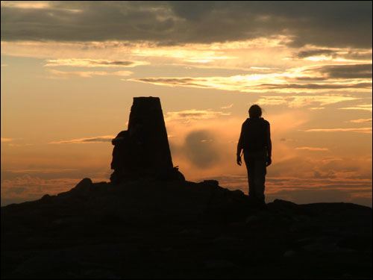 | 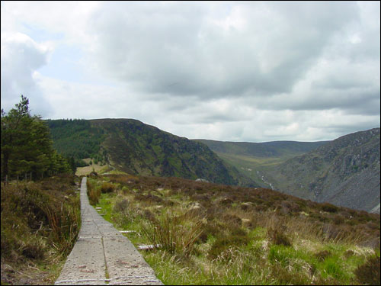 | 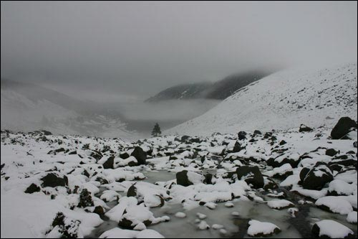 | 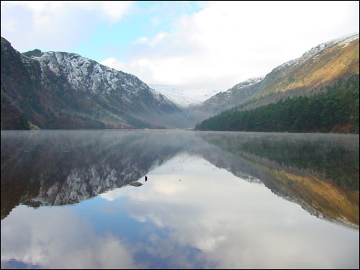

Participation and Risk…

All walks require a reasonable level of fitness. Long walks in particular may be strenuous. Hillwalking is an activity with a risk of personal injury or death. Participants should be aware of and accept these risks and be responsible for their own actions and involvement

Please note that for the safety of everyone in the group all walkers must have adequate clothing and equipment on all walks. This includes…

- Hiking Boots. These must have good ankle support, good grip, and be waterproof.
- Waterproof Jacket and leggings.
- Hat and gloves.
- All walkers should also carry some spare clothes with them.
- A flask with a warm drink ( and also a cold drink )
- Packed lunch .
Walkers without adequate clothing will not be permitted to participate on walks.

We hope you enjoy your walk with us, and we look forward to you joining us on many walks in the future

