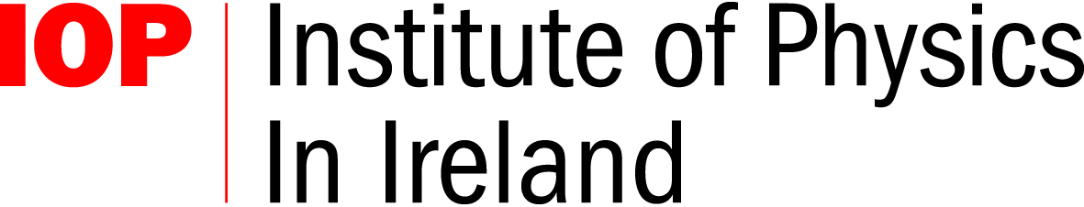
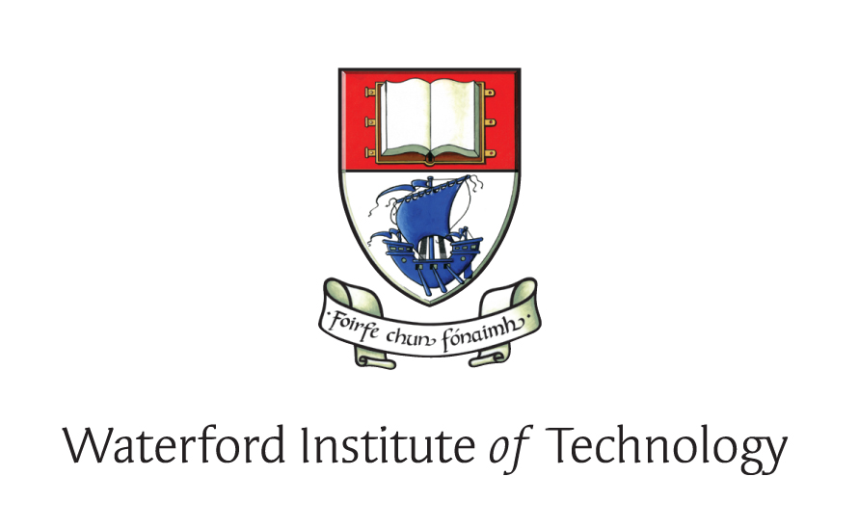



Programme

Speaker | Title/Activity
 | Registration
Dr. Eilish McLoughlin  IoPI Education Group | Words of Welcome
Prof. David W Hughes,  University of Sheffield | Telescopes: their history and development
 | Tea/Coffee
Eoin Gill, CALMAST,  WIT | Life and Legacy of Robert Boyle
Dr. Cormac O’Raifeartaigh,  WIT | From Walton to the LHC
 | Lunch
Jonathan Sanderson, SciCast video competition  2 X 70min sessions | Video making workshop
Robert Hill, Northern Ireland Space Office and IYA  2 X 70min sessions | Astronomy software for schools  workshop
Dr. Willie Donnelly,  Head of Research, WIT | Close of conference
David Keenahan, IOP Teacher Network Co-ordinator | Review of Leaving Cert 2009 exam papers

