Plastic Processing
Extrusion

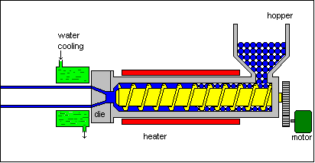

This process can be compared to squeezing toothpaste from a tube. It is a continuous process used to produce both solid and hollow products that have a constant cross-section. E.g. window frames, hose pipe, curtain track, garden trellis.
Thermoplastic granules are fed from a hopper by a rotating screw through a heated cylinder. The tapered screw compacts the plastic as it becomes elasticised. The die which is fitted to the end of the extruder barrel determines the cross-section of the extrusion. Extrusion rates typically vary between nine and sixty metres per minute. Thicker cross-sections are extruded more slowly as more time is required for the initial heating and subsequent cooling of the larger quantities of material which are involved. As the extrusion leaves the die it is cooled by passing through a cooling trough (below) containing cold water.

Materials used
This extrusion is part of a window seal made from thermoplastic elastomer (TPE).

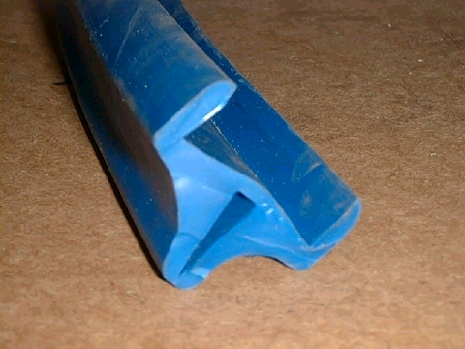
Injection Moulding
Powder or granules are fed from a hopper into a hollow steel barrel which usually contains a rotating screw. The barrel is surrounded by heaters which melt the material as it is carried along the barrel by the screw towards the mould. The screw is forced back as the melted plastic collects at the end of the barrel .
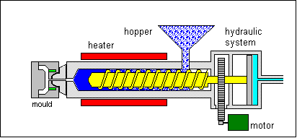
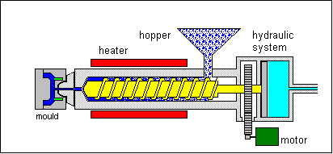
Once a sufficient charge of melted plastic has accumulated a hydraulic ram forces the screw forward injecting the thermoplastic through a sprue into the mould cavity.
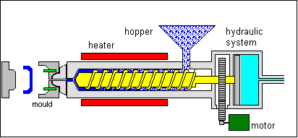
Pressure is kept on the mould until the plastic has cooled sufficiently
for the mould to be opened and the component ejected.

Materials used
Normally thermoplastics are used in this process although a few thermosetting plastics can also be injection moulded.
The photo below shows a typical product manufactured by injection moulding. This toy saxophone has been made in high impact polystyrene (HIPS).


Blow Moulding
1. 2.
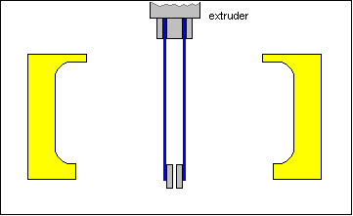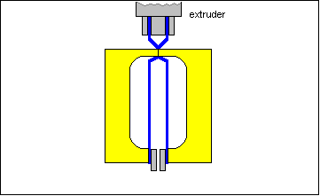
A hollow length of plastic, called a parison, is extruded down between the two halves of the mould.
The mould closes.

3. 4.
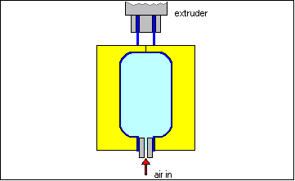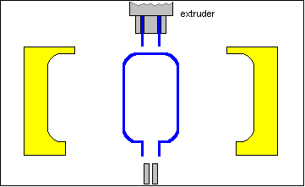
Compressed air is blown into the inside of the parison which inflates it, pushing the soft plastic hard against the cold surfaces of the mould.
The mould is then opened the moulding ejected and the waste (called flash) is trimmed off with a knife.

Materials used
High density polyethylene (HDPE) and low density polyethylene (LDPE) are both
commonly used for blow moulding as are other types of thermoplastics. The thermoplastic used in blow moulding needs to be more viscous (flow less easily) than that used for injection moulding as the parison must retain its form before the mould closes around it.
Used extensively to make bottles and other lightweight , hollow parts
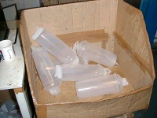
Vacuum Forming
- 2.
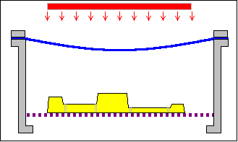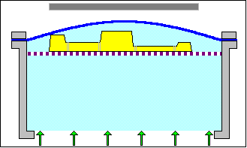
Mould is attached to a platen (support plate). The platen and mould are then lowered and a rigid thermoplastic sheet material is clamped onto an air tight gasket and usually heated from above.
Once the thermoplastic sheet is softened enough (reaches a plastic state) then air is blown in to raise the sheet in a slight bubble before the platen is raised bringing the mould into contact with the plastic.

3. 4.
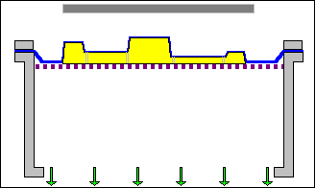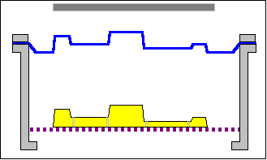
Any trapped air remaining between the platen and the heated plastic sheet is then evacuated by a vacuum pump. Atmospheric pressure acting over the top surface completes the forming process by pressing the plastic sheet onto the mould.
Once the plastic sheet has cooled down to below it's freeze point the air flow is reversed to lift the forming off the
mould and the mould lowered

Materials used
Many types of thermoplastics are suitable for vacuum forming. The most popular is Polystyrene (HIPS). It is relatively cheap, comes in a wide range of colours and is easy to form. This process is used to manufacture a variety of products in thermoplastic materials. These products range in size from garden pond liners to food trays used in supermarkets.

Compression Moulding

- 2.
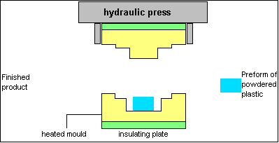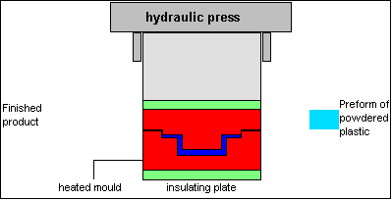
The mould is charged with a measured amount of powder or granules ready to be compressed. Sometimes plastic charge is first compacted into a shape called a preform.
When the two halves of the mould are brought together the plastic material is forced under compression to flow
rapidly around the cavity. heat from the platens causes the plastic to cure resulting in a permanent change in shape.

3.
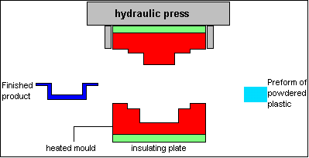
The component is ejected from the mould and any excess material formed at edges (flash) is removed.

Materials used.
Typical thermosetting plastics used in compression moulding are urea formaldehyde and
phenol formaldehyde.



Calendering

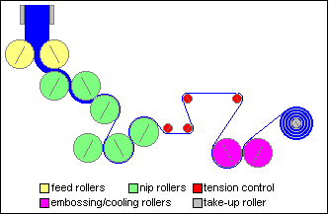
Involves rolling out a mass of premixed plastics material between large rollers to form a continuous and accurately sized film. The main material used is PVC, others include ABS and cellulose acetate. PVC ranges from flexible to rigid and the final product is composed of a number of basic materials which must be combined in a uniform mixture of measured ingredients. These ingredients include a resin of a specified molecular weight, stabilisers, lubricants, reinforcing materials, colorants and plasticisers.
The process begins with the ingredients being blended and fluxed in a mixing mill at approx.100°C. Nip rollers control the thickness of the sheet material can be gradually reduced in thickness. Rolls of semi-rigid PVC which will be used to manufacture
transparent A4 folder 'pockets'.

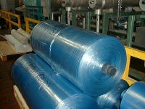

Strip Heating

1. 2.
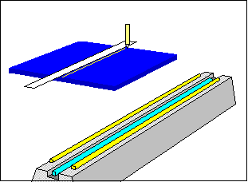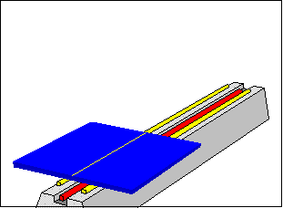
The line to be bend is marked on both sides
The material is placed on supports on the strip heater. Heating times will vary due to thickness and colour of the thermoplastic.

3.
Bending jigs are used to attain the desired bend angle. Internal stresses can occur around the bend lines of materials like Acrylic.
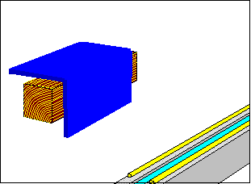

Rotational Moulding
A measured weight of thermoplastic is placed inside a cold mould. The mould is then closed and moved into an oven chamber
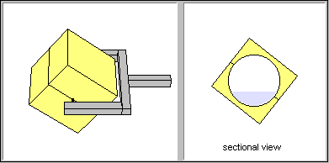
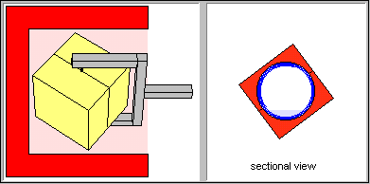
It is heated to a temperature of 230-400 C whilst being rotated simultaneously around both vertical and horizontal axes. As it rotates the mass of powder at the bottom of the mould fuses and sticks to the
mould surface.
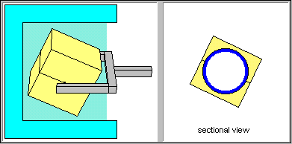
the mould moves into a cooling area or chamber where it is cooled by air or water jets.
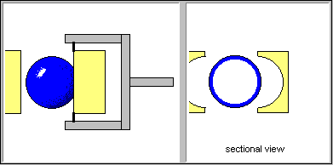
The hollow moulding can be removed as soon as it is cool enough to hold its
shape.

Materials used
90% of rotational mouldings are made from polyethylene (PE), used mainly to manufacture hollow shaped products such as footballs, road cones and storage tanks up to 3m³ capacity.

