Plastics
When we refer to plastics we usually mean polymers, since plastic is a condition or state of a material. (metals when heated can be plastic: can be moulded into shapes).

Types of plastics

- Natural Plastics
  - Amber.
  - Animal Horn.
  - Natural rubber.
  - Shellac.

- Modified natural plastics
  - Cellulose (made from cotton fibre and wood pulp).
  - Casein (made from cows milk).

- Synthetic plastics
Produced entirely by human-controlled chemical processes:
  - By-products from the production of gas from coal.
  - By-products from the distillation of crude oil.

Polymerisation

The word polymer comes from the Greek word for “many parts”. They are the result of joining a number of basic units known as “monomers”. Within the polymer molecule there is a repeated unit known as a “mer”. Mers are the building blocks of all plastics.
The process in which monomers are joined together in known as “polymerisation”. It can occur in two ways:

- Addition polymerisation (chain-growth)
Adding together of a large number of mers so that they form into long-chain molecules.
e.g. In the production of Polyetylene(Polythene), the basic monomer ethylene is used. Step 1 A catalyst is added to the ethylene this breaks one of the bonds between the carbon atoms in ethylene, step 2 thus allowing them to link up with other similar carbon atoms, the catalyst or “free radical” contains an unpaired electron which helps initiate and terminate the polymerisation process.
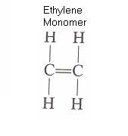Step1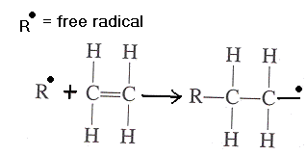 Step2 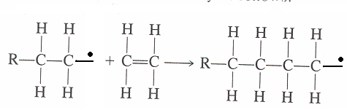

The long-chain molecules form a complex coiling structure similar to spaghetti.
- Condensation polymerisation (step-growth)

In the example for phenol formaldehyde:
Two phenol molecules are linked by the formaldehyde molecule during the reaction. When this happens the phenols each give up a hydrogen atom and the formaldehyde gives up an oxygen atom. This produces water as a by-product which is condensed out leaving a cross-linked structure. The phenol molecule has several contact points, this generates a three-dimensional network.
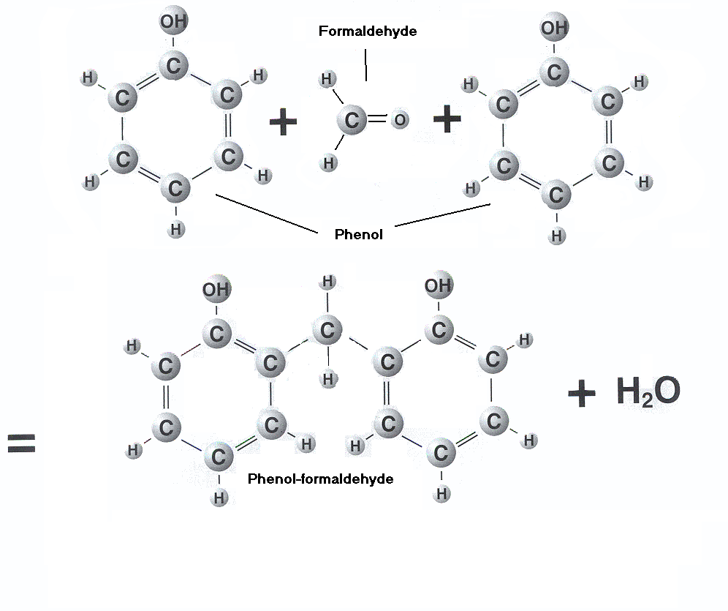

Molecular structure

- Linear polymers
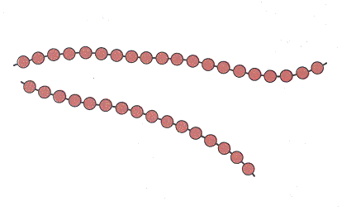
Mers are joined end to end in single chains. These are long and flexible. Some common polymers (polyethylene, PVC, polystyrene and nylon)

- Branched polymers
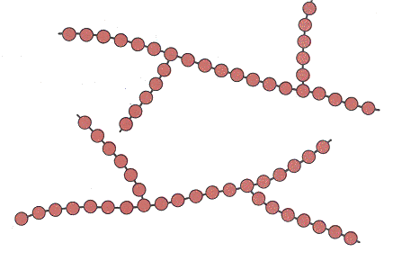
Side branches are connected to the main chains, these result from reactions in the polymerisation process. this can lower the polymer density and increase strength.

- Crosslinked polymers
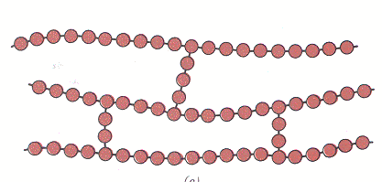
Adjacent linear chains are joined to one another at various points by covalent bonds. Many rubber elastic materials are crosslinked in rubbers this is called “vulcanisation”.

- Network polymers
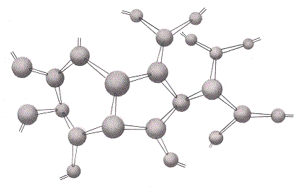
Certain mer units form three-dimensional networks, a material that is highly crosslinked can be classified as a networked polymer.

Copolymerisation

This is the process where mers of different kinds are linked together in the same addition chain. This makes it possible to create many different kinds of polymers with a variety of properties.

Classificaton of Polymers

Polymers can be classified under two main headings:

- Thermoplastics
Can be heated and formed, then re-heated and re-formed repeatedly. The shape of the polymer molecules is generally linear, or slightly branched, allowing them to flow under pressure when heated above the effective melting point. All of the bonds within the polymer molecule are primary bonds which are very strong chemical bonds. The bonds between adjacent molecules are secondary bonds or Van der Waals forces they have relatively weak forces of attraction. They can be weakened even further by raising the temperature, this is why they flow under pressure.

- Thermosetting
Undergo a chemical as well as a phase change when they are heated. Their molecules form a three-dimensional cross-linked network, this is known as curing. Once they are heated and formed they can not be reprocessed – the three- dimensional molecules can not be made to flow under pressure when heated. (normally condensation polymerisation). Primary bonding occurs and strong covalent bonds hold atoms together.

Additives used in plastics

Polymers are often combined with other materials to give them certain desired properties. They include:

- Fillers
Used to improve polymers mechanical properties, can also reduce the amount of polymer present to make them cheaper.
Wood flour - gives strength and good mouldability.
Cloth fibre - gives good impact strength.
‘whiskers’ of metal - gives very high strength.
Mica - good electrical insulating properties.

- Plasticisers
Added to improve flexibility, the plasticiser separates the molecules and reduces the forces of attraction between them.

- Stabilisers and antioxidants
Help to prevent the degrading effects of heat, ultraviolet light and oxidation on the polymer.

- Colour pigments
Give the plastic the desired colour.

- Flame retardants
Used when plastic is to be used as a building material or for clothing or furniture.

- Lubricants
Added to make it easier to mould. Waxes and soaps are examples of lubricants. Usually very little is used as they affect the engineering properties of the moulded material.

Increasing the strength of plastics

Crystallizing the structure to produce an aligned arrangement of adjacent molecules. the long chains from a more rigid structure as opposed to an amorphous polymer which has a disorganised structure with bulky molecules with large side structures.

Vulcanisation of rubber the long chains are connected at various points (cross linking) with primary bonds through the addition of sulphur and heating to a suitable temperature. These materials have limited cross-linking and have a glass transition temperature below room temperature(below a certain temperature they are rigid solid and above this temperature the material is leathery, rubbery or liquid.)

Composite Material

A combination of two or more components .e.g. Fibre reinforced plastics (FRP). one such includes Glass fibre Reinforced polyester (GRP), commonly called “Kevlar”, which is the strongest of all human developed organic fibres(it has a higher tensile strength than steel).

Table of Common Plastics
NAME | TYPE | USES
ABS (acrlonitrile butadiene styrene) | thermoplastic | car dash boards, telephones, safety helmets, electrical appliances
Acrylic | thermoplastic | display signs, baths, roof lights
Cellulose Acetate | thermoplastic | cutlery handles, chisel / screwdriver handles
Nylon | thermoplastic | combs, bearings, clothes, gear wheels
PET (polyethylene terephthalate) | thermoplastic | bottles for food and drink (up to 2 litres)
Polycarbonate | thermoplastic | riot shields, safety spectacles, machine guards, light diffusers, skylights
Polypropylene (PP) | thermoplastic | bottle crates, medical equipment, syringes, food containers, nets,
Polystyrene (expanded, PS) | thermoplastic | packaging, sound and heat insulation, ceiling tiles
Polystyrene (high impact, HIPS) | thermoplastic | toys, model kits, refrigerator linings
Polythene (HDPE) | thermoplastic | bottles, pipes, bowls, milk crates, buckets
Polythene (LDPE) | thermoplastic | packaging film, carrier bags, toys, detergent 'squeezy' bottles, dip coating
PTFE (polytetrafluoro-ethylene | thermoplastic | non stick coatings (Teflon), low friction applications, mechanical pipe joint sealing tape
PVC, plasticised (polyvinylchloride) | thermoplastic | leathercloth, dip coating, hose pipes, insulation around electrical wiring, vinyl wallpaper, toys, dolls, footballs
PVC, rigid | thermoplastic | rainwater goods, air and water pipes, shoe soles, shrink and blister packaging, floor and wall coverings
Polyurethane | thermoset / | as solid: skateboard wheels, shoe soles,
Urea Formaldehyde (UF) | thermoset | electrical fittings, domestic appliance parts, textiles, wood adhesives
Epoxy Resin | thermoset | adhesives, castings, printed circuit boards (PCB's), surface coatings
Phenol Formaldehyde | thermoset | dark coloured electrical fittings and parts for domestic appliances, high strength fabrics, bottle tops, kettle / iron / saucepan handles
Polyester Resin | thermoset | laminated to form GRP, casting, encapsulating, car bodies, boats

Recycling Plastics

Most thermoplastic polymers can be recycled - that is converted from their initial use as a consumer, business, or industrial product, back into a raw material from which some other product can be manufactured. Recycled materials are often classified as Post-Industrial and Post-Consumer. Post-Industrial includes such things as manufacturing scrap, containers and packaging. Post-Consumer is basically any product, container, packaging, etc. that has passed through the hands of a consumer, e.g. plastics bags, beverage containers, carpeting, home appliances, toys, etc.
Thermosetting polymers can only be recycled for use as an inert filler (something to take up space) in another material.
The keys to effective recycling are:
- an efficient infrastructure for collecting used materials
- ease of separation and low levels of contamination
- an established market for reprocessing/reusing the materials
There are many arguments whether there is not enough of a market for recycled materials to create the proper recycling infrastructure, or not a consistent supply of recycled material to encourage the growth of a market. In the case of the US paper industry, decreasing availability of virgin wood pulp rapidly created a profitable market for recycled paper.
The contamination issue is very important for plastics. While oil, grease, paper labels, glue, etc. will burn off when glass or metals are recycled, they become contaminants and degrade thermoplastics during reprocessing.
There are three versions of the recycling logo. The original one was three arrows chasing each other in the shape of a triangle, the second was just a triangle, and the current one is a pair of angle brackets.
< 1 >
The number inside the triangle or brackets indicates the material used in the part.
There are six specific categories, and a generic seventh for "other". In the case of "other" it is good form to put the material name under the recycling logo.

