Machining – The Centre Lathe

  - Introduction
  - Center Lathe
  - Cutting Tools
  - Basic Metal Cutting Theory
  - Tool Angles
  - Characteristics of Tool Material
  - Tool Material in Common Used
  - Tool Life
  - Chip Formation & Chip Breaker
  - Cutting Speed & Feed
  - Cutting Fluid & Lubricant
  - Screw Cutting
  - Safety
  - Conclusion

Introduction
This training module is designed to give you 'hands-on' experience through which you can gain a good appreciation of this well-known type of machine tool. In particular your attention will be directed towards its operational uses and parameters, the general layout of controls, accessories, associated tooling, and the maintenance factors related to lathes.
In order that you can make the most use of the limited time available on lathes it is essential that you use every chance to consolidate what you observe. This type of work is largely self-motivated and the drive and desire to find out must come from you.
It takes a considerable time to become a skilled lathe operator and to possess all the skill of hand that goes with it. Therefore it is not expected that you will be manually skilled on completion of the module but you will have gained intellectually and without doubt, by practical involvement, some skill of hand will be achieved.
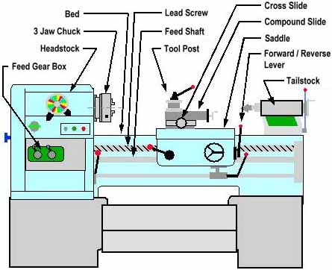
Example of a Typical Centre Lathe

Centre Lathe
The term Centre Lathe is derived from the fact that in its operation the lathe holds a piece of material between two rigid supports called centres, or by some other device such as a chuck or faceplate which revolves about the centre line of the lathe.
The lathe shown above is a typical example. This machine is usually used in a jobbing (one off) situation or for small batch work where it would be too expensive to specially 'tool up' for just a few items.
The lathe on which you will work is a machine used to cut metal. The spindle carrying the work is rotated whilst a cutting tool, which is supported in a tool post, is made to travel in a certain direction depending on the form of surface required. If the tool moves parallel to the axis of the rotation of the work a cylindrical surface is produced (Parallel Turning), whilst if it moves at right angles to this axis it produces a flat surface is produced (Facing off).
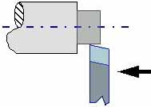 | 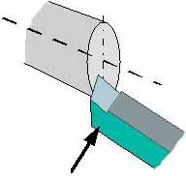
Parallel Turning | Facing off
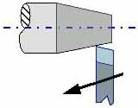 | 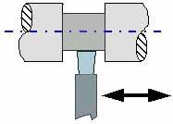
Taper Turning | Parting Off / Under Cutting
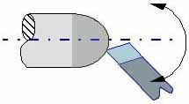 | 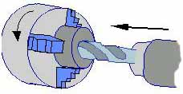
Radius Turning Attachment | Drilling on a Lathe

Cutting Tools
The tool used in a lathe is known as a single point cutting tool. It has one cutting edge or point whereas a drill has two cutting edges and a file has numerous points or teeth.
The lathe tool shears the metal rather than cuts as will be seen later and it can only do so if there is relative motion between the tool and the workpiece. For example, the work is rotating and the tool is moved into its path such that it forms an obstruction and shearing takes place. Of course the amount of movement is of paramount importance - too much at once could for instance result in breakage of the tool.
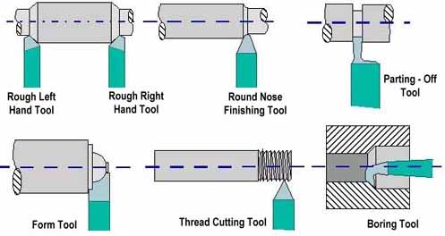
Types of Cutting Tool
The type and design of the tools selected will depend on the job in hand, the machining operation selected and the material to be cut. The correct tool especially the various face angles are essential if the operation is to be done in a cost-effective (i.e. productive) way. The tools used in a lathe are various, some of which are shown in figure 3.
The range of cutting tool types is extensive and a few examples only are shown in this handout. Nonetheless you should take every opportunity to look deeper into the types of tools available.

Basic Metal Cutting Theory  The usual conception of cutting suggests clearing the substance apart with a thin knife or wedge. When metal is cut the action is rather different and although the tool will always be wedge shaped in the cutting area and the cutting edge should always be sharp the wedge angle will be far too great for it to be considered knife shaped. Consequently a shearing action takes place when the work moves against the tool. | 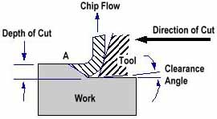  Basic Metal Cutting Theory
Figure 4 shows a tool being moved against a fixed work piece. When the cut is in progress the chip presses heavily on the top face of the tool and continuous shearing takes place across the shear plane AB. Although the Figure shows a tool working in the horizontal plane with the workpiece stationary, the same action takes place with the work piece revolving and the tool stationary.

Tool Angles
There are three important angles in the construction of a cutting tool rake angle, clearance angle and plan approach angle.
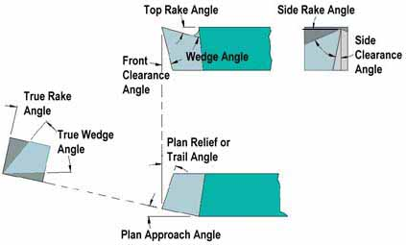
Main Features of a Single Point Cutting Tool
Rake Angle
Rake angle is the angle between the top face of the tool and the normal to the work surface at the cutting edge. In general, the larger the rake angle, the smaller the cutting force on the tool, since for a given depth of cut the shear plane AB, shown in Figure 4 decreases as rake angle increases. A large rake angle will improve cutting action, but would lead to early tool failure, since the tool wedge angle is relatively weak. A compromise must therefore be made between adequate strength and good cutting action.
Metal Being Cut | Cast Iron | Hard Steel / Brass | Medium Carbon Steel | Mild Steel | Aluminium
Top Rake Angle | 0° | 8° | 14° | 20° | 40°
Typical value for top rake angle
Clearance Angle
Clearance angle is the angle between the flank or front face of the tool and a tangent to the work surface originating at the cutting edge. All cutting tools must have clearance to allow cutting to take place. Clearance should be kept to a minimum, as excessive clearance angle will not improve cutting efficiency and will merely weaken the tool. Typical value for front clearance angle is 6° in external turning.

Plan Profile of Tool
The plan shape of the tool is often dictated by the shape of the work, but it also has an effect on the tool life and the cutting process. Figure 6 shows two tools, one where a square edge is desired and the other where the steps in the work end with a chamfer or angle. The diagram shows that, for the same depth of cut, the angled tool has a much greater length of cutting edge in contact with the work and thus the load per unit length of the edge is reduced. The angle at which the edge approaches the work should in theory be as large as possible, but if too large, chatter may occur. This angle, known as the Plan Approach Angle, should therefore be as large as possible without causing chatter. | 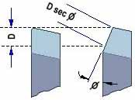  Plan Approach Angle
The trailing edge of the tool is ground backwards to give clearance and prevent rubbing and a good general guide is to grind the trailing edge at 90° to the cutting edge. Thus the Trail Angle or Relief Angle will depend upon the approach angle.
A small nose radius on the tool improves the cutting and reduces tool wear. If a sharp point is used it gives poor finish and wears rapidly.

Characteristics of Tool Material
For efficient cutting a tool must have the following properties:
Hot Hardness
This means the ability to retain its hardness at high temperatures. All cutting operations generate heat, which will affect the tool¡¦s hardness and eventually its ability to cut.
Strength and Resistance to Shock
At the start of a cut the first bite of the tool into the work results in considerable shock loading on the tool. It must obviously be strong enough to withstand it.
Low Coefficient of Friction
The tool rubbing against the workpiece and the chip rubbing on the top face of the tool produce heat which must be kept to a minimum.

Tool Materials in Common Use
High Carbon Steel
Contains 1 - 1.4% carbon with some addition of chromium and tungsten to improve wear resistance. The steel begins to lose its hardness at about 250° C, and is not favoured for modern machining operations where high speeds and heavy cuts are usually employed.
High Speed Steel (H.S.S.)
Steel, which has a hot hardness value of about 600° C, possesses good strength and shock resistant properties. It is commonly used for single point lathe cutting tools and multi point cutting tools such as drills, reamers and milling cutters.
Cemented Carbides
An extremely hard material made from tungsten powder. Carbide tools are usually used in the form of brazed or clamped tips. High cutting speeds may be used and materials difficult to cut with HSS may be readily machined using carbide tipped tool.

Tool life
As a general rule the relationship between the tool life and cutting speed is
VTn = C
where;
V = cutting speed in m/min
T = tool life in min
C = a constant
For high-speed steel tools the value of C ranges from 0.14 to 0.1 and for carbide tools the value would be 0.2.

Chip Formation & Chip Breaker
The type of chip produced depends on the material being machined and the cutting conditions at the time. These conditions include the type of tool used tool, rate of cutting condition of the machine and the use or absence of a cutting fluid.
Continuous Chip  This leaves the tool as a long ribbon and is common when cutting most ductile materials such as mild steel, copper and Aluminium. It is associated with good tool angles, correct speeds and feeds, and the use of cutting fluid. | 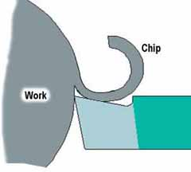  Continuous Chip
Discontinuous Chip  The chip leaves the tool as small segments of metal resulted from cutting brittle metals such as cast iron and cast brass with tools having small rake angles. There is nothing wrong with this type of chip in these circumstances. | 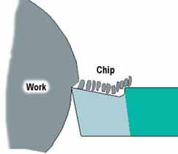  Discontinuous Chip
Continuous Chip with Builtup Edge  This is a chip to be avoided and is caused by small particles from the workpiece becoming welded to the tool face under high pressure and heat. The phenomenon results in a poor finish and damage to the tool. It can be minimised or prevented by using light cuts at higher speeds with an appropriate cutting lubricant. | 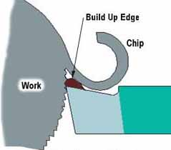  Continuous Chip with  Buildup Edge
Chip Breaker
A chip breaker is used to break the continuous chip into sections so that the chips cannot tangle around the cutting tool. The simplest form of chip breaker is made by grinding a groove on the tool face a few millimeters behind the cutting edge.

Cutting Speed & Feed
As you proceed to the process of metal cutting, the relative `speed' of work piece rotation and `feed' rates of the cutting tool coupled to the material to be cut must be given your serious attention. This relationship is of paramount importance if items are to be manufactured in a cost-effective way in the minimum time, in accordance with the laid down specifications for quality of surface finish and accuracy. You, as a potential supervisory / management level engineer, must take particular note of these important parameters and ensure that you gain a fundamental understanding of factors involved.
Cutting Speed
All materials have an optimum Cutting Speed and it is defined as the speed at which a point on the surface of the work passes the cutting edge or point of the tool and is normally given in meters/min. To calculate the spindle Speed required,

Where:
N = Spindle Speed (RPM)
CS = Cutting Speed of Metal (m/min)
d = Diameter of Workpiece
Table 2 shows the cutting speed recommended for some common metals. It may be possible to exceed these speeds for light finishing cuts. For heavy cuts they should be reduced.
Metal | meters /min
Cast Iron | 20-28
Mild Steel | 18-25
High Speed Steel | 12-18
Brass | 45-90
Bronze | 15-21
Aluminium | up to 300
Cutting Speed
Feed
The term `feed' is used to describe the distance the tool moves per revolution of the workpiece and depends largely on the surface finish required. For roughing out a soft material a feed of up to 0.25 mm per revolution may be used. With tougher materials this should be reduced to a maximum of 0.10 mm/rev. Finishing requires a finer feed then what is recommended.

Cutting Fluid & Lubricant
The aims in metal cutting are to retain accuracy, to get a good surface finish on the workpiece and at the same time to have a longer tool life.
However during the metal cutting process heat is generated due to:
- the deformation of the material ahead of the tool
- friction at the tool point
Heat generated due to friction can readily be reduced by using a lubricant. Heat caused by deformation cannot be reduced and yet it can be carried away by a fluid. Thus the use of a cutting fluid will serve to reduce the tool wear, give better surface finish and a tighter dimensional control.
The proper selection, mixing and application of cutting fluids is however often misunderstood and frequently neglected in machining practice. In order that the cutting fluid performs its functions properly it is necessary to ensure that the cutting fluid be applied directly to the cutting zone so that it can form a film at the sliding surfaces of the tool.
Cutting fluids in common use
Water
It has a high specific heat but is poor in lubrication and also encourages rusting. It is used as a cooling agent during tool grinding.
Soluble Oils
Oil will not dissolve in water but can be made to form an intimate mixture or emulsion by adding emulsifying agents. The oil is then suspended in the water in the form of tiny droplets. These fluids have average lubricating abilities and good cooling properties. Soluble oils are suitable for light cutting operations on general purpose machines where high rates of metal removal are often not of prime importance. There are many forms of soluble oil in the market and the suppliers instruction should be followed regarding the proportions of the `mix'.
Mineral Oils
They are used for heavier cutting operations because of their good lubricating properties and are commonly found in production machines where high rates of metal removal are employed. Mineral oils are very suitable for steels but should not be used on copper or its alloys since it has a corrosive effect.
Vegetable Oils
They are good lubricants but are of little used since they are liable to decompose and smell badly.

Screw Cutting  During this module you are required to explore the use of the lathe to cut, amongst other things, a metric screw thread on a bar. It is a slightly more difficult task than plain turning because it involves accurate setting up of the tool and exact setting of feed in relation to the work rotation. Once this is done however, and this you will be shown, the process of screw cutting becomes relatively simple. Fig 10 shows the arrangement in simplified form. | 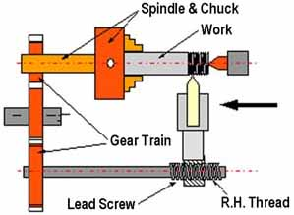  Screw Cutting Set-up
There are many different forms of screw thread, Fig 11 shows the 'sections' of three most common types.
More types and specifications of screw threads can be found in any Workshop Technology Hand Books and you must get used to finding such information and knowing how to apply it.
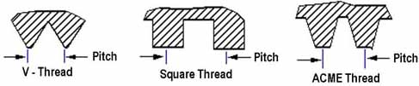
Types of Screw Thread

Safety
It is imperative that you fully understand that machine tools are potentially dangerous and that you must at all times:
Follow the laid down Section and IC Safety Rules.
Know what to do in an emergency. NEVER switch your machine tool on for the first time until given permission by your Staff Member to do so. At varying stages in your programme if the Staff Member is satisfied with your operational knowledge you will be given permission to proceed on specific steps unsupervised. This is a measure of the Staff Member confidence in you and you should be pleased that you are so trusted and live up to that trust by taking all reasonable safety precautions.
Well-qualified and enthusiastic IC staffs are ready and willing to help you and it is up to you to make most use of their willingness to transfer their technical knowledge and their experience to you.

Conclusion
Lathes are normally robust in construction and they will, with good care, last for many years. It is not unusual for instance to see good lathes still in uses that are 50 years old. To ensure good, accurate, trouble free use it is necessary that the correct maintenance routines are regularly carried out and that important surfaces such as slide-ways are kept well protected so as to reduce wear and thus maintain good accuracy. This aspect of 'good husbandry' should be of interest to you and you will be expected to demonstrate an understanding of this. In this respect the types of maintenance routine carried out, the design and accessibility of the maintenance system, and the lubricants used, are all factors that require your attention.

