NOT Covered in O. Murphy’s book: M.Selkirk

m1
m2
M3
a
b
If mass m1 accelerates upwards at a m/s² , then it will cause M3 to accelerate downwards at $\frac{a}{2}$ m/s²,
If mass m2 accelerates upwards at b m/s² , then it will cause M3 to accelerate downwards at $\frac{b}{2}$ m/s²,

So, overall, M3 will accelerate downwards at $\frac{a}{2}$ + $\frac{b}{2}$ = $\frac{a+b}{2}$

m1
m2
M3
a
b
a
2
b
2

See next pages for solutions to 2009 Q4(b) and 2007 Q4(b) :

2009 Q4(b):
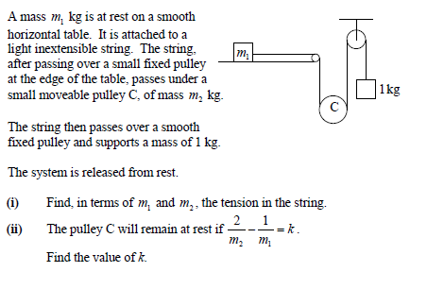

NB: Consider the moving objects separately: Remember .. same string, same tension.

m1
1K
m2
T
T
T
1g
m₂g
b
1.) T = m₁ a
2.) m₂g - 2T = m₂ (
)
T
3.) T- 1g = 1b
a
(i) From 1: a = T/m₁ , 3: b = T – g so, a + b = T + m₁T – m₂g
2 2m₁

Sub into 2: m₂g - 2T = m₂ (T + m₁T – m₂g ) and solve to get T= 3m₁ m₂ g_
2m₁ 4m₁+m₁m₂+m₂

(ii) If pulley at rest, that means that acceleration of pulley = 0. REM: For a fraction to be = 0 we only need to make the top (numerator) = 0.
So, if a + b = 0 then a + b = 0 or a = - b
2

From 1: a = T/m₁ , 3: b = T – g so if a = -b then

T = - (T – g) or T = m₁ g (4)
m₁ 1 + m₁

but from ans to part (i) T= 3m₁ m₂ g_ (5)
4m₁+m₁m₂+m₂

So letting (4) = (5) gives 4m₁ – 2m₁ m₂ - 2m₂ = 0

Divide across by 2m₁ m₂ to give : 2 - 1 - 1 = 0
m₂ m₁

or …….. 2 - 1 = 1 so k = 1
m₂ m₁

2007 Q4(b):
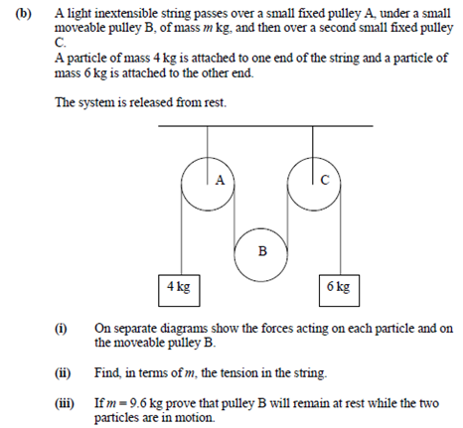

NB: Consider the moving objects separately: Remember .. same string, same tension.

4K
4g
mg
m
6K
6g
T
T
T
T
a
b
a + b
2
(1) T - 4g = 4a
(2) mg - 2T = m (a + b)
2
(3) T - 6g = 6a
(i) From 1: a = 4g - T From 2: b = 6g - T …. sub into (3) to get :
4 6

T = _48mg____
48 + 5m
(ii) If pulley stays at rest, then a + b = 0 which means a = -b
2

But a = 4g - T and b = 6g - T so letting = 4g - T = - (6g - T)
4 6 4 6

Gives : 48g = 10T and sub in for T = 48mg
48 + 5m

To get : 48g = 480mg
48 + 5m

Which gives 5m = 48 …………… or m = 9.6Kg

