

Response to Request
for

Internet Services

Mary McCabe
Eircom Net
087 2244090
mary.mccabe@eircom.net

CONFIDENTIALITY STATEMENT

This document contains eircom net confidential and proprietary information and is supplied to the customer solely in order to enable it to evaluate details concerning our products and services. This document (including any part hereof) is not to be disclosed or transferred outside your organisations without prior written consent of a duly authorised representative and may not be copied or reproduced in any form or by any means except internally within your organisation in order to enable such evaluation.

This document is submitted “subject to contract” based on the information currently available (for instance in your request for information). None of the information contained in this document shall be contractually binding unless and until incorporated in a formal written contract between the parties.

eircom net

eircom net - Network Description

eircom net has three core nodes in Dublin (Crown Alley, Adelaide Road and Exchequer Street). These are connected using redundant links (multiple STM1 circuits, using SDH and ATM) and each has its own international and INEX connectivity.

The eircom net Dublin Core Network schematic is outlined in Figure 1 below:
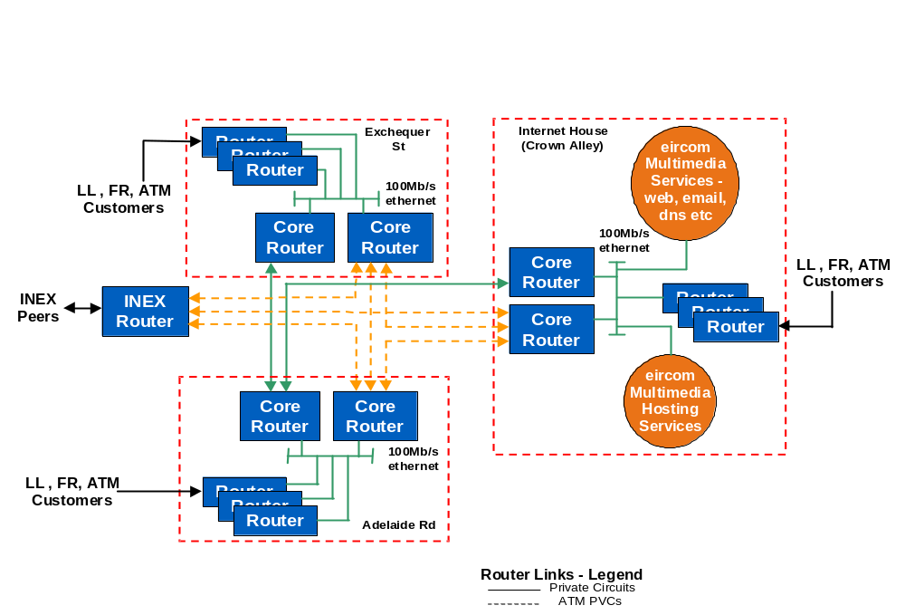

Figure 1: eircom net ISP Core network in Dublin

At present the ATM mesh connecting Crown Alley, Exchequer St, and Adelaide Rd exchanges is at 155Mb/s, however, this can be upgraded to up to 622Mb/s should demand require.

At each core network node there are two core routers. In the event of failure of one of them, the second one can maintain connectivity through its own redundant links. All our core routers have dual power supplies backed up by UPS / Generator power. They are also covered by a 24-hour pager monitoring system, with staff always on call to replace faulty equipment with available spares.

eircom.net
UUNET

Cable & Wireless
111, 8th Ave., New York
155Mbps
45Mbps
34Mbps
34Mbps
LINX
Ebone
KPN Qwest
Telehouse, London
100Mbps
100Mbps
100Mbps
LINX Peers
45Mbps
Router
Router
155Mbps
2 x 155Mbps
Amsterdam
Frankfurt
Paris
155Mbps
155Mbps
155Mbps
45Mbps
45Mbps
45Mbps
155Mbps
155Mbps
155Mbps

Legend

STM-16
STM-1
STM-1 (planned)

Exchange

INEX

34Mbps

Figure 2: eircom net International Connectivity

All core international routers are 7507s with the appropriate interface / processor cards.

Our international connectivity can be described as follows:

- Full global transit:

34Mb/s direct connection to UUNET direct to their Dublin node.
100Mb/s to KPNQwest/EUnet from our router in London Telehouse.
34Mb/s backup to UUNET from our router in London Telehouse.
155Mb/s to Cable & Wireless USA from our router in 111, 8th Ave, New York City.

Should any of these connections fail traffic will re-route on the remaining links.

- European transit only:

100Mb/s to Ebone (GTS)

Should any of these connections fail traffic will re-route via the remaining European and Global transit links.

Peering Arrangements

We peer at the INEX and LINX as follows:

- INEX(Irish Internet Exchange)

Currently we have a 34Mb/s ATM connection to the INEX. We take ATM PVC's from our INEX router to each of eircom.net core nodes in Dublin. By utilising ATM we can upgrade the PVC's to meet our traffic requirements as they arise. For example, if one particular PVC needs to be upgraded it can be done within days.

The peering arrangements at the INEX are as follows:

Ireland Online
Esat Net
HEANet
Stentor
Via Networks
NTL
MCI WorldCom

Internet Access-

Installation and set-up charges for each service
The once off set-up costs for the Leased Line Internet Services are outlined below

Once off costs 64kps | 64 kps | 128kps | 256kps | 512kps | 1MB | 2MB
Service Registration | £ 500 | £ 500 | £ 500 | £ 500 | £ 500 | £ 500
Leased Line Connection Charge | £1,500 | £1,500 | £1,500 | £1,700 | £1,700 | £3,000
Total | £2,000 | £2,000 | £2,000 | £2,200 | £2,200 | £3,500

Access and Service Set-Up costs for

The annual recurring costs for Leased Line Rental and Internet service subscription are outlined below.

Annual Charges 64kps | 64 kps | 128kps | 256kps | 512kps | 1MB | 2MB
Leased Line Connection  Charge (physical line) | £ 3,182 | £ 3,965 | £ 6,665 | £ 9,718 | £15,572 | £20,630
Internet Connectivity Charge | £3,500 | £ 5,000 | £ 8,500 | £ 15,000 | £22,000 | £35,000
Total | £ 6,682 | £ 8,965 | £15,165 | £24,718 | £37,572 | £55,630

Once off Charges for Hardware
Cisco 1700 Series Router with WIC Card for ISDN Back Up | £1,750

Consultancy and Implementation
Any Consultancy required or implementation onsite will be charged at £850 per day

