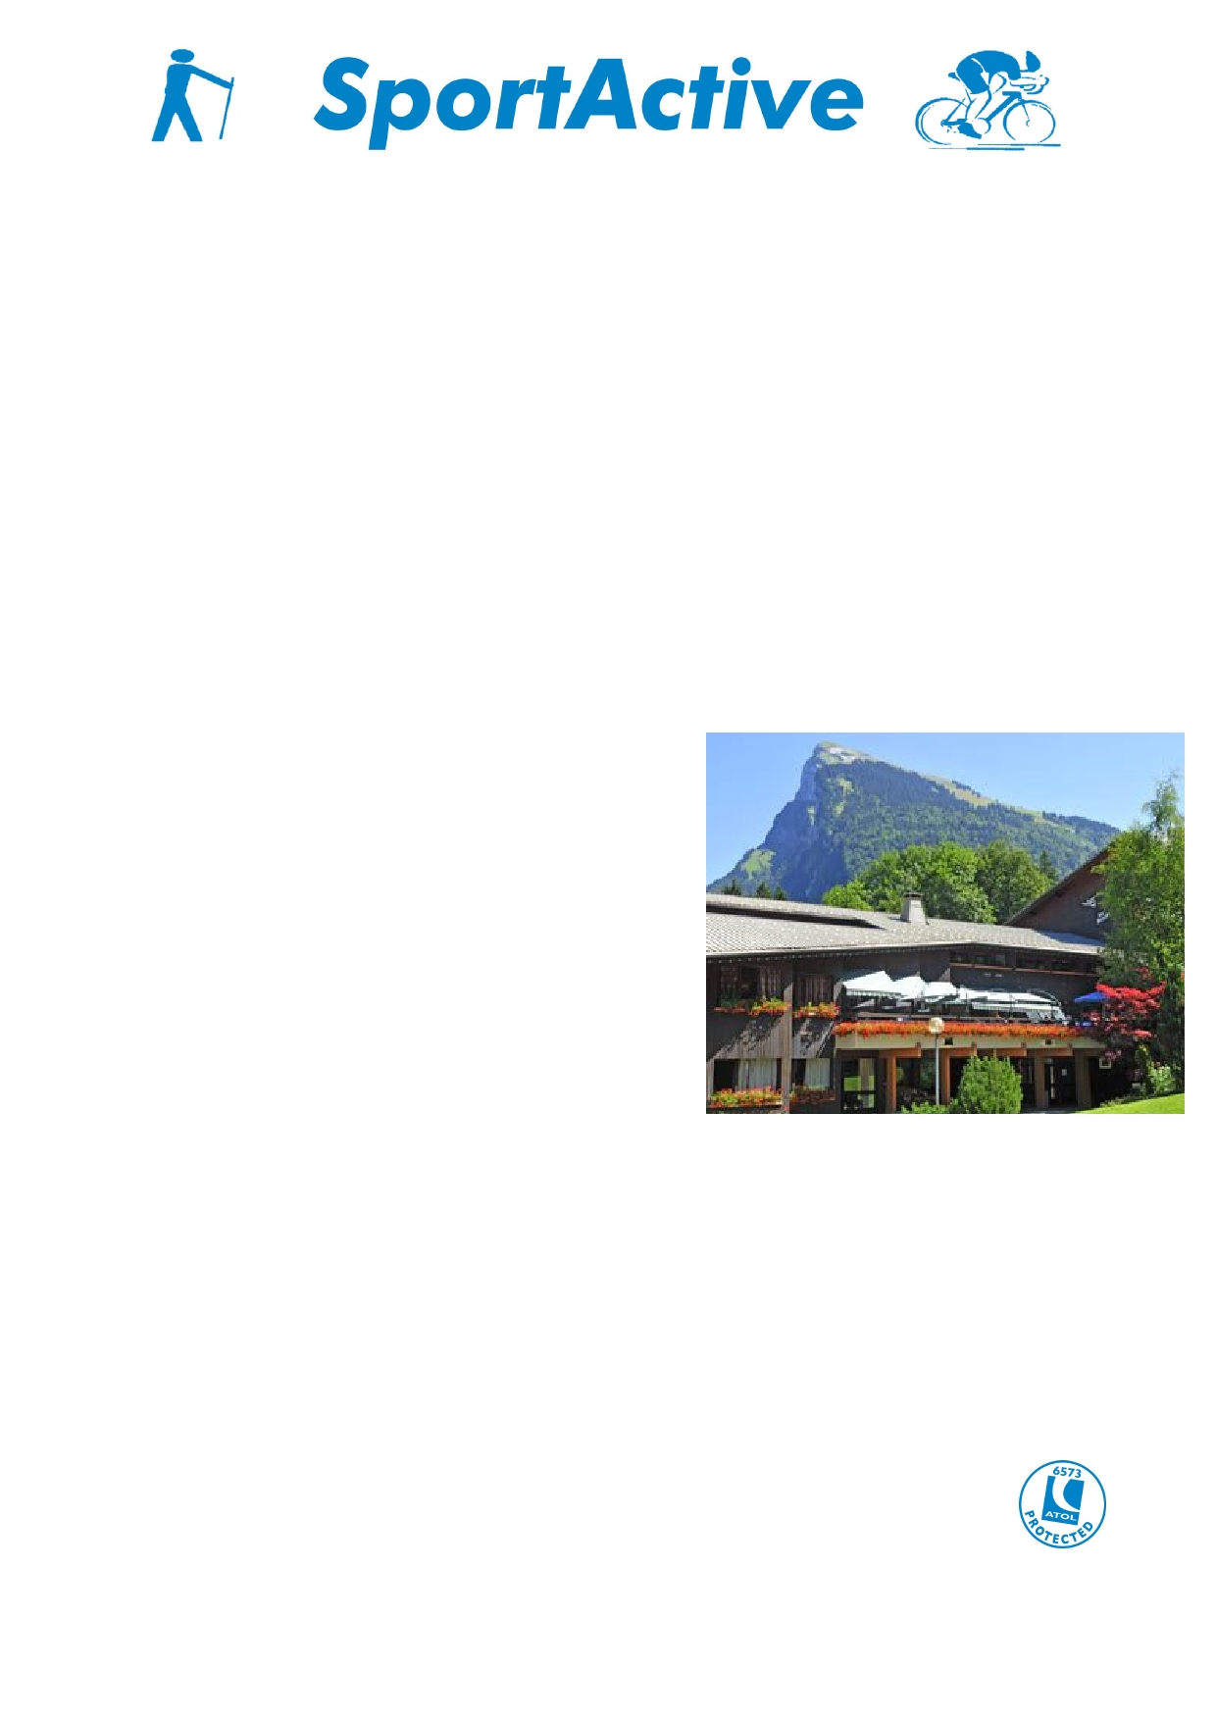
The Wee Binnians Walking Club

Walking Holiday in Samoëns - France

June 2012

For group of 50 people minimum

Located in the Alps, in the region of Haute Savoie, Samoëns offers an exceptional mountain environment boasting much diversity including a flat glacier valley, forests typical of mid altitude mountains, high mountain pastures, alpine summits and more…

Samoëns is one of the oldest authentic mountain villages lying at 720 m altitude. It offers not only fantastic walks but also exudes in culture with quaint architecture, botanic gardens and its famous stonecutters….
"The experience of each individual is the treasure of all people"[Nerval]

Accommodation : village de vacances Les Becchi

Located at 400 m from the village centre, on the edge of a wood, Les Becchi offer a friendly mountain atmosphere. Rooms are twin for our group, on suite.

You will find a full offer of leisure facilities: Spa centre with sauna, Turkish bath, indoor heated swimming pool (28°C!!), sport courts (volley ball, pétanque (good fun, typically French! you have to try it and drink pastis while you play before dinner), ping-pong etc.

The chefs will serve you the local gastronomy, with fondue Ssvoyarde (cheese fondue), crozets (type of pasta from the Savoie mountains) diots au vin blanc (local sausage cooked in white wine), tartiflette (potatoes baked in the oven, with onions, bacon and cheese), raclette….Wine is included and served "à discretion" (as much as you wish).

Evening animations: dance, plays, shows…coloured moments to share with everybody.

Service level for our group:
• Full board, wine included, base 2 sharing
• Lunch packs for the walks (not sandwiches but a variety of salads, eggs, ham…)
• Access to leisure facilities and evening animations
• Room cleaning on Sunday and Tuesday; no room cleaning the other days ; towel change
3 times during the week

Les Becchi offers an extremely friendly and warm mountain atmosphere which allows everybody to feel at ease

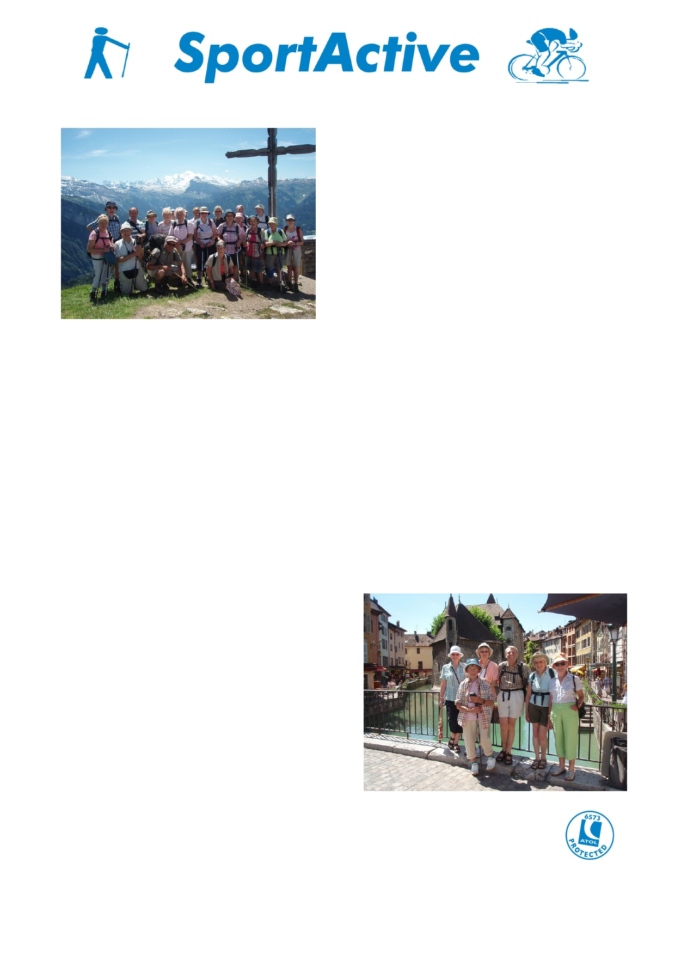

Walking programme : 5 walks

A variety of walks are available in the region without long bus trips to the departure of the
walks. The selection allows offering long and hard walks for tough walkers as well as more moderate
walks and even easy ones. Easy walks does not
mean that the eyes will not be delighted ;
actually, one of the easy walks is amongst the nicest in the area.

You will have 3 walking groups. One will be
guided by Xavier, our local SportActive guide ; for
the other 2 self-guided groups a walking programme will be prepared by Xavier.

Walking time will be up to 6 hours. Length and difficulty of the walks will be adapted to each
group in consultation with your group leader. The walking programme will be flexible and
adapted to weather conditions.

To loosen the muscles for the next day's walk or/and the dancing evening, Flora will offer stretching sessions (45-60 min) after the walks.

The package includes:
• 7 nights full board in Les Becchi, based on two sharing one room
• Lunch packs for the walks
• 5 days with Xavier guiding one group
• Stretching sessions with Flora after the walks
• Local transport to the walks and back with private bus (there can be a bus for each
group if necessary : the shorter walk will not have to wait for the longer walk to finish
before being picked up after the walk)
• airport transfers from and to Geneva with private bus

Not included are:
• Single room supplement: 15 €/night
• Private medical insurance & travel
insurance
• Rest day activity

Rest day activities

A rest day in the middle of the week allows you to explore the area which we can't reach by walking. A bus trip to Annecy is a great way to spend the day. Drive over le Col de la Colombière, make a

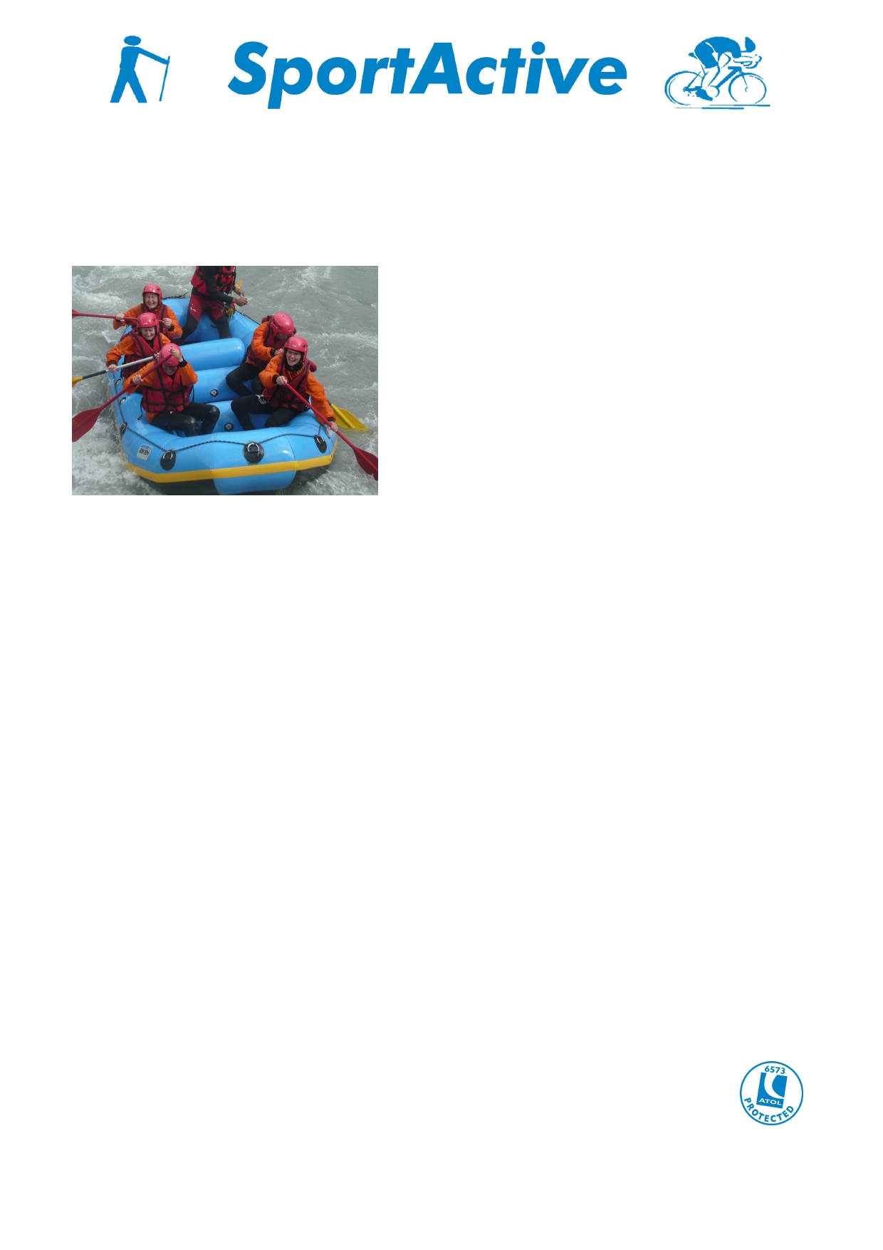
short stop at the monastery "La Chartreuse du Reposoir", a lunch in St Jean de Sixt close to Le
Grand Bornand, at Forgeassoud - (a sister hotel of Les Becchi) and on to Annecy to visit its lake and the old town, known as "La petite Venise".

The price per person for this rest day tour is around 40 €/person for a minimum of 20 participants.

White water rafting, operated by a specialized company in Samoëns, is an option for a half day activity. Cost around 35 €/person.

Flight details: (not available yet)
Dublin Geneva with Aer Lingus or Belfast Geneva with Easy Jet.

SportActive regards,
Flora & Martin

15.05.2011

You are reminded to ensure that you have current and valid travel insurance
for all bookings.

