2 The Victorian Image of Africa
Ignorance of Africa
Europeans in the nineteenth century were almost totally ignorant of all but a few small corners of Africa. Until late in the century they knew practically nothing of the geography or the peoples of its interior. When they spoke - as they frequently did - of the ‘Dark Continent’, they properly meant a continent which was dark to them, about which they knew little. But this idea merged imperceptibly with another more sinister idea of ‘Darkest Africa’, Negro Africa, a place of savagery and brutality. Circumstances seemed to conspire to increase misunderstandings.

In 1880, the phrase 'the civilized world' was readily understood. It meant Europe and those countries which inherited European traditions and values. The Europe-centredness of civilization was easy to distinguish. The result was a domination of the world by European culture and institutions which has spread and been consolidated ever since.

1. Decline of African communities; B. Technological gap.

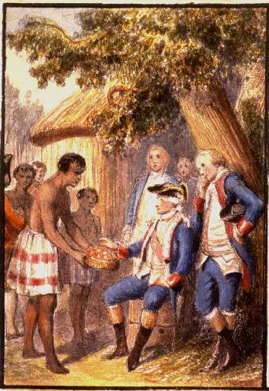
When Europeans first penetrated into Africa south of the Sahara a number of African communities were in decline. The Atlantic slave trade in the west and the Arab slave trade in the east accounted for some of this, but other African states, like the savanna empires, seem to have declined for purely local reasons. It is possible that the ‘Balkanisation’ of Africa was more extreme in the middle of the nineteenth century than it had been for centuries. If it is true that it was African strength which had kept the European on the coast in the past, this may itself be a contributory factor in the timing of the European ‘opening up’ of Africa. Probably, though, this was secondary to another factor, the enormous technological gap which had appeared between European and African civilisations. When the Portuguese first reached the Congo in the late fifteenth century they found a powerful and well-organised state. In the sixteenth century cordial relations developed between the two powers. Congolese came to Europe. Portuguese ‘experts’, including even printers, went to the Congo to instruct the inhabitants. Clearly, even then, the Congolese admired European skills but, equally clearly, no unbridgeable gap was felt to exist between the two cultures. This fruitful relationship continued until the Portuguese became more interested in their Brazilian colony and largely lost interest in Africa except as a source of slaves. A few centuries later such a relationship would have been almost unthinkable.

The Background

The peasant communities of medieval Europe, even perhaps the towns of Renaissance Europe, were not impossibly far removed from their African counterparts. But Africa had nothing remotely like the urban civilisation of Europe in the period after the industrial revolution. Psychologically the two cultures had moved very far apart, the more so because of the great stress nineteenth century Europeans were prone to put on technological advance. To them it became almost a badge of
civilisation’.

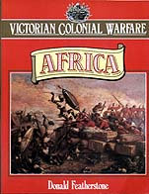
But Europe had changed at incredible and unprecedented speed in more ways than in technological advance in the centuries after the Renaissance and, perhaps still more, after the scientific revolution of the eighteenth century. Whole ways of thinking had been revolutionised. Rationalism and humanitarianism had made Europe turn its back on much of its own past. Many things which nineteenth century Europeans found shocking in Africa - and which appear equally shocking to the twentieth century - public executions, torture, mutilating punishments such as lopping off the hand of a thief, a prevailing fear of witchcraft, would have been part of the fabric of life to their own recent ancestors. At no moment in time perhaps were Europeans less able to understand African society than at a period of break-neck change in their own in the nineteenth century.

SLAVE TRADE
European views of Negro Africa were originally formed during the slave trade era and related particularly to the coast of West Africa. In the eighteenth century West Africa was particularly important to Britain. Britain sent manufactured goods to West Africa to exchange for slaves who were shipped to the West Indies in return for sugar and similar tropical products. Although there are difficulties in accepting, in its simple form, Dr Eric Williams’s famous thesis that the profits of this ‘triangular’ trade provided the capital to support the industrial revolution in Britain. it was certainly central to the British economy in a way in which West African trade never was to be again,

West Africa therefore naturally attracted some popular attention. The slave trade itself was necessarily brutalising for all who participated in it. Most Europeans were shocked by their first contact with it (14). Dealing with men as merchandise in this way almost compelled those concerned not to see them as men at all. Paradoxically, however, since they also dealt with the African merchants who sold the slaves, the slavers were among those most able to think of Africans as individuals and not just see them as a stereotype ‘Negro’.

The agitation for the abolition of the trade in the late eighteenth century cut both ways in forming the image. Some defenders of the trade, and in the next generation those who opposed the abolition of slavery itself in the British empire, argued that the Negro was not fully human, or was such a degenerate form of humanity that slavery was a desirable condition for him.. Arguments raged between those who supported the theory of ‘polygenesis’, that is that the different races of mankind were created separately and were therefore technically different ‘species’, and the more orthodox believers in ‘monogenesis’, that the whole human race sprang from a single pair, Adam and Eve, whatever might have happened to its different branches since. It was noticeable, though, that even those who argued for abolition tended to condemn the cruelty of the trade and of the condition of slavery, or to emphasise the spiritual equality of mankind which derived from the common fatherhood of God, and to slide
over the difficult question of the temporal equality of the Negro to the white man in this world. Indeed, many abolitionists inclined to take a paternalistic line and to suggest that the Negro must be defended because he could not defend himself, to see him as a child in an adult world (2).

There were a few correctives to the general ‘slave’ stereotype. There was the literary tradition of the ‘noble savage’ which had a considerable vogue in the eighteenth century. This was usually applied to the American Indian or the Polynesian, but the Negro occasionally benefited from it. Indeed the first African hero in English literature (leaving aside the difficult question of Othello’s colour) was Oroonoko who appeared in 1688. More important than this, real Africans were not totally unknown in England in the eighteenth century. First, there were several thousand personal servants of one kind or another. Some of them had originally been slaves brought from the West Indies, but the famous judgement by Lord Mansfield in Somersett’s case in 1772 (15) laid down that no man could be a slave in England whatever his status elsewhere. There were also, perhaps more surprisingly, some fifty African ‘trainees’ in Liverpool in the 1780s direct from West Africa, learning English and English commercial practices. The scanty information available suggests that the relations of these people with the indigenous population was neither better nor worse than that of any other group of foreigners, generally amicable but prone to occasional friction arising from dislike of strange customs or competition for jobs or girls (2).

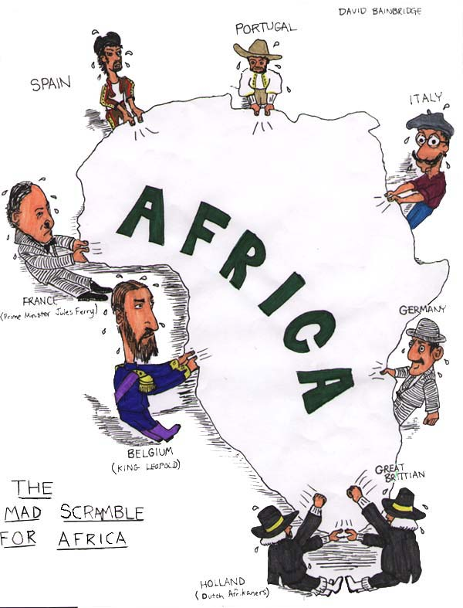
If slavery forced men to formulate an attitude towards the Negro, the late eighteenth century also saw an unprecedented flowering of scientific interest. Both geographical and biological enquiries were the fashion. Captain Cook’s voyages had solved many long-standing problems concerning the Pacific. A number of men longed to do the same for Africa. The African Association (strictly the ‘Association for promoting the Discovery of the Interior Parts of Africa’) was founded in 1788, largely under the inspiration of Joseph Banks, the President of the Royal Society, who had accompanied Cook to the Pacific in 1768, with the support of a few personal friends. They were principally interested in the interior of West Africa. Although nothing new had emerged since the accounts, mainly Arabic, of the tenth to the sixteenth centuries, these had become widely available in English for the first time in a number of famous collected works in which the eighteenth century excelled. The greatest triumph of the African Association was the despatch of Mungo Park’s first expedition, that of 1795-97, which finally established the general direction of the river Niger which had long mystified Europeans (44).

There was also some British government interest in this period when it was looking for possible compensation for the material and prestige losses of the American War of Independence and for strategic positions during the French revolutionary and Napoleonic wars. Mungo Park’s second expedition to the Niger, that of 1805, was government-financed. This interest survived into the early nineteenth century. In 1817 a mission was despatched to the king of the Ashantee in his capital at
Kumasi, to sign a political and commercial treaty. A member of the expedition, T. E. Bowdich, published a book about it two years later (Mission from Cape Coast Castle to Ashantee, London, 1819). This was a meticulous account of Ashantee culture, including beautifully illustrated sections on subjects like architecture and musical instruments. Bowdich did not attempt to disguise the harsh side of Ashantee life, including public executions and the human sacrifices demanded on the death of the king and on certain other occasions, but they were seen in their context as part of a highly organised society.

SLAVERY
Generally, however, British interest in West Africa declined during the first thirty or forty years of the nineteenth century, though the Sierra Leone experiment continued. This was the nearest approach to a colony that Britain maintained on the coast at this time, though there were small communities of merchants resident on the Gold Coast and at the mouth of the river Gambia. The Sierra Leone colony was founded in 1787 as a home for freed slaves and was the forerunner of the better-known American experiment in Liberia. Sierra Leone had a chequered early career and played a paradoxical role in the development of British thinking about Negro Africa. It was under frequent attack from the indigenous population of the area, and while it convinced many that, given time, Africans could adopt a European form of civilisation successfully, it also led to increasingly hostile comparisons being drawn between westernised Africans and their primitive’ brethren who had been a danger to the colony (2).

Interest in the West Coast revived with the ill-fated ‘Niger experiment’ of 1841-42. This is always associated with the name of the a slave-trade crusader, Thomas Fowell Buxton, although he took man his ideas from James MacQueen an earlier writer, better known in own day than in ours (2). Since Britain and the United States outlawed the slave trade in 1807 and since other European countries had committed themselves, at least nominally, to the same position 1815, Britain alone of the European powers had made serious attempts to police the West Coast and stamp out the trade. Her success had been limited
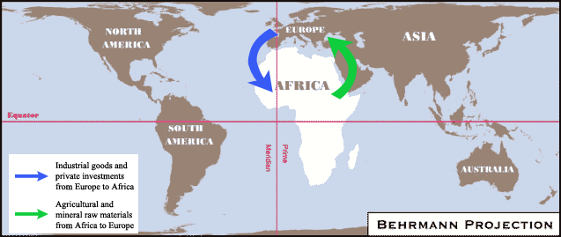
As long as slavery continued in the United States and Brazil slavers of various nationalities would try to carry on the contraband trade, and as long as there were customers Africans would sell slaves, A growing body of opinion in Britain believed that only legitimate commerce would stamp out the trade. The African middlemen must have commodities other than human beings to sell to Europe traders. In West Africa a promising beginning had been made with the trade in palm much in demand for soap and for the lubrication of the new machinery now employed in industrial Britain. The Niger experiment was an attempt to expand this. It failed because of the heavy mortality suffered by the expedition (2, 32).

But the principle was of wider application than the Niger. That legitimate trade would drive out the slave trade became a generally held maxim to be applied to the Arab slave trade of the East Coast as well as to the Atlantic trade, which died a natural death with the abolition of slavery in the United States in the 1860s. But it went further. Commerce it was held, would raise the African standard of life. It was natural transition from ‘barbarism’ to civilisation. It was necessary the advance of Africa and Europeans were increasingly beginning to be responsible for bringing about such an advance. It also of course, promised rewards to European traders and investors, but a historian very sympathetic to Africa, P. D. Curtin, rightly warns against the crude simplification of seeing this philosophy simply as a cover for immediate economic self-interest (2). Among the many theories advanced in the middle of the century there were even some forerunners of Lugard’s famous Dual Mandate, the hypothesis that the interest the Europeans and of the Africans were essentially complementary. “”Europe benefited by the wonderful increase in the amenities of life for the mass of her people which followed on the opening up of Africa at the end of the 19th century. Africa benefited by the influx of manufactured goods, and the substitution of law and order for the methods of barbarism’ (120).

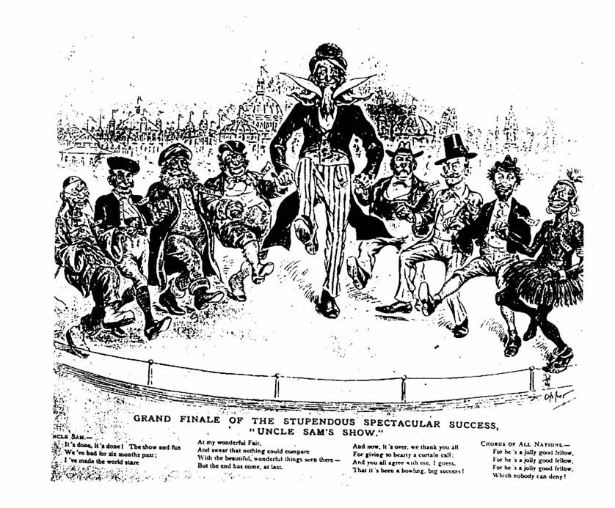
Despite its ill-success, the Niger experiment temporarily revived British interest in Negro Africa, especially West Africa, but it was at a much lower intellectual level than the scientific enquiries of Park or Bowdich. The 1840s saw a rash of ephemeral publications, mainly travellers’ tales. Curtin remarks that the only excuse for yet another new book seemed to be a story of personal adventure and the accounts became steadily more subjective and more sensational. The nadir was perhaps reached with J. Smith’s Trade and Travel in the Gulf of Guinea (1851) with chapters such as ‘Human Sacrifice - Nailing prisoners, Jack Ketch, Decapitation, cooking and eating human flesh. King Pepple cats King Amacree’s heart. , . .’ But saturation point was eventually reached. Interest fell off in the 1850s. Blackwood’s magazine, which had carried much on West Africa in earlier decades, published nothing at all on the subject in die 1850s. The noted traveller Richard Burton wrote in 1845 that people were bored with ‘ugly savages’ and with ‘the monotonous recital of rapine, treachery and murder’. Unfortunately this boredom also extended to much more serious studies. The great compendium of information gathered by the German, Heinrich Barth, first published in English in 1857, sold so badly that the print of 2,250 copies for the first three volumes was reduced to 1,000 for the later volumes (2).

DARWIN
This dismissal of African societies as savage and uninteresting coincided with other developments. The period 1829 to 1859 saw a complete rethinking of biological concepts. This reappraisal went back earlier, in fact, to Linnacus’s work in 1734 and was to culminate in Darwin’s Origin of Species ( 1859). Men were fascinated by the ‘classification’ of natural phenomena; the definition of species and ideas of natural selection and even of evolution were already in the air long before Darwin gave them a coherent form. It was natural that the study of human races should play a part in these enquiries. Old disputes about polygenesis and monogenesis were revived, given special impetus by arguments
about the abolition of slavery in the United States. It was understandable that European scholars should conclude that the white or ‘Caucasian’ races of their own kind were the most highly developed. All men are prejudiced in favour of their own kind and the superior technology of Europe gave the proposition a good deal of plausibility in the nineteenth century. It was easy enough then to rank other races according to their resemblance to Europeans, and physically Negroes were the least like Europeans in their external appearance. (No one, of course, could know in the nineteenth century that blood groups and ‘tissue typing’ would cut across all racial groups.) This comforting thesis seemed to receive reinforcement from the fact that the Chinese and other Asians, who were more like Europeans, had achieved some degree of civilisation. The Africans at the bottom of the heap seemed to be sunk in savagery.

As ideas of evolution gained a hold on public imagination men increasingly saw African societies as examples of what their own societies had been in earlier eras, ‘contemporary ancestors’ in H. A. C. Cairns’s phrase (1). This theory at least held out hope that the Africans could improve. Even in the nineteenth century it was attacked from
two different sides. First, there were the objections of a man of African descent, the West Indian Edward Blyden, an important figure who has only recently become the subject of serious study. Writing in 1887, he rejected the idea that ‘the Negro is the Eurpean in embryo ... and that when, by and by, he shall enjoy the advantages of civilisation and culture, he will become like the European; in other words, that the Negro is on the same line of progress, in the same groove, with the European, but infinitely in the rear’ (1). A more common type of
objection to trying to change Africa was that expressed by a correspondent to John Bull in 1823, ‘We are expending our thousands and tens of thousands a year: to do what, Sir? To wash the Blackamoor white - monstrous absurdity!’ (2).

In fact the British taxpayer had little reason to complain for most of the century that his money was being spent on Africa. The upkeep of the Africa squadron to thwart the remaining slavers cost a certain amount until the 1860s. So did the upkeep of the four British stations on the West African coast, the Gambia, Sierra Leone, the Gold Coast (Cape Coast Castle) and, after 1862, Lagos, but in 1865 a Select Committee of the House of Commons reported that Britain would be well advised to relinquish all her holdings on the West Coast, except perhaps Sierra Leone. which had Possibilities as a naval base. Although the century connection between Europe and Africa emerge strengthened and reinforced in the late nineteenth century. There is an increasing awareness of the economic possibilities of Africa, a genuine scientific interest, an equally genuine humanitarian interest, but. arising from this melange, a deep and inexorable misunderstanding growing between Europeans and Africans.

MISSIONARIES
The heirs of the eighteenth century humanitarians were the missionary societies. Missionary endeavour came to most of Africa comparatively late. The great era for the foundation of missionary societies in Britain was the late eighteenth century, but not all of them were at first interested in Africa. Even in Sierra Leone the Church Missionary Society did not begin work until 1806 and the Wesleyan Methodist Mission until 1811. The Wesleyans began work in Ashantiland in 1842. In what later became Nigeria the first permanent mission was established in 1844 by the Church Missionary Society. It is worthy of note that during the early days of the missions on the Guinea coast Africans played a more prominent part than they were to be allowed to do again for several generations. Philip Quaque, a Fante who had been educated in England, was the chaplain at Cape Coast Castle in the late eighteenth and early nineteenth centuries. Rather later Samuel Crowther, a Yoruba who had been rescued from a slave ship and also educated in Britain, became a bishop. In South Africa the Boers had tended to avoid missionary activity among the Africans because of the tattered remnants of the doctrine that a baptised Christian had a claim to civil rights, irrespective of his nationality but the London Missionary Society was active there by 1800. The Church Missionary Society had a small station at Mombasa on the East Coast, staffed by German Lutherans, in the middle of the century. Two of these Germans, Johann Krapf and Johann Rebmann, were the first Europeans to set eyes on Mounts Kenya and Kilimanjaro in 1847. But the classic missionary penetration into the interior of Africa was a phenomenon of the 1880s. The missionary societies, almost without exception, had very effective propaganda machines and the picture they drew of -Africa gained very wide acceptance.

Unfortunately, in the opinion of Cairns (1), the missionaries bore a special responsibility for increasing the ‘cultural arrogance’ of the British public and misrepresenting African society in a way calculated to give rise also to racial arrogance. The reasons are not difficult to discern. The missionaries were entirely dependent on public support and subscriptions to carry on their work. Missionaries were urged to send home detailed reports of their activities and of the conditions they found. These reports were then given a very wide circulation. The breadth of the range they covered may be judged by the fact that the societies found it worth while to run special publications for children and for ‘working-class’ readers. To gain public sympathy missionaries were inevitably tempted to stress the temporal as well as the spiritual aspects of their work and to represent the life of the unconverted African here on earth as brutal and barbarous. Sonic resorted to a kind of ‘before and after’ vignettes, representing the converted African in a much happier condition. This form of propaganda (like the theories of the evolutionists) did at least portray the African as capable of improvement but it also of necessity denigrated his indigenous culture. African religion was often particularly ill-served by missionary observation. Few tried to penetrate below the surface and ask what rituals and apparent crudities meant to the believer. It was easier to assume that Africans worshipped monkeys and serpents, although one wit did comment that an observer from another planet might, on much the same evidence, come to the conclusion that Christians worshipped lambs and doves in their churches. Against this, however, must be set valuable pioneering work by the missionaries in the study of
African languages and, where their prejudices were not too deeply engaged, sonic of the earliest attempts at scientific anthropology.
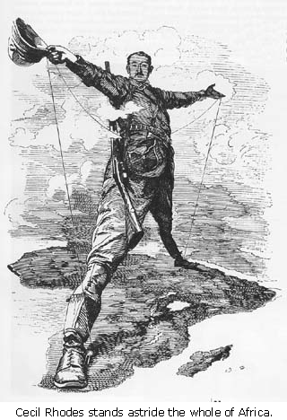
If humanitarian impulses produced ambiguous results in nineteenth century Africa, so did science. Many motives drove men into Africa during the great age of exploration, a hope of gain, a love of adventure and just plain curiosity. The last should not be underestimated. The Victorians had intensely enquiring minds. The interior of Africa held the most tantalising. mysteries left in the world after the exploration of the Americas Australia and much of Asia. The public at home shared the thrill of discovery of the man on the spot. Space exploration in the twentieth century has never succeeded in generating a quarter of the enthusiasm that the search for the source of the Nile aroused in the nineteenth. The Victorians loved heroes. R. C. K. Ensor once suggested that Victorian politicians were gladiatorial figures to the public, fulfilling a role that in the twentieth century was taken over by sporting personalities. Explorers and quarrelsome scientists seem to have filled something of the same role. Sometimes national competition entered into it, as in the race between H. M. Stanley and de Brazza to reach Stanley Pool in 1880, or of Lugard and Decocur to reach Borgu in 1894. But at other times it seems to have been simply a love of a good scrap, as in the eager public anticipation of the expected confrontation between Richard Burton and John Harming Speke at the British Association meeting in Bath in 1864 to defend their rival views of the source of the Nile, a confrontation prevented by Speke’s death by shooting (probably accidental, although the suspicion of suicide has never been completely laid) on the very morning of the meeting.

EXPLORATIONS OF INTERIOR
The exploration of the interior of Africa centred on the four great river systems, the Niger, the Zambesi, the Nile and the Congo. The pioneering work on the Niger had been done long ago by Mungo Park. He was to be followed by Hugh Clapperton, the Lander brothers Williarn Baikie, Rene Caillie the Frenchman who reached Timbuktu in the late 1820s, and the great German explorer Heinrich Barth. The Zambesi was, above all, the territory of David Livingstone who explored much of the course of the river, 185 1-56. In another great journey, 1858-64, with John Kirk, subsequently the British consul general at Zanzibar, Livingstone explored the river Shire and discovered Lake Nyasa. His later years were taken up with his almost obsessive search for the headwaters of the Nile. Livingstone was rivalled in his search for the Nile by Richard Burton, who had already made a name for himself for his travels in Arabia and the Horn of Africa, and a young officer, John Harming Speke, who accompanied Burton on his expedition in 1857-59. Speke returned alone in 1860 and met Samuel Baker and his young Hungarian wife who were travelling up the Nile, also searching for its source. Livingstone’s activities also drew in two other men, H. M. Stanley and Lieutenant Lovett Cameron. Stanley was at this time a journalist on the staff of the New York Herald and he was sent to look for Livingstone who was believed to be missing near Lake Tanganyika in 1871. He found Livingstone and brought the story out for the world.
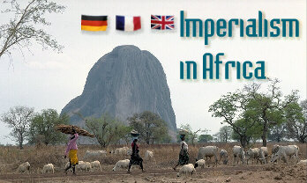
Livingstone died in 1873, before Cameron who had been sent out by the Royal Geographical Society, could make contact with him. Cameron carried on with his scientific mission, crossing central Africa from east to west (the first European to do so) and emerging in Portuguese Angola in 1875. Cameron had not attempted to follow the river Congo all the way and, when he heard of Livingstone’s death, Stanley determined to do so and settle once for all whether the river ‘Lualaba’ that Livingstone had sighted was the Congo or the Nile. The result was Stanley’s east-west crossing of die African continent between 1874 and 1877. The Germans, Gerhard Rohlfs and Georg Schweinfurth, the Portuguese, Serpa Pinto, and the Frenchman, de Brazza, also contributed much to the exploration of Central Africa in this period (12, 13).

All these men wrote long, and often vivid, accounts of their experiences for their public at home [docs 1, 3, 4, 51. Read a century later, they exhibit some curious features. Most of them wrote as if they were the first men to penetrate to unknown regions. The African inhabitants were regarded as mere background, ‘part of the local fauna’. 26. At the same time they were very conscious of the possibilities of these 1 new’ regions. Africa was once again coming to seem an EI Dorado. There had always been stories of the wealth of Africa, the legendary kingdom of Prester John or the fabled city of Timbuktu. Africa had been known as a source of gold for centuries - Edward 11 had struck his coins from African gold. Now the careful reports of men like Lieutenant Cameron [doe. 31 seemed to confirm this. Many of these ,prospectuses’ that came out of Africa in this period proved false, but the diamonds of Kimberley, which burst on an astonished world in the early 1870s, and the gold of the Witwatersrand, discovered in 1886, were real enough. Men did grow rich in Africa: Cecil Rhodes for example, or Leopold II of the Belgians.

The possibilities seemed unlimited and, behind it all, stood the new Victorian technology, the steam ship, the telegraph and, above all, the railway, which for the first time seemed to promise the real opening up of the interior of Africa, defeating the limitations imposed by the tsetse fly. Men began to ‘think big’. It was not coincidental that Africa began to be opened up on a large scale just as the American frontier was ‘closing’. Men meant it when they spoke of Africa as the ‘new America’. Planning was on a continental scale. The Cape to Cairo railway did not seem an extravagant project to those who had seen the Canadian Pacific or the Union Pacific take shape.

PROGRESS
Livingstone himself had been an enthusiast for ‘progress’ [doe. 21. But Livingstone’s enthusiasm had always been tempered, indeed in part forged, by his concern for the African. A few men of the next generation, notably Joseph Thornson (1), shared Livingstone’s regard for the African and even, in Thomson’s case, questioned whether this kind of progress would be good for the average African. But this was very much the exception. A new sense of racial superiority had emerged in which the European’s sense that lie had the right to do what he liked with Africa was only one manifestation.

The European explorers of Africa were unquestionably brave men venturing into a situation totally unknown to them. They seldom had men of their own race with them, and they often found their African hosts strange and unpredictable, and feared their hostility. In this situation they created their own image of themselves. They must be wise sometimes they even resorted to fireworks, musical boxes or electric batteries to overawe surprised tribes and establish their reputation as near-magicians. They must be strong, always keeping their word and never showing physical weakness. They must maintain that British tradition of the ‘stiff-upper lip’ and never show emotion - this may well be the real explanation of Stanley’s strange greeting to Livingstone ‘Dr Livingstone, 1 presume’ (1). This ‘white man’s burden’ that they created for themselves was not altogether without a good side. Sometimes it involved trivialities, like Harry Johnston’s insistence on dressing for dinner in the jungle, but the concept of a ‘gentleman’, whose word was his bond and who was chivalrous to those weaker than himself, especially towards women, was a very meaningful one to many Victorians and may explain why the British were often far from the worst ‘aliens’ with whom the Africans found themselves dealing (1).

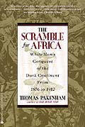
But there was a much darker side to this growing sense of the gap between the black and the white races. If the white man had a position to maintain, respect for the black man sank lower and lower. There had always been those who preferred the sensational to the objective. Smith’s Trade and Travel in the Gulph of Guinea has already been quoted. A much greater writer than Smith, Richard Burton !so did his share, notably in his Mission to Gelele, the King of Dahomey (1864) which had chapter headings very similar to those of Smith. Burton also discussed ‘the Negro’s place in Nature’, which he placed very low, contending that, although a Negro child might be intelligent, lie became stupid at puberty, like the great apes. He was also an exponent of the ‘Hamitic theory’, believing that there had only been progress in Africa where more advanced peoples had penetrated. Burton’s theories demonstrably influenced certain politicians, including Lord Derby and even the liberal and enlightened Lord Ripon (1).

But the man who reached by far the widest public was Henry Morton Stanley. It was no accident that Stanley’s greeting to Livingstone on the shores of Lake Tanganyika became a Victorian catchphrase, still remembered today, indeed described in a recent issue of the Radio Times as one of the four most memorable phrases of the Victorian era. All Stanley’s activities took place in a blaze of publicity. He usually had massive Press backing. His expedition to find Livingstone was undertaken for the New York Herald (see above p. 26), his transcontinental journey was financed by the New York Herald and the Daily Telegraph jointly. His best-known books, How I found Livingstone, Through the Dark Continent, and In Darkest Africa (the very titles give the flavour) ran through numerous editions, including cheap 3s. 6d. ones. In Darkest Africa sold 150,000 copies in the English edition alone (like Stanley’s other works it was translated into many other languages), and one reviewer commented that ‘it has been read more universally and with deeper interest than any other publication of the
present year’ [doc. 51 .

Stanley lectured all over the world, in America and Australia, as well as on the continent of Europe. He was a natural showman. Even his worst public quarrels at the British Association or the Royal Geographical Society only served to focus more public attention on him. Fate could hardly have chosen a worse interpreter of Africa to Europe. Stanley’s childhood experiences - lie was illegitimate, rejected by his family, brought up ill a workhouse of Dickensian horror - were enough to have soured any man His own character and judgement seem to have undergone a progressive degeneration as a result of years of loneliness, anxiety and malarial fever. There is a great difference between the lone of’ the first book lie wrote describing the British Abyssinian expedition of 1868, in which lie posed as a disinterested American observer (lie [lad emigrated from Wales to the United States as a boy) prepared to criticise both the Europeans and the Abyssinians, and his last book describing the Emin Pasha Relief expedition in which lie almost exulted at atrocities [doe. 51 Not everyone admired Stanley. The authorities of Westminster Abbey refused to bury him in the Abbey near Livingstone, as Stanley and his family wished. But, although the discriminating might criticise him he undoubtedly had the ear of the new literate public which seemed to enjoy sensationalism, especially if it were laced with jingoism. J. A. Hobson, the most cogent of the contemporary critics of the ‘new imperialism’, exclaimed in disgust, ‘Popular education, instead of serving as a defence, is an incitement towards Imperialism., it has opened up a panorama of vulgar pride and crude sensationalism to a great inert mass who see current history and the tangled maze of world movements with dim, bewildered eyes . .’

Stereotypes are always dangerous, whether of one’s own people or of others. Cairns reminds us of Inge’s remark, ‘If you marry the Spirit of your generation you will be a widow in the next’ (1). Nineteenth century Englishmen frequently saw Africa through what Curtin calls ‘a haze of cross-cultural misunderstanding’ (2) which led to the acceptance of views of Africa more prejudicial than factual’ (1). Nevertheless, there is an opposite danger, namely that ‘the pull of contemporary liberal opinion, opposed to policies of imperialism and racial hegemony, may incline the researcher to select his material in favour of the non-white races’ (1 ). To slide over criticisms of other cultures which one would apply to one’s own, can be as patronising as any Victorian attitude (7). Even exaggerated feelings of guilt may be a final fling of Victorian arrogance, for it is to take the white men who ventured into Africa at their own valuation, as masters of their own and Africa’s destinies. Often, as the sad tale of the ‘Scramble’ developed, both individual Europeans and Africans seemed to be at the mercy of’ forces which they neither understood nor controlled.

