Club Merchandise
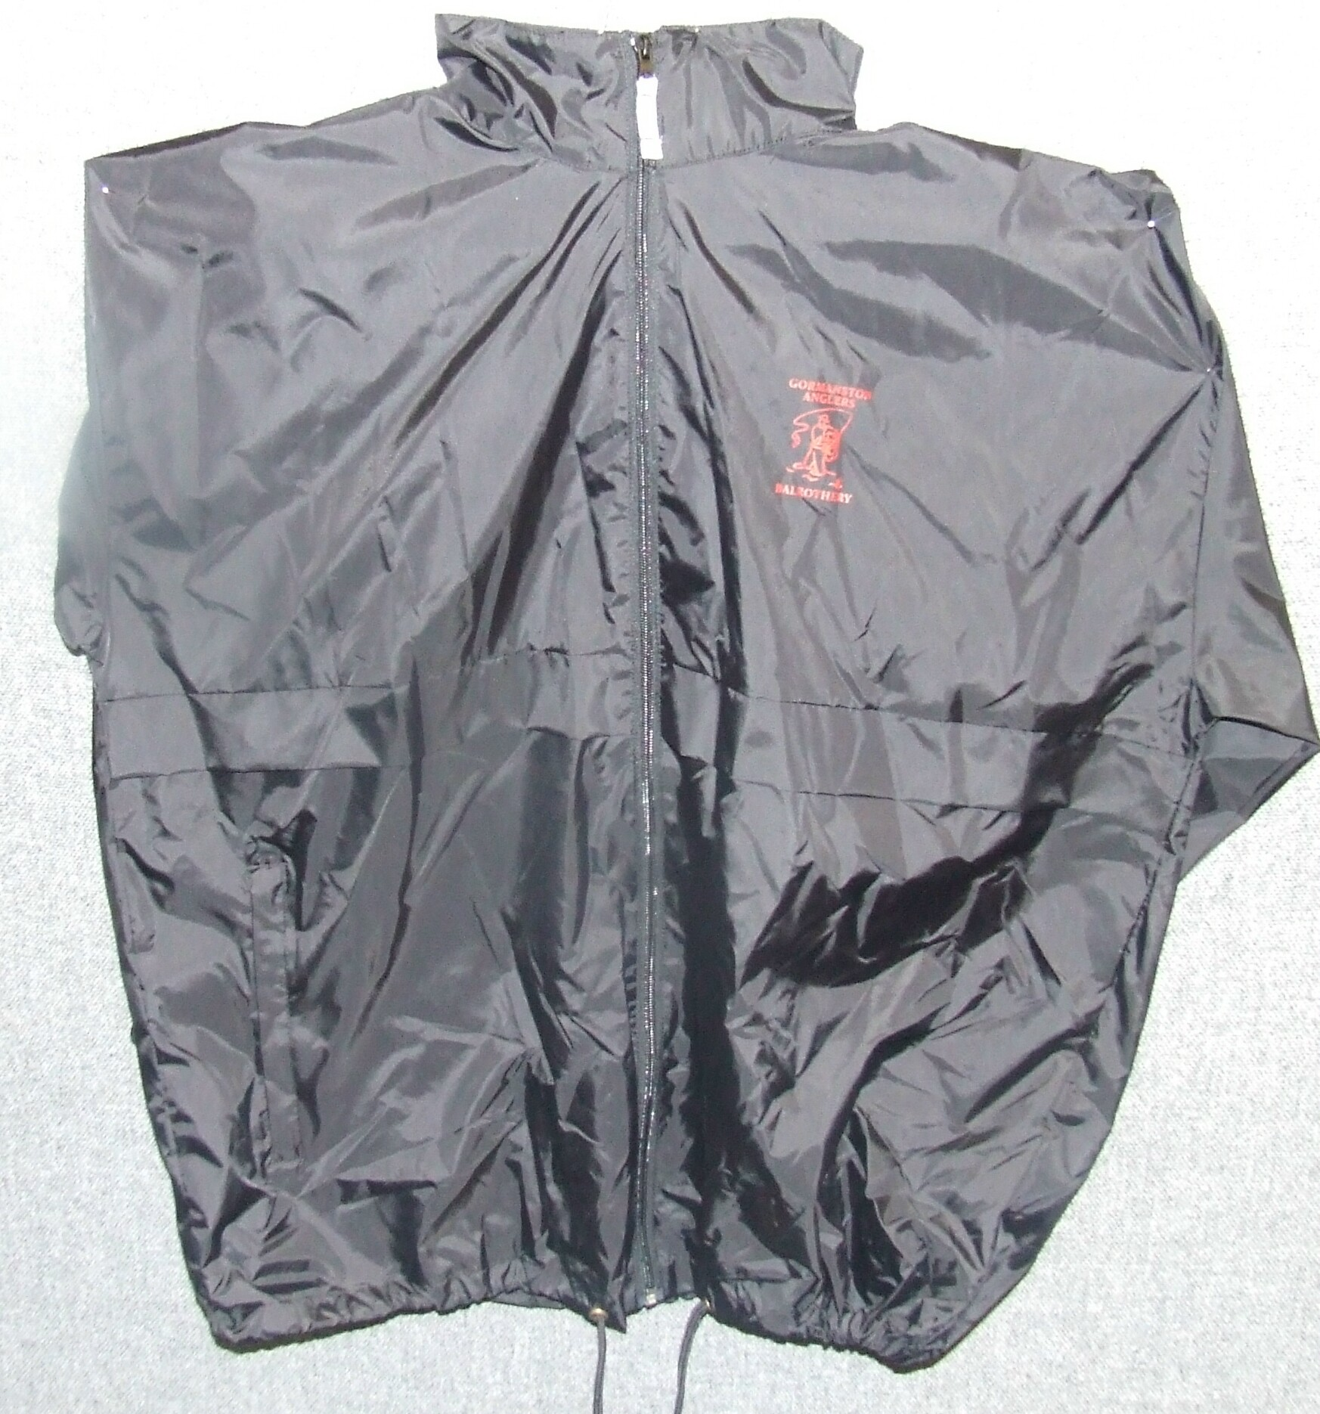 Club Windbreaker ( One size XL)… €20.00 ea
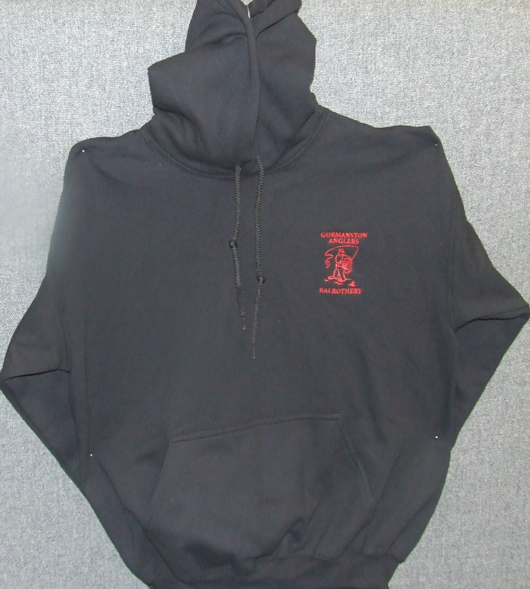 Club Hoodie (L & XL)…………………€20.00 ea
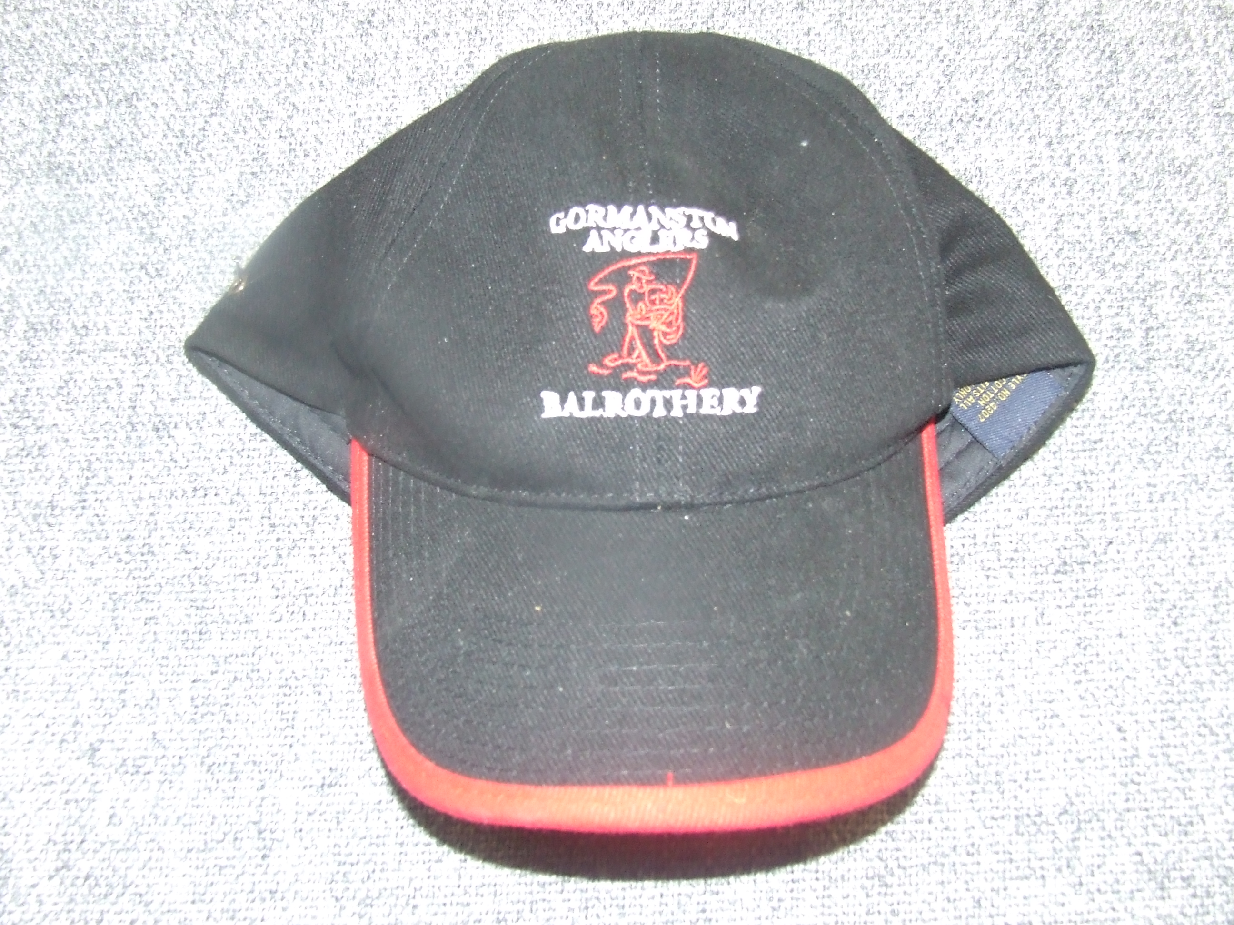 Club Baseball Cap (one size fits all)…..€10.00 ea

