STORMONT TO THE DÁIL
320 MILES - FOUR DAY BIKE RIDE
3 – 6 SEPTEMBER 2008

The Garda and PSNI have once again joined forces and taken on the challenge of cycling 320 miles over four days in support of three charities, Co-operation Ireland, the Ulster Cancer Foundation and the Marie Keating Foundation.

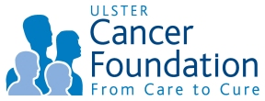  The Ulster Cancer Foundation combats  Cancer by providing immediate and sustained care for patients and their families by supporting local research and by prevention programmes and public campaigns that save lives | 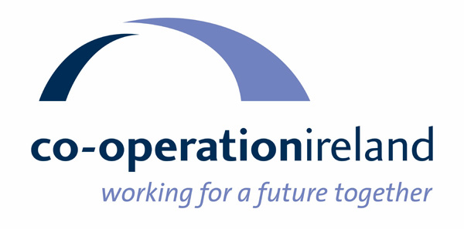  Co-operation Ireland aims to advance  Mutual understanding and respect by  Promoting practical co-operation between  The people of Northern Ireland and of the  Republic of Ireland. | 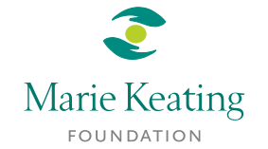  Working together to beat cancer through awareness, education and support services  The foundation’s vision is a future free from the fear of cancer.  Making Cancer less frightening  by enlightening

The bike ride starts on Wednesday 3 September from Stormont Buildings in Belfast, and finishes on Saturday 6 September at The Dáil in Dublin, both home to the Houses of Parliament in Northern Ireland and the Republic of Ireland. Overnight stops are scheduled in Newcastle, Co. Down, Drogheda, Co. Louth and Clane in Co. Kildare.

The bike ride will take in some of the most breathtaking scenery in Ireland, through the Ards Peninsula, Strangford Lough, the Mourne Mountains, Carlingford Lough, the Louth coastal route to Drogheda, County Meath, Ireland’s Heritage Capital and the Sally Gap, the highest crossroads in Ireland in the ‘Garden’ County of Wicklow.

The bike ride is on offer to cyclists who can raise a minimum target sponsorship of £800/€1200 for the three worthy charities. Included is entry to the bike ride, bed and breakfast hotel accommodation and evening meals for 5 nights with lunches supplied on the road, support vehicles and full backup services. A specially designed cycle shirt will also be available for each cyclist.

ROUTE

Tues 2 September Pre-event overnight accommodation at La Mon Hotel & Country Club, Belfast

Day 1 – Wed 3 September Starting at Stormont Buildings, Belfast via Newtownards and Downpatrick to Newcastle.
Overnight at the Burrendale Hotel & Country Club, Newcastle.

Day 2 - Thurs 4 September Cycle from Newcastle via Newry and Dundalk to Drogheda. Overnight at The d Hotel, Drogheda.

Day 3 – Fri 5 September Cycle from Drogheda via Navan and Kinnegad to Clane. Overnight at the Westgrove Hotel, Clane.

Day 4 - Sat 6 September Cycle from Clane via Naas, Blessington and the Sally Gap to Dublin. Final night at the Ballsbridge Inn, Dublin city centre. Celebratory Party at the Garda Club in Harrington Street.

Stormont to The Dáil– Why Take Part?

By taking part in the bike ride you have the opportunity to contribute towards some of the most important work taking place throughout the whole of Ireland. All the funds that you raise will go firstly to the fight against cancer in both Northern Ireland and the Republic of Ireland, and secondly to help create a sustainable peaceful future for all the people living on the island.

Not only are you given the opportunity to support these three worthwhile charities, but we know you will enjoy the challenge, the scenery, the new friends you will make and the whole event in general.

Places are limited, so if you are interested in taking part, please complete the application form and return with a deposit for £100 or €150 as soon as possible.

Contact

For further details, please contact: Winnie Orr, Co-operation Ireland, telephone + 44 (0) 28 9089 1004 (as from 1 March telephone +44 (0) 28 9032 1462) or email worr@cooperationireland.org

STORMONT TO THE DÁIL
320 MILE, FOUR DAY BIKE RIDE
3 – 6 SEPTEMBER 2008

Application Form – Please complete in full, clearly & in block.

Mr/Mrs/Miss/Ms _________ Forename ________________________ Surname ___________________________

Address____________________________________________________________________________________

__________________________________________________________________________________________

_________________________________________ _________________________________________________

Tel (Home) ________________________ Tel (Work)____________________________________________

Mobile _____________________________ Email ________________________________________________

Date of Birth ____________________________________ Age________________________________________

Important (This section must be completed)
Please state any medical condition that we should be aware of.

__________________________________________________________________________________________

In the event of an emergency please give the name & telephone numbers of a person we can contact.

Name _____________________________________Tel/Mobile _______________________________________

Payment Details
A deposit of £100/€150 is required to secure your place (non refundable)
* Cancellations made within one month before the event will result in a £500 / €725 Cancellation Charge*

I enclose a cheque for the amount of ____________ (Please make cheque payable to Co-operation Ireland)
Or charge my credit card VISA/MASTERCARD/AMEX (Please delete as appropriate)

Credit card number _________________________________ Exp date _________ CVV No.__________________
(last 3 digits on reverse of card)

Name on card _______________________________ Signature _____________________________________

Gift Aid UK Taxpayers
Co-operation Ireland can claim back the tax element of donations made to our charity, by PAYE tax payers which amounts to an extra 28% at no cost to them. Should you wish our charity to reclaim the tax back on donations made, simply tick the Gift Aid box

Republic of Ireland Taxpayers
Co-operation Ireland can claim back the tax element on donations of €250 or more made to our charity by PAYE taxpayers at no extra cost to them. The additional amount reclaimed by Co-operation Ireland will vary according to the percentage of the tax band of the donor (eg 20% or 42%). Should you wish our charity to reclaim the tax back on donations made, tick the box and Co-operation Ireland will forward the relevant form for you to complete and return.

Insurance Details
Although Co-operation Ireland has taken out a small personal injury policy on all participants, you are strongly recommended to take out your own personal injury and public liability insurance to provide cover while training and taking part in the challenge.

Declaration

Important – Cycle helmets must be worn during the Stormont to The Dáil Bike Ride

I, the undersigned participant, hereby irrevocably confirm that my participation in this event is entirely at my own risk. I agree that Co-operation Ireland, the Ulster Cancer Foundation, the Marie Keating Foundation, PSNI, Garda or any other official engaged by them, as organisers of the event, will not be responsible for any personal injuries howsoever sustained by me or any other medical condition arising out of, or exacerbated as a result of, my participation in this event or any property lost, stolen or damaged during the course of the event.

Signature____________________________________________________ Date ___________________________

All cyclists may be asked to take part in the street collections during the bike ride on request

Please return completed form to:
Winnie Orr, Co-operation Ireland, Glendinning House, 6 Murray Street, Belfast BT1 6DN
New Address as from 1 March 2008
Co-operation Ireland, Unit 5, Weavers Court Business Park, Linfield Road, Belfast BT12 5GH

