Hello; Márħaban; Ni Hao; Ahoj; Hallo; Salut; Shalóm; Dia dhuit; Ciao; Ohayl; Salâm; CzeſĿ; Olá; Privét; Hola; Jambo; Merhaba; Sawubona.
F.A.B. (Firhouse & Bohernabreena) Community Network Services.
Newsletter – June 2007.

INTRODUCTION:
The FAB Community Services Network is a community-based forum for individuals, voluntary groups, agencies and residents working and living in the Firhouse and Bohernabreena electoral districts. There is a FAB meeting every couple of months at which a wide range of community related issues are discussed, and community initiatives are planned. Meetings are currently held in the mornings in Firhouse Community College. If you would like more information or if you or your group would like to become involved in FAB, please contact us as follows:
Mary Roberts: 087 9967225.
Website: www.firbohgroup.org.
E-mail: info@firbohgroup.org.

NEIGHBOURHOOD DISCUSSION FORUM:  An internet discussion forum has been set up to allow people living in the FAB area to have their say on local issues, or just to keep in touch with local activities. Please feel free to register and voice your opinions at www.neighbours.ie/fab. If you are a member of any local sports/community group and wish to publicize any upcoming events, this is also a good place to post. | 

FIRHOUSE COMMUNITY COLLEGE SPORTS HALL:
The new sports hall at Firhouse Community College is now open for groups in the evenings and at weekends. There are four fully trained sports instructors who will provide sports activities for groups of 10 or more, with the main focus on the 10 to 21 age group. The staff ran a very successful Easter Camp and intend to run Summer Camps during the day throughout July/August. There will be a sports camp for the 10+ age group and a fitness club for the 16+ age group. These will be run on a daily basis at the cost of €1 per day. For more information on any of the sports hall activities contact Helen Diamond at 4518150.

FOROIGE FUN AND GAMES CLUBS:
Two Foroige Fun and Games Clubs have already started in the above sports hall on Thursday evenings, one for 10 to 12 year olds and the other for the 12+ age group. These will close for Summer but will resume again in September. Volunteers to act as a support for the instructors are urgently needed, especially 18-25 year olds. For more information contact Jean Lowry at 4516322 or email jean.lowry@foroige.ie.

COMMUNITY FUN-DAY: FAB’s second Community Fun-Day will take place on September 16th, in Ballycragh Park. If you would like to get involved or to be a sponsor for the event, please make contact with the FAB group. | 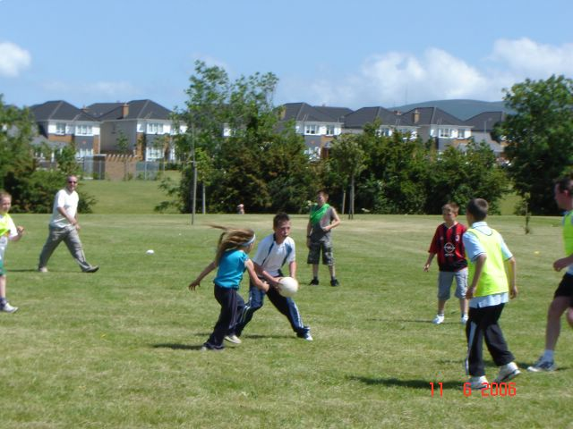

JUNK COLLECTION:  A junk collection will be carried out by South Dublin County Council over the Summer months. FAB are in contact with SDCC and have requested that Beech Dale, Hunterswood and Parklands be included in this collection. Householders will be notified by letter a week before the collection is due to take place. | 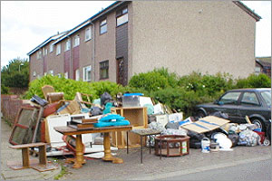

NEW COMMUNITY FACILITY:
The second set of architect’s drawings/plans for the community facility in Ballycragh Park are just ready for viewing by the community facility development group. The development group requested a set of drawings for a community facility which would be eco friendly and which would enhance the park and blend in well. The new drawings are described as “impressive” by council members.

BALLYCRAGH PARK:  On 16th of April, three representatives from SDCC Parks Department met up with local residents for a walk-around of Ballycragh Park. The council reps saw at first hand some of the issues and concerns of locals regarding the park and have agreed on the following positive actions: | 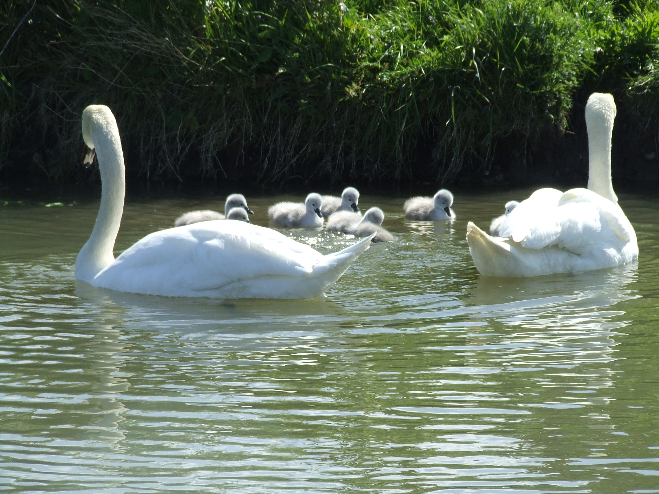
- New sign in the park with map etc.
- Vandalised trees will be replaced in Winter 2007/Spring 2008
- Litter bins will be placed outside the park gates
- The lake and river area will be cleaned up
- Glass will be swept from the paths
- Anti dog fouling signs will be placed in the park
- Information on the park wildlife will be made available
- Graffiti will be removed from the bridges
- The possibility of a new diagonal path will be investigated
- The drainage problem will be investigated in Winter 2007
- The possibility of a safe platform at the lake will be investigated in 2008

The next community park clean-up will take place on Saturday 16th June from 2.00p.m. - 3.00p.m. Congratulations to Lauren McColgan and Damien Thomson on receiving their bronze medals for showing up to five or more clean-ups. Thanks to all the other young people who have helped out over the year. There is a park clean-up on the third Saturday of every month, weather permitting. All are welcome to come along and help.

OTHER INFORMATION:
The Firhouse Carmel F.C. Mini World Cup will take place during the week starting the 25th June. Registration will take place on Monday 18th, Tuesday 19th and Wednesday 20th in the evenings at the clubhouse.

The Local Area Plan for West Oldcourt (possibly 2500 new housing units) may not be ready until the Summer months. FAB will request that the local community be given until the end of September at least to study the plan and respond.

Please note that contact numbers for local groups or amenities can all be obtained on our website. The Community Guards for the area are:
Patrick Tarrant, Rathfarnham Garda Station. Tel. (01) 6666500.
Paul Flood, Tallaght Garda Station. Tel. (01) 6666000.

