F.A.B. (Firhouse & Bohernabreena) Community Network Services.

Newsletter – June 2006.

Introduction:
The F.A.B. Community Network Services Group is an organisation recently established by a group of concerned residents to deal with issues within the Firhouse and Bohernabreena residential areas. These issues include traffic, parks, litter, social awareness & community development. If you have any issues you would like to raise or if you would be in a position to help out as much or as little as your lifestyle allows, please contact us.
Contact details are as follows:
Mary Roberts: 087 9967225.
Website: www.firbohgroup.org.
E-mail: info@firbohgroup.org.
If you would like to be kept up to date on any upcoming meetings, please register your interest by e-mail at info@firbohgroup.org.

FUN-DAY:  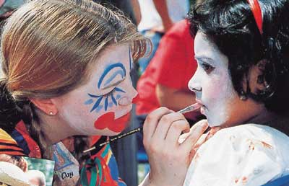
F.A.B. is currently organising a Family Fun-Day on Sunday, 11th June from 2 – 5 p.m. in Ballycragh Park (opp. Scholar’s Pub). This will incorporate athletics, fun races, face painting, penalty shoot-out, soccer, a D.J. & many other events to keep all the family entertained. Winners in the athletics will automatically qualify to represent the Bohernabreena Parish in the Community Games. The Bohernabreena parish includes the following areas: -
- Bohernabreena; Glenasmole; Allenton: Old Court; Ely; Ferncourt; Beechdale;
Oakdale; Daletree; Wood Dale & Parklands.
The day promises to be a lot of fun and we look forward to your support.

LOCAL ISSUES:
F.A.B. are raising local issues with South Dublin County Council on an on-going basis. We have had discussions regarding traffic problems in the area, litter & Ballycragh Park
We are hoping to organise a deputation to meet with the Council in the near future. If you have concerns now is your chance to have them voiced on your behalf. Please make contact with us via any of the above channels & we will be happy to raise your concerns with the Council when we meet.

YOUTH DROP-IN: 
We are hoping to organise a weekly youth drop-in night in the Firhouse Community Centre in September. This is currently in the planning stage and any local residents who would like to get involved should contact us at one of the above contact numbers.
This is aimed at the 15+ age group. It will be unlike a youth club in that that the youths decide what they want to do themselves, i.e. play cards, playstation, listening to music, or playing musical instruments, etc. There will be adult supervision, but there will be no interference from the adults unless deemed necessary.

Junk Collection: 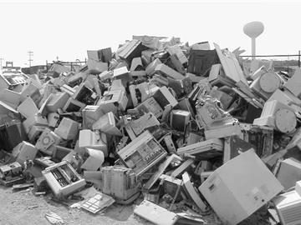 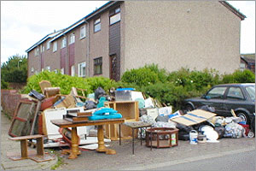
South Dublin county council carry out junk collections on a yearly basis. We have managed to have Ballycullen View, Daletree & Oakdale included on the list for the next collection, which will take place in late July / early August. Residents will be notified by letter approx. 1 week in advance. It was only possible to have three areas included this time round. However, we did give them the names of the other estates in the Parish and have been assured that they will be included in subsequent years.

Ballycragh Park:
Park Ranger - Mr.
We are hoping to arrange a walk around Ballycragh Park (opp. Scholars) with the Park Warden at 10 a.m. on Friday, 9th June. This has yet to be confirmed. For more information please contact Mary Roberts at 087 9067225.

Other Information:
Please note that contact numbers for local groups or amenities can all be obtained on our website. These include:
- The Young Mother’s Group; Mobile Library; local G.A.A. or Soccer Clubs;
Citizens Advice; Community Guards, etc.

ENJOY THE FUN DAY. WE LOOK FORWARD TO SEEING YOU ALL THERE!

