Hello; Márħaban; Ni Hao; Ahoj; Hallo; Salut; Shalóm; Dia dhuit; Ciao; Ohayl; Salâm; CzeſĿ; Olá; Privét; Hola; Jambo; Merhaba; Sawubona.
F.A.B. (Firhouse & Bohernabreena) Community Network Services.
Newsletter – November 2006.
INTRODUCTION:
The F.A.B. Community Network Services Group is an organisation recently established by a group of concerned residents to deal with issues within the Firhouse and Bohernabreena residential areas. These issues include traffic, parks, litter, social awareness & community development. If you have any issues you would like to raise or if you would be in a position to help out as much or as little as your lifestyle allows, please contact us as follows:
Mary Roberts: 087 9967225.
Website: www.firbohgroup.org.
E-mail: info@firbohgroup.org.
FUN-DAY: 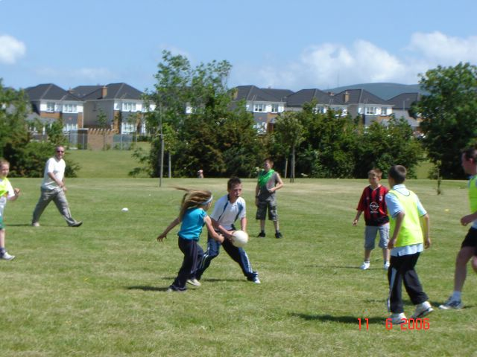 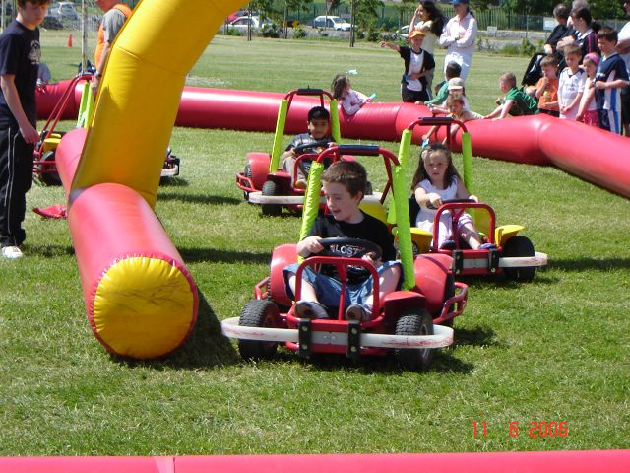
F.A.B.’s first Family Fun-Day, incorporating qualification to represent the Bohernabreena Parish in the Community Games, took place on Sunday 11th June, 2006. We are sure anyone who was there will agree it was a resounding success. We would like to express our sincere thanks to all the Sponsors and the volunteers who helped out on the day.
Following on from the Fun Day, 4 children participated in the Dublin Community Games Art final, with Glenn Plunkett winning gold at U8 boys; two swimmers participated in the swimming finals and 10 children took part in the Athletics final at Santry. Damien Thomson came 4th in the 100m final.
LOCAL ISSUES:
- F.A.B. have written to the V.E.C. requesting that the new sports hall at the Firhouse Community College be opened for community use. The V.E.C. advised that the hall will open from early new year. A committee to run the hall should be in place by December and ads for Management Staff should be in the papers in the next 2 weeks.
- We are raising local issues with South Dublin County Council on a regular basis. If you feel that there are any items of concern that need to be raised, please make contact with us via any of the above channels.
- The Community Centre Development group met this week. The main focus of the committee is to build a facility that will enhance the park, together with a playground. Tallaght Youth Service has expressed an interest in being the anchor tenant. New drawings are currently being drafted and the group will engage with the architects from the onset to ensure their requirements are being included.
Please note that this is a Community Facility, not to be confused with a Community Centre. It is envisaged that this facility will be more family orientated and will facilitate smaller more intimate activities, e.g. dancing, yoga, meetings, youth groups, parent/toddler, arts & crafts, Drugs Awareness Programmes, etc. It will not cater for indoor sports as this is already catered for at the local Firhouse Community Centre and the new Firhouse College P.E. Hall. We hope that the Community Facility will also serve the local community as a local Citizen Information Centre.
YOUTH DROP-IN: 
We are still hoping to organise a weekly youth drop-in night in the Firhouse Community Centre. This is currently in the very early planning stages as we have encountered problems securing premises. This will be aimed at the 15+ age group and will be unlike a youth club in that the young people will decide what they want to do. There will be adult supervision, but there will be no interference from the adults unless deemed necessary.

JUNK COLLECTION: 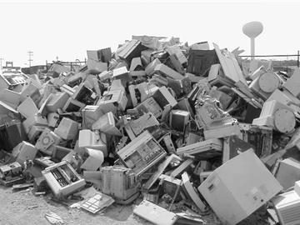 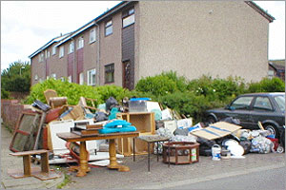
The junk collection was carried out by South Dublin County Council in August. This year Ballycullen View, Daletree, Oakdale & Ely were included. We are in contact with SDCC and have been told that Beech Dale & Parklands will be included in next year’s collection.

BALLYCRAGH PARK:
Park Ranger - Mr. Willie Byrne, Tel. 086 2515539.
Another clean up of the park was carried out on Saturday, 21st October. Future clean-ups will take place on the third Saturday of every month from 2 – 3 p.m. (excluding December) and will be advertised on our website.

OTHER INFORMATION:
- As part of the Tallaght Drugs Education & Prevention Programme 2006/2007 a Drugs Awareness Programme for local parents will be held in the Parents Room at Firhouse Community College. This is a very informative 5 week course commencing on Tuesday, 7th November from 10 – 11.30 a.m. or 7.30 – 9.00 p.m. (Parents have the option of attending the morning or evening course). There will be no charge for this course.
- Please note that contact numbers for local groups or amenities can all be obtained on our website. The Community Guards for the area are:
Patrick Tarrant, Rathfarnham Garda Station. Tel. (01) 6666500.
Paul Flood, Tallaght Garda Station. Tel. (01) 6666000.
The Youth Officer for the area is Jean Lowry of the Tallaght Youth Service. Jean may be contacted at 4515322 for further youth information & activities.
- Finally, the season of goodwill is fast approaching. If you are involved in a local group or organisation and are looking for a charity to donate to for Christmas, why not consider Operation Christmas Child. All you have to do is fill a shoe-box with gifts for boys or girls in different age categories. These boxes are collected from local drop-off points and sent to children in impoverished countries. Many of these children have nothing and it’s their only Christmas present. If you are interested, leaflets explaining what to do are available from Rachel Kavanagh, Tel. 087 9296066.
- The next FAB meeting takes place on Friday, 10th November at 10 a.m. in the Parents Room at Firhouse Community College. If you are interested in getting involved please come along.

Prepared by: Margaret Hackett; Rachel Kavanagh; Mairead Flanagan.
Printed by: Bohernabreena Community Enterprise.
Funded By: South Dublin Co. Council.

