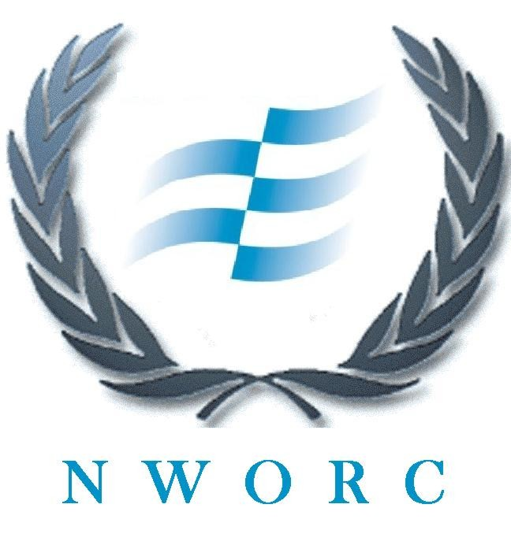 | 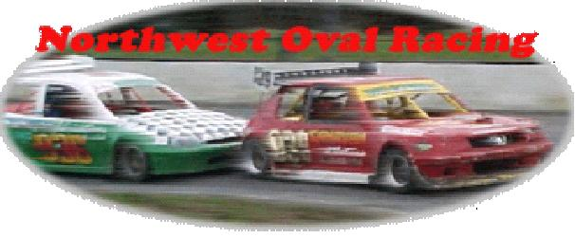

APPLICATION FOR CLUB MEMBERSHIP

NAME……………………………………………………………………………………………………

ADDRESS……………………………………………………………………………………………….

TELEPHONE NO. HOME…………………………………….MOBILE………………………………

OCCUPATION…………………………………………………Date of birth…………………………..

DRIVING LICENSE NO………………………………………EXPIRY DATE………………………
CATEGORY OF VEHICLES……………………………………………………………………………

Are you or have you been a member of any other motor sport club? Yes No
If yes state
- The name of the club………………………………………………………………………………
- The address of the club……………………………………………………………………………
- When you joined the club…………………………………………………………………………
- If you are no longer a member, date your membership ceased and why…………………………………………………………………………………………
- The name, address and telephone no. of secretary from said club…………………………………………………………………………………………
Do you own your own racing motor vehicle? Yes No
If yes specify
- Make & Model…………………………………………………………………………………...
- Engine cc………………………………………………………………………………………...

I hereby DECLARE the particulars set out in this form to be true to the best of my information, knowledge and belief and I APPLY to become a member of N.W.O.R.C.
Dated the………Day of ……………………….20………….

SIGNED……………………………………………………..
APPLICANT
NOTES.
1.Any false or misleading statement made in this application form will automatically lead to membership being refused or revoked as the case may be.
2. The acceptance or refusal will be at sole discretion of the directors
3.The Applicant by the lodgement of this Application Form hereby agrees to be bound by the Articles and Memorandum of Association of North West Oval Racing Club Limited and any Rules or Regulation made thereunder.

FOR CLUB USE ONLY

Application granted / not granted to ………………………………………………………
At committee meeting dated the…………..day of……………… 20……………………..

Signed…………………………..
Club Registrar

