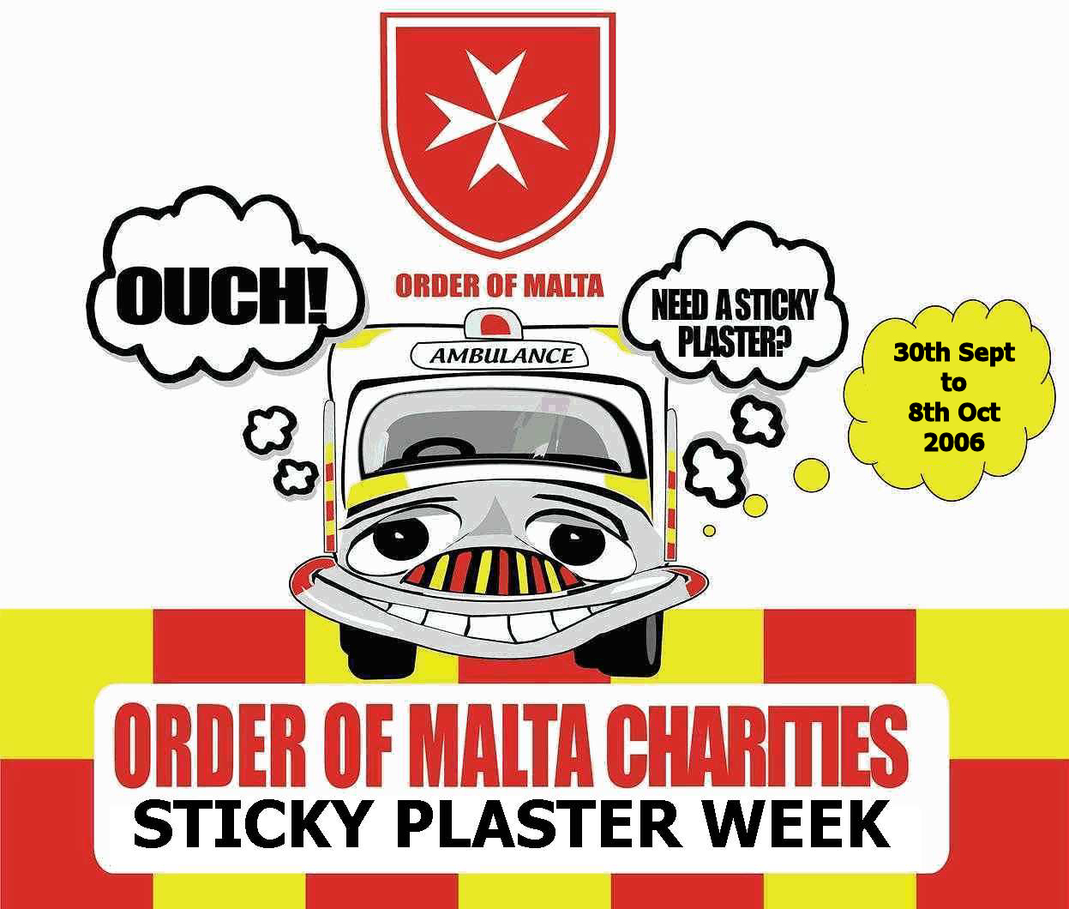
ORDER OF MALTA
AMBULANCE CORPS

This is our National Fund Raising Event

30th September to 8th October 2006

Buy our Special
Sticky Plaster Packs
for only €2 each.
Help Us Provide
Community Services in Your Area.

PLEASE GIVE GENEROUSLY

