John Sloman
Workshop 1
Introducing Economics
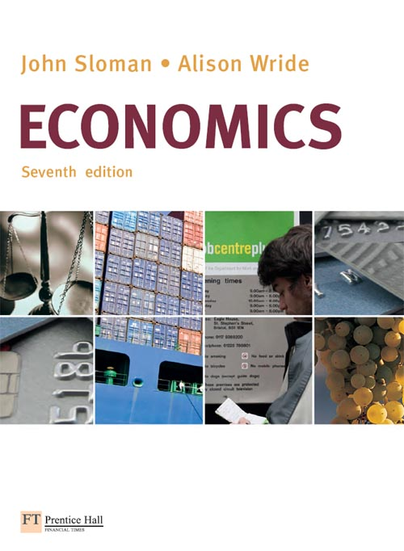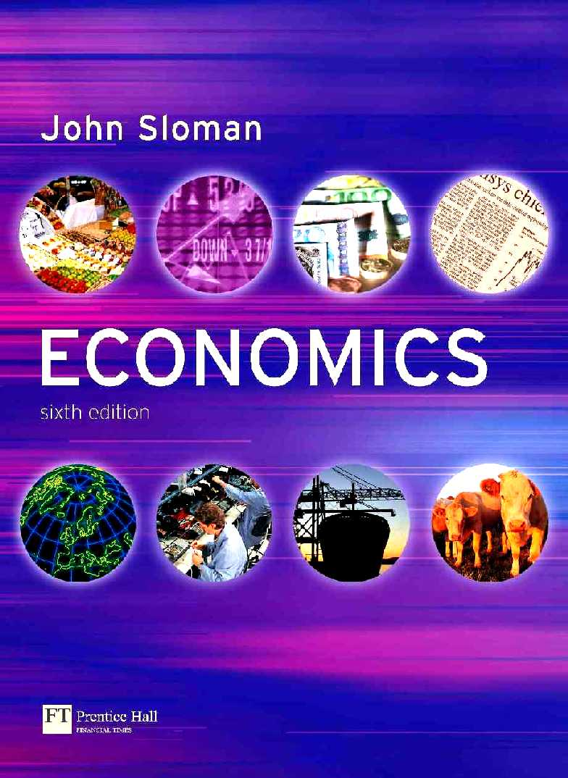

1. Which of the following are macroeconomic topics/issues and which are microeconomic ones?
(a) The level of consumer spending Micro / Macro
(b) Subsidies paid to farmers Micro / Macro
(c) The level of UK exports Micro / Macro
(d) The price of DVDs Micro / Macro
(e) The rate of unemployment Micro / Macro
(f) The average wage rate paid to textile workers Micro / Macro
(g) The total amount spent by UK consumers on clothing and footwear Micro / Macro
(h) The amount saved last year by UK households Micro / Macro

2. Economists assume that economic decisions are made rationally. In the case of consumers, rational decision making means:
(a) That consumers will not buy goods which increase their satisfaction by only a small amount.
True / False
(b) That consumers will attempt to maximise their individual satisfaction for the income they earn.
True / False
(c) That consumers buy the sorts of goods that the average person buys. True / False
(d) That consumers seek to get the best value for money from the goods they buy. True / False

3. Make a list of three things you did yesterday. What was the opportunity cost of each? Have a look at your neighbours’ lists and see if you agree with their estimates of the opportunity costs.

(a)

(b)

(c)

4. A country is capable of producing the following combinations of goods and services per period of time, assuming that it makes full use of its resources of land, labour and capital.
Goods (units) | 100 | 80 | 60 | 40 | 20 | 0
Services (units) | 0 | 50 | 90 | 120 | 140 | 150

(a) Draw the production possibility curve for this country on the following diagram.

(b) Is it possible for this country to produce the following combinations of goods and services?
(i) 80 units of goods and 50 units of services Yes / No
(ii) 70 units of goods and 90 units of services Yes / No
(iii) 40 units of goods and 100 units of services Yes / No

(c) What is the opportunity cost (in terms of services) of producing 20 extra units of goods when this country is initially producing:
(i) 60 units of goods
(ii) 20 units of goods

5. (a) Referring back to question 4, assume now that technological progress allows a four-fold increase in the output of goods and double the amount of services for any given amount of resources. Assuming that the country’s total amount of resources stays the same, fill in the new figures on the following table to show the new production possibilities.

Goods (units)
Services (units)

(b) Draw the new production possibility curve on the following diagram.
(c) How has this technological progress affected the opportunity cost of a unit of goods. (Tick the correct one of the following answers.)

A. Stays the same.
B. Doubles.
C. Halves.
D. Increases four times.
E. Decreases four times.

6. In Country A, which has full employment of its resources, a large increase in the production of goods and services provided by the public sector (such as health, education and new roads) would only be possible if there were a reduction in the production of other goods and services, such as consumer goods. In Country B, however, which is suffering from economic recession, it is argued that an increase in public expenditure on such things as health, education and roads, would result in the production of more consumer goods.

(a) Explain briefly why the effect of an increase in public expenditure on the production of consumer goods would be different in the two countries.

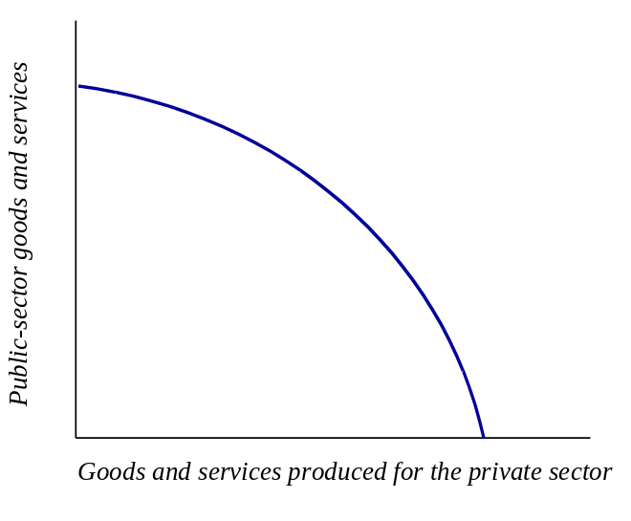
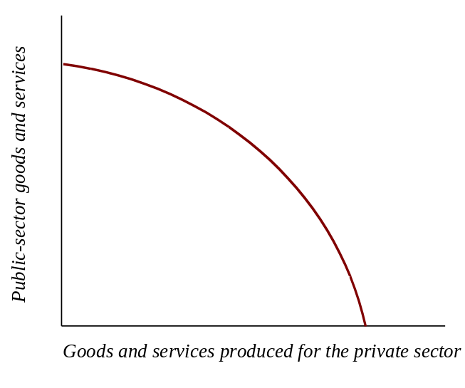
(b) The following diagrams show the production possibility curves for the Countries A and B. Mark the current production point on each diagram at a point consistent with the statement above. Then mark a new position on each diagram that would result from an increase in public expenditure.
Country A
Country B
(c) Explain your answer to (b).

