Answers to Workshop 1
Introducing Economics
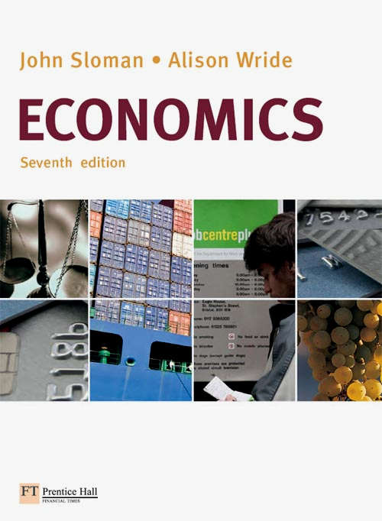

1. Which of the following are macroeconomic topics/issues and which are microeconomic ones?
(a) The level of consumer spending Macro
(b) Subsidies paid to farmers Micro
(c) The level of UK exports Macro
(d) The price of DVDs Micro
(e) The rate of unemployment Macro
(f) The average wage rate paid to textile workers Micro
(g) The total amount spent by UK consumers on clothing and footwear Micro
(h) The amount saved last year by UK households Macro

2. Economists assume that economic decisions are made rationally. In the case of consumers, rational decision making means:
(a) That consumers will not buy goods which increase their satisfaction by only a small amount.
False
(b) That consumers will attempt to maximise their individual satisfaction for the income they earn.
True
(c) That consumers buy the sorts of goods that the average person buys. False
(d) That consumers seek to get the best value for money from the goods they buy. True

3. Make a list of three things you did yesterday. What was the opportunity cost of each? Have a look at your neighbours’ lists and see if you agree with their estimates of the opportunity costs.

In each case you should think of the next best thing you could have done with your time or money, because it is that which you effectively ‘gave up’ to do the thing you chose to do. So, by choosing to go to the cinema, for example, the opportunity cost is what you could have done with the money you spent on the ticket and transport, and with the time spent at the cinema.

4. A country is capable of producing the following combinations of goods and services per period of time, assuming that it makes full use of its resources of land, labour and capital.
Goods (units) | 100 | 80 | 60 | 40 | 20 | 0
Services (units) | 0 | 50 | 90 | 120 | 140 | 150

(a) Draw the production possibility curve for this country on the following diagram.
The curve shows all the possible combinations of two goods that a country can produce within a given time period. If a country was fully using its resources, then it would produce somewhere on the curve. If there was unemployment or under-utilisation of one or more factors of production, the country would be producing inside the curve. The country could not produce beyond the curve.

(b) Is it possible for this country to produce the following combinations of goods and services?
(i) 80 units of goods and 50 units of services Yes (on the curve)
(ii) 70 units of goods and 90 units of services No (outside the curve)
(iii) 40 units of goods and 100 units of services Yes (inside the curve)

(c) What is the opportunity cost (in terms of services) of producing 20 extra units of goods when this country is initially producing:
(i) 60 units of goods 40 units of services (90–50)
(ii) 20 units of goods 20 units of services (140–120)
Here, the opportunity cost of producing more goods is the reduction in the production of services that this entails. In the case of (i), producing an extra 20 units of goods would mean that production was now at 80 units. From the table, and the curve, you can see that this will allow a maximum of 50 units of services to be produced. Thus production of services has fallen from a maximum of 90 to a maximum of 50 units: a fall of 40 units. Thus 40 units of services is the opportunity cost. In the case of (ii), moving from producing 20 units of goods to 40 units means moving from 140 units of services to 120 units: an opportunity cost of 20 units of services.

5. (a) Referring back to question 4, assume now that technological progress allows a four-fold increase in the output of goods and double the amount of services for any given amount of resources. Assuming that the country’s total amount of resources stays the same, fill in the new figures on the following table to show the new production possibilities.

Goods (units) | 400 | 320 | 240 | 160 | 80 | 0
Services (units) | 0 | 100 | 180 | 240 | 280 | 300

(b) Draw the new production possibility curve on the following diagram.
(c) How has this technological progress affected the opportunity cost of a unit of goods. (Tick the correct one of the following answers.)
A. Stays the same.
B. Doubles.
C. Halves. ✓
D. Increases four times.
E. Decreases four times.
If you can produce four times as many units of goods and twice as many units of services with a given amount of resources, then, as production moves from services to goods, only half as many units of services will need to be sacrificed for each extra unit of goods (compared with the situation before the technological progress).

6. In Country A, which has full employment of its resources, a large increase in the production of goods and services provided by the public sector (such as health, education and new roads) would only be possible if there were a reduction in the production of other goods and services, such as consumer goods. In Country B, however, which is suffering from economic recession, it is argued that an increase in public expenditure on such things as health, education and roads, would result in the production of more consumer goods.

(a) Explain briefly why the effect of an increase in public expenditure on the production of consumer goods would be different in the two countries.
In Country A, with resources fully employed, there could only be an increase in the production of certain goods and services (in this case health, education, new roads, etc.) by diverting resources away from the production of other goods. In Country B, however, by using resources more fully, there could be an increase in production of all goods. In fact, an increase in expenditure on public services, by increasing the incomes of those employed in the public sector, could lead to more expenditure on consumer goods, and this would stimulate firms to produce more of them to meet the extra demand.

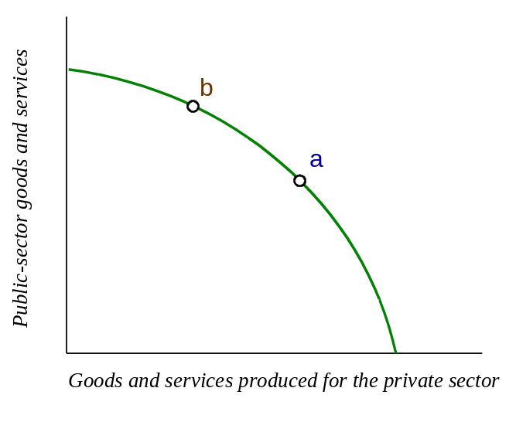
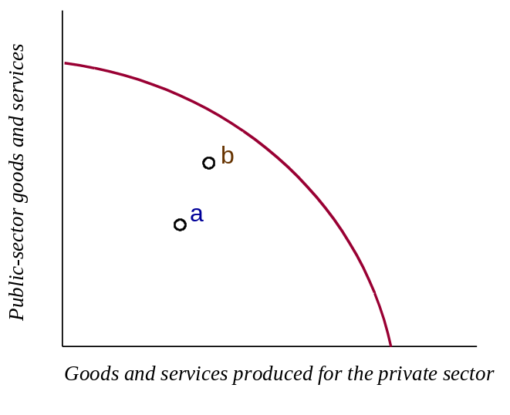
(b) The following diagrams show the production possibility curves for the Countries A and B. Mark the current production point on each diagram at a point consistent with the statement above. Then mark a new position on each diagram that would result from an increase in public expenditure.

Country A

Country B
(c) Explain your answer to (b).
In each case there is a movement from point a to point b. In the case of Country A, which is already producing on the production possibility curve, there is a movement along the curve, showing that the opportunity cost of producing more public-sector goods and services is the amount of private-sector goods and services that have to be sacrificed. In the case of Country B, production was inside the production possibility curve. By making a fuller use of resources, more of both categories of goods and services can be produced: point b is closer to the production possibility curve than is a.

