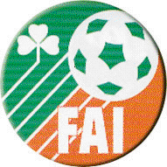

Is Mór Linn Peil na hÉireann
FUTSAL EQUIPMENT PACK CONTENTS.

10 Size 2 Futsal Balls
10 Size 4 Futsal Balls
20 Bibs
1 Set of Cones
1 Ball Bag

NAME OF SCHOOL/CLUB: _________________________________

CONTACT PERSON: _________________________________

Phone No. Mobile No. E-mail Address.

________________ ___________________ __________________________

DELIVERY ADDRESS: ____________________________________________

____________________________________________

____________________________________________

I ENCLOSE HEREWITH PAYMENT OF €250.00 PER SET.

NUMBER OF PACKS REQUIRED: __________

TOTAL AMOUNT ENCLOSED: €__________

CHEQUE _______ POSTAL ORDER ________ BANK DRAFT _______

Please ensure all cheques/postal orders/bank drafts are made payable to the Football Association of Ireland.

