Functional Specification

For a virtual music instrument plug-in

9th January 2006

Project developer: Cathal O’ Callaghan
ID: 50649775
Stream: SE

Project Supervisor: Alistair Sutherland

Table of Contents

Foreword 3

Glossary 4

Introduction 5

General Description 6

Functional Requirements 10

System Architecture 15

Operational Scenario 17

Preliminary Schedule 20

Foreword

The world of digital audio is an exiting and wide-open space for prospective developers. The amount of high quality digital audio software already out there, ranging from sequencers to vocal auto-tuners, is quite vast. In 1996, the introduction of virtual studio technology (VST) by Steinberg was a giant leap forward for the digital music scene, and was one of the main factors that contributed to the massive growth of the digital audio software industry. Suddenly, audio software companies everywhere, were developing VST plug-ins for use with Steinberg’s flag-ship audio sequencer, Cubase VST. The modular nature of the plug-in technology meant that very small companies and even individuals had the resources to create and sell new and innovative DSP audio effects in the form of a VST plug-in, which could simply be “plugged-in” to the Cubase VST application for added functionality.
The fact that Steinberg created the VST standard and made the technology freely available for all, is one of the main reasons for its success. By 1998 many other audio sequencers also supported the VST standard, thereby exposing their users to its processing power. From then on VST has gone from strength to strength, and has catapulted its creators, Steinberg onto the level of being one of the most profitable and respected audio software houses on the market today. Steinberg has recently been taken over by music hardware giants Yamaha, a relationship which is sure to produce more high quality software.

January 2006

Glossary

- VST – Virtual Studio Technology. The audio plugin standard created by Steinberg to allow any third party developers to create VST plug-ins for use within VST host applications.

- MIDI – Musical Instrument Digital Interface. An industry-standard communications protocol that precisely defines each musical note in an electronic or software musical instrument. It allows electronic and software instruments to exchange data with computers, or "talk", with each other. MIDI does not transmit audio - it simply transmits digital information about a musical performance.

- Audio Sequencer – Software which allows the user to record, edit and layout sound/MIDI data, in order to create a musical composition. An Example of an audio sequencer is Cubase SX, or FL Studio.

- Dll File – Stands For Dynamic Linked Library. Implements the concept of dynamic linking. For this project, the linking of a plug-in to a sequencer program.

- GUI – Graphical User Interface

- Oscillator – Responsible for the creation of an audio signal.

- LFO – Low Frequency Oscillator.

- Polyphony – A musical texture consisting of several independent voices, as opposed to just one voice.

- VSTi – A virtual music instrument complying with the VST plug-in standard.

- Waveform – The shape of a signal, such as the vibration of a plucked string. Common waveforms include Sine, Square, Triangle and Saw-tooth.

- ADSR Envelope – A parameter used in synthesizers to control the volume of a sound over time.

Introduction

This document describes a functional specification for a 4th year project, which is the design and implementation of a virtual music instrument plug-in complying with the VST standard. The specification will describe in detail all aspects of the application from the users point of view. It will define how the program will be used, what features it will have, and how it will work in conjunction with a host audio sequencer, such as FL Studio or Cubase.

Before any specifics are given about the functionality of the application, the author feels it is necessary to inform the reader what a VST plug-in actually is from the users point of view. Like many kinds of plug-ins, a VST plug-in comes in the form of dll file, which in order to use, is placed in the VST folder of the users chosen audio sequencer program (this is often done automatically during installation). The user then simply loads up the plug-in from within the host application and depending on what kind of VST plug-in it is (effect or instrument), the user will apply it across an audio signal (for example a delay effect), or will send it information (MIDI data) on which notes to output as audio.

The VST instrument plug-in that this project will produce will be a 16-voice additive sound synthesizer called ‘Apache 1.0’. The purpose of the synthesizer is to allow users to create a wide variety of original sounds, for use in music production. The plug-in will include 3 independent sound generators, which will generate sound waves in a variety of shapes. These generators/oscillators are the engine behind the sound synthesis and will initially allow the user to control exactly what kind of sound is produced (by adding together waves of differing frequencies and shapes). In addition to the 3 oscillators, the plug-in will also have many effects that can be applied to the generated sound, such as delay and filters. Once created, the user will be able to save his or her unique sound using presets. This way a user can build up banks of original sounds for repeated use with the VST Instrument. To use Apache 1.0, the user will load it up in the host audio program. A graphical user interface will appear with many adjustable dials and buttons that will correspond to the sound generation parameters. The user will tweak these parameters until satisfied with the sound produced. A full operational scenario is given further on.

The demand for quality VST instruments is quite large, but unfortunately most of the best instruments are very expensive. The plug-in proposed here will be one of many free synthesizers already available on the market, but will have its own unique style which will hopefully be useful to the amateur home musician, and can warrant ongoing development past version 1.0. Before all that thought, the application needs to be built. The following pages will detail exactly what will be the end product.

General Description

Note: please refer to glossary for explanations of terminology, if needed.

-BASIC FUNCTIONS

Apache 1.0 will function as a 16-voice additive sound synthesizer. It will exist as a dll file, and will be run in conjunction with a VST 2.0 (or higher) compatible audio program. It will run only on Windows NT/XP. The host application will initialize the plug-in and will display the plug-in’s user interface within its own GUI. The host program will also allow the user save a snapshot of all the values of the plug-in’s parameters (presets). No work on our behalf is needed to accomplish these functions, as a compatible VST host will know how to do this. The following lists exactly what we will provide in terms of functionality or features.

Once loaded, Apache 1.0 will provide the following basic functionality:

- Receive MIDI input data from host application.

- Output audio data corresponding to the MIDI input combined with the values of the user parameters.

-SOUND GENERATION FEATURES

Apache 1.0 will have the following sound generation features:

- Three independent user controlled wave generators.

- Each generator/oscillator will be capable of producing waves of the form: sine, saw-tooth, square and triangle.

- Each oscillator will be able to produce waves of frequencies spanning the audible spectrum.

- The amplitude (or volume) of each generator can be precisely controlled, thereby allowing the user to control how much of each wave is present in the summed signal. Each generator can be deactivated by setting the amplitude to zero.

- The sum of the generated waves will have the option of being further manipulated by various sound effects (see next part).

-SOUND MANIPULATION FEATURES

After generation of the audio signal, various effects can be applied on it. These effects can be turned on or off at the leisure of the user:

- High pass, Low Pass and Band Pass Filters. The user will have the option of applying any one of these three filters across the generated audio. The cut-off frequency of the high and low pass filters can be controlled by the user. For the band pass filter, the band range can be controlled.

- Gap Filter. This produces an interesting effect on an audio signal. The signals amplitude will intermittently drop and restore at a rate determined by the user. The depth of amplitude drop can be specified by user, and can go right down to zero (mute). A helicopter-like audio effect can be achieved with this kind of filter, hence the name Apache.

- Pitch LFO. This effect will oscillate the frequency of the input signal following a shape determined by the user. The shapes available will be Sine, Saw-tooth, Square and Triangle. The speed of oscillation can be set. As can the amount of the effect to apply to the input signal.

- Delay. This process will add one or more time-delayed versions of the original signal to the output, producing an echo like effect. The time between the original signal and the delayed versions can be specified by the user in milliseconds. The feedback (how long it takes for the echoes to dissipate) can also be set.

- Reverb. This process will emulate the effect of sound reverberation on the input signal. The user will be able to set the amount of reverb to be applied to the signal.

- ADSR Envelope. This will allow the user to specify the relative volume of the generated sound over a period of time. This process will have four user controllable parameters:

Attack – How quickly the sound reaches full volume after the sound is activated (user presses a key).

Decay – How quickly the sound reduces after the initial peak.

Sustain – The constant volume that the sound takes until the sound is deactivated (user releases the key).

Release – How quickly the sound fades away after the key release.

- Overall Gain. This will be a control that will increase or decrease the final output amplitude of the signal in the range: –15dB - +15dB.
-MIDI FEATURES

Apache 1.0 will be driven by MIDI input and will have the following MIDI related features:

1. Sixteen Voices:

It will be capable of polyphony of up to sixteen voices. This means that the user can input up to sixteen different MIDI notes at the same time and get a combined audio signal out of all those different notes together. In practical use though, the amount of simultaneous notes being played will be far less. The functionality is typically useful when a user wants to overlap notes of different frequencies (as occurs commonly in music to create a chord). The plug-in should be able to accommodate this requirement. Apache 1.0 will be able to do this.

- General MIDI Messages:

The plug-in will support all general midi messages relating to note, and volume of individual note. It will not support audio panning via MIDI.

3. Pitch-bend Messages:

Apache 1.0 will support MIDI pitch-bend messages, and will slope the frequency of the final output audio signal up or down as specified by MIDI pitch-bend messages from the sequencer.

-PARAMETER PRESET FEATURES

As a VST instrument, users will expect that the plug-in comes with its own collection of parameter presets, which they can use as a starting point for their creating their own sounds. Apache 1.0 will provide at least 40 separate presets, ranging from bass to percussion like sounds.

-GUI FEATURES

The sound generation/manipulation is the engine of the plug-in, but the function of the graphical user interface should be to make the user experience as smooth and easy as possible. The GUI is all the user sees.

The specified GUI layout is as shown below:

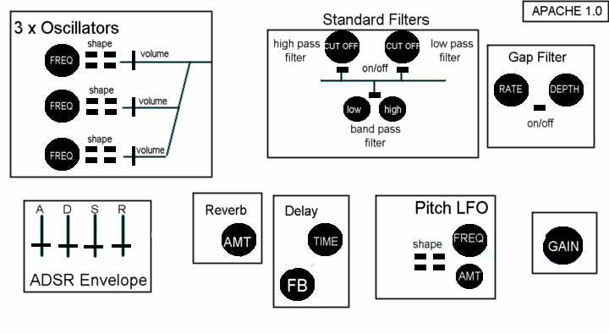 FIGURE 1: Layout of Graphical User Interface

Above, all black-labeled objects correspond to an individual user adjustable parameter. Parameters of related functions are grouped beside each other. This design is of course just the bare bones; color and other textures will liven up the finished GUI background. However, the position of the parameter objects will be the similar to above.

The three types of parameter object used in the GUI are the:

- Dial – twisted clockwise and counter-clockwise
- Slider – moved in a vertical or horizontal direction
- Button – Turned on or off. In the ‘on’ state the button should appear to be illuminated.

Functional Requirements

The following is a ranked list of what the plug-in must accomplish in order to provide the features described in the last section. The rank is based on how important each feature is to the overall functionality of the plug-in.

- Handling of MIDI and Parameter Data – The plug-in must be able to:

A – Recognize relevant MIDI messages sent to it from the sequencer and determine which voice that this message corresponds to. This will allow the proper output of up to 16 simultaneous tones of audio.

B- Process each relevant MIDI message according to frequency (note), volume and pitch-bend, and output audio accordingly. (i.e. know when to output audio and when to stop outputting audio).

C- Change the outputted audio accordingly to correspond with changes in the user parameter values. Parameter values are totally separate from MIDI values and should be handled differently.

This first requirement is obviously of paramount importance, as the plug-in must understand the two kinds of user input, and output corresponding audio when appropriate. If the plug-in can’t do this then its totally useless.

The plug-in is always dependant on the hosting program. If the host cannot send this information to the plug-in then nothing will happen.

- Generation of Digital Audio Waves – The Vsti must be able to:

A – Generate up to three separate waveforms of any of the four shapes specified. It must then be able to add these waveforms together in different combinations (specified by user), without any audible distortion such as clipping.

B – Do all this in reasonably efficient way. The generation of the waveforms should not use more than 5% of the CPU power. *

This is the second most important requirement for the plug-in to operate as previously specified. Even if none of the effects work after this stage, then at least the plug-in will still be able to create entry-level waveforms using the three oscillators. This is why the waveform generation is so important, it makes the actual sound that comes out of the plug-in. The effects applied to that sound only tweak the original sound. Most of the sounds produced with Apache 1.0 will be roughly 75% defined by the oscillator’s parameters, and only 25% defined by the optional effects. In other words, the waveform generators will produce the foundation of the sound, with the effects only adding a gloss to the sound. There can be exceptions of course.

The dependencies of this section of the plug-in are really just the power of the computer that the plug-in is running on. * The projection above, that the generation of waveforms should not use more than 5% of CPU power is based on a P4/2.66Ghz chip, having observed other sound generator plug-ins running.

3. ADSR Envelope – In order to recreate a reasonable first approximation of a musical instrument, an ADSR envelope is a basic requirement. For example, a pipe organ, when the key is pressed, plays a note at a constant volume, the sound ending virtually as soon as the key is released. The sound of a guitar by contrast, is loudest immediately after its played, and fades with time. Other instruments have their own characteristic volume patterns. This part of the plug-in must only accomplish one thing :

A – Efficiently alter the amplitude at set points of the input according to the parameter values of attack, decay, sustain and release.

The main issue here is the changing of the amplitude at set points in the input, which correspond to the parameters above. The extension of the signal duration, after the reception of a MIDI note-off message (provided the release parameter is greater than zero), will be the most difficult part.

This part of the plug-in (ADSR Envelope) is third most vital, and is the most important of the sound effects applied over the generated signal, as it can greatly change what the user hears. The ADSR Envelope only changes the sounds volume. It will allow the user to precisely define how the sound’s amplitude changes over set points in time. While an ADSR envelope is a first step in emulating the sound of classic musical instruments, it is not going to give anywhere near an authentic sound on most instruments. Still, it is an extremely useful process, and any good synthesizer should have at least a basic version.

The ADSR Envelope is dependant on the sound generators, as it needs an input sound to operate on. It is also, to a lesser extent, dependant on the power of the CPU.

4. Other Sound Effects – All of the remaining sound effects (standard filters, gap filter, pitch LFO, delay and reverb) are of equal importance in terms of overall functionality they provide. Some musicians will use reverb most frequently and never touch filter effects, while others will combine pitch LFOs and filters with impressive results. The keyword here is choice, and that’s why all the following effects are deemed to be of equal importance to the overall plug-in:

A – The Filter section must be able to:

- Efficiently cut the input sound at the frequency specified by the user parameter
- If the filter is high pass, it will cut all frequencies below the specified value. If it is low pass, it will cut all frequencies above the parameter value.

- If the filter is band pass, it will combine methods used in low and high pass filters, to cut frequencies above and below the upper/lower band limit parameters respectively.

- The gap filter will not cut frequencies, but will intermittently reduce and restore the amplitude of the input signal at a speed and depth specified by user parameters. The depth will be how much the amplitude is reduced each cycle, before being restored. The depth can go right down to mute.

- All the above filters will have the option of being turned on or off, without affecting the set parameter values.

B – The Pitch LFO section be able to:

- Efficiently shift the frequency of the input up and down in repeating cycles corresponding to the shape of either sine, saw-tooth, square or triangle. The frequency range will be from –2 octaves to +2 octaves.

- Allow the user to control the speed of oscillation and the shape used in the oscillation.

- Allow user to specify how much of the overall effect is applied to the input signal.

C – The Reverb section will:

- Apply a reverberation effect to the input corresponding to a middle size box studio. This is a standard neutral reverb, which is commonly used.

- Allow the user to control how much reverb is applied to the input signal.

D – The Delay section will:

- Apply a delay or echo effect to the input, corresponding to t milliseconds, specified by a user parameter called ‘delay time’.

- Allow the user to control how much of the delay effect is applied over the input signal

The four sections of effects described above will be of more or less equal difficulty to implement. Each section has its own design aspects, which will need to be addressed, but the end results should function exactly as described above.

The dependencies in this section are much the same as for the ADSR Envelope. The only difference being that some of the effects such as reverb and Pitch LFO will be, by their nature, more CPU intensive than the others. The overall CPU usage of the effects section should not exceed 5%. That means the plug-in’s overall CPU drain should not exceed 10%.

Note, these figures are just absolute limits. It will be desirable to have the CPU usage as low as possible, and this will have to be addressed at design and implementation time.

5. Overall Gain – This section is of least importance to the audio engine, as it will only alter the overall amplitude of the outputted signal in the range –15 dB to +15 dB. It is the final link in the chain. It should also be trivial to implement. Its omission however, would be a bad idea in terms of design, as we can’t assume anything about the host sequencer except that it will open our plug-in and send it midi data. If the volume level in the host sequencer, for some reason was low for our synthesizer, then this control could increase the output volume to compensate. Or perhaps we just want to listen carefully to some element of a sound that we are creating with Apache. We can turn up the output of the plug-in without having to touch the overall gain in the host sequencer.

6. Graphical User Interface – For this project, a custom made GUI will be constructed as shown earlier, to emphasize the brand-name Apache, and its creator. To provide the custom GUI we must:

A – Create the GUI background, and related graphics such buttons and dials. Integrate all these together to form a stylish interface.

B – Know when a user is turning the dials/pressing buttons, and update the GUI with appropriate data.

The GUI is ranked low because to create a VST plug-in, it is not necessary to also program a custom GUI. The reason for this is that the host sequencer can create a default GUI automatically upon loading of the plug-in which represents completely all the user controllable parameters. The generated GUI will obviously be quite bare, but still perfectly functional. If time is tight, there is the option be of omitting the custom GUI in exchange for a standard ‘boring’ default GUI created by the host program. Hopefully this will not be the case.

7. Default Presets – This requirement is the lowest priority and simply refers to the supply of sound presets with the final product. While this requirement will involve coding, it will be more fun than work as we will get to finally use our creation to make ‘cool’ sounds, and test its sonic capabilities. Still, for the user the inclusion of preset sounds, such as bass and piano are important. This requirement involves playing around with the controls until a good sound is created and then ‘hard-coding’ the parameter values into data structures provided by the VST SDK.

System Architecture

Firstly the overall way that the plug-in will operate in terms of the sequencer and Windows is best understood through the following diagram: 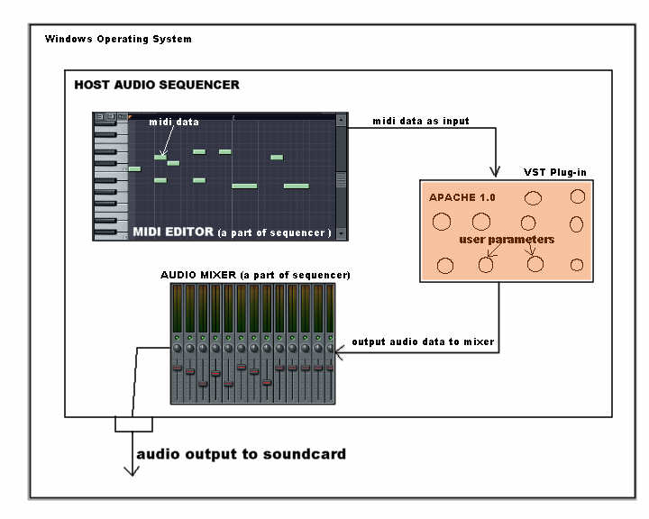
Figure 2: The overall place of the plug-in.

The nature of the VST Standard set out by Steinberg defines the relationship shown above between the VST plug-in and the sequencer. The sequencer must call the plug-in and send it information. The sequencer doesn’t know what the plug-in does. All it knows is that the plug-in is a black box with an arbitrary number of inputs, outputs and related parameters.

The architecture of the plug-in itself will be quite simple. The waveforms will be generated, then the various effects will be applied in series across the generated signal, in the ranked order described in the last section. The following diagram illustrates:

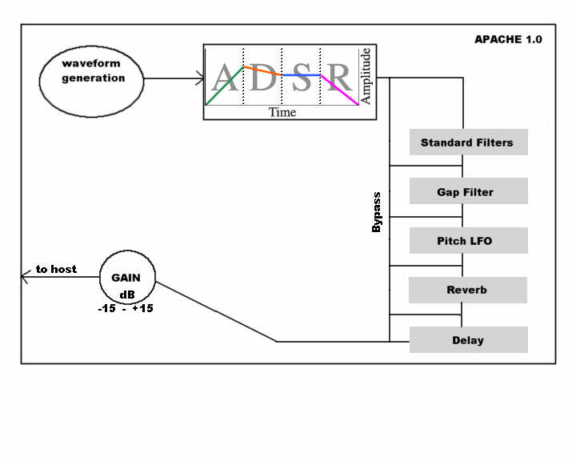
Figure 3: Flow of data inside plug-in

Operational Scenario

This section will detail a typical user experience from start to finish when using Apache 1.0. The sequencer used in this scenario will be FL Studio 6. Since the purpose of this plug-in is to allow the user to create sounds for use in a musical composition, there can be only one scenario:

For this example the users name will be John.

- John loads up FL Studio, and clicks on channels -> Add one. He navigates down to the menu item which says ‘Apache 1.0’ and clicks on it. FL Studio opens the plug-in and displays its graphical user interface on top:

Pc based viewers, Please zoom in for a closer look.

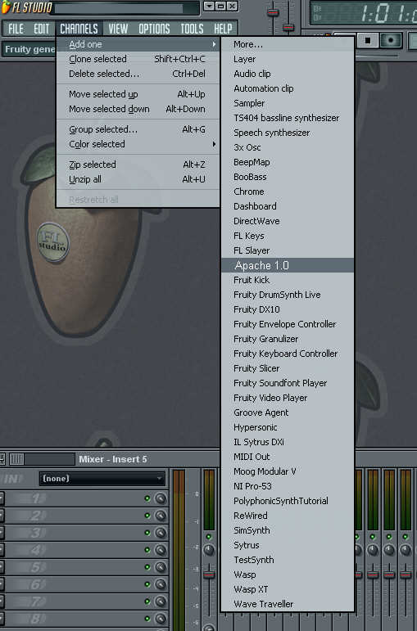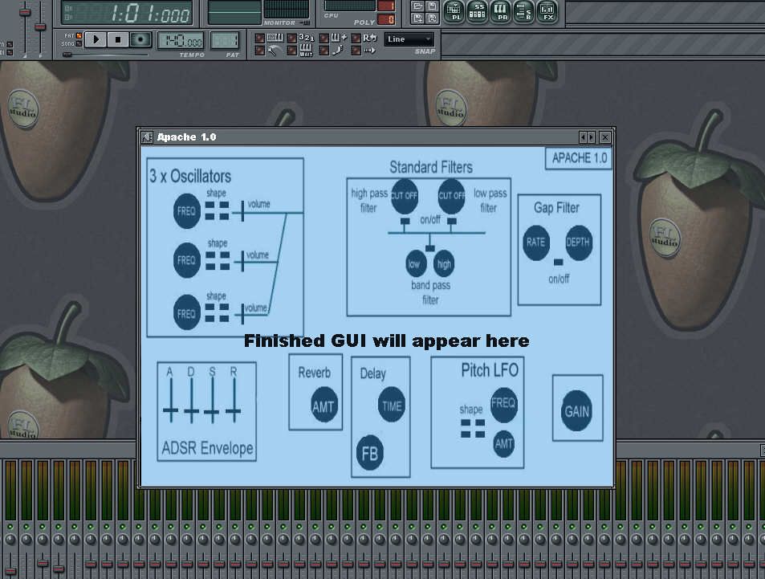

- John opens the MIDI preview function, and clicks on a graphical key on the graphical piano supplied by FL Studio. He hears the default or initial preset on Apache. The sound is a nice smooth bass sine wave.

- John decides that he would like to liven up the bassy tone. He observes that waveform generator 1 is set to sine wave at a frequency of 300 Hz. He also observes that the other two waveform generator’s amplitudes are set to zero.

- John selects saw-tooth on Generator 2 at a frequency of 440Hz. He initializes this generator by increasing its volume from zero to 50%.

- John, eager to hear what the Sine and Saw wave of of differing frequencies will sound like, presses the C-5 key on the MIDI preview window. He hears a low rough bass tone:

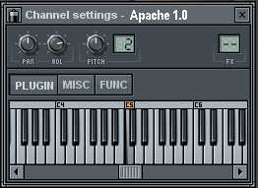

- John like what he hears and decides that he will use this sound for his bass line. He adjusts the ADSR envelope control so the bass quickly and smoothly fades in when he presses the preview key. The adjustment he makes is to the attack parameter, increasing its value from 0 to 7%.

- John now opens FL Studio’s MIDI editor (called the piano roll), and programs in a little melody. He can hear the melody being played back by Apache using the bass sound he made, by pressing the play button on the main sequencer control panel:

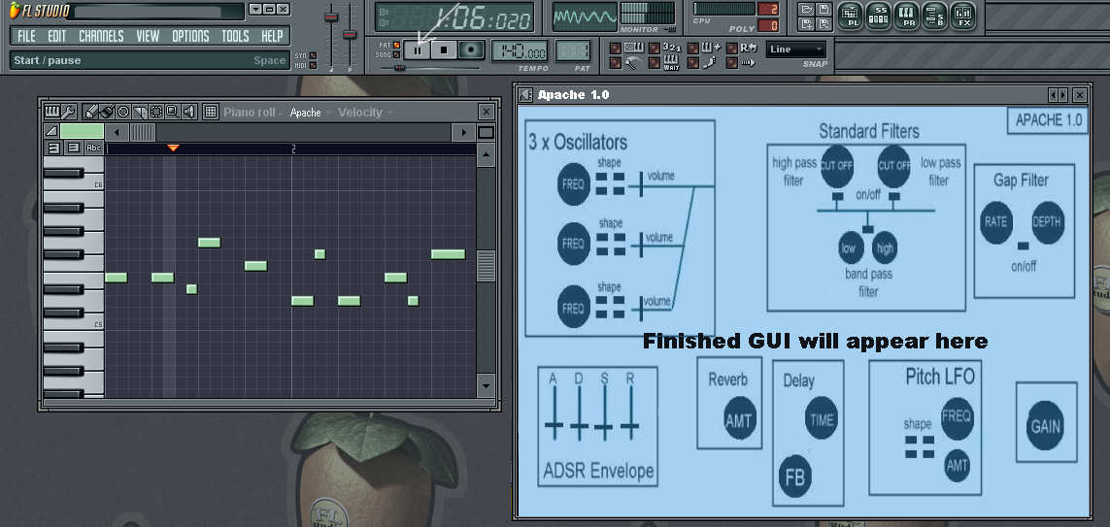

- John likes the melody and saves his work. He also decides to save the bass sound that he altered, so he can use it again. He left-clicks on the plug icon in the upper left hand side of apache’s window and selects ‘Save Preset As’.
- A window appears and he types in the name ‘John_Bass1’. He then clicks save. Now John can load up this preset any time he wants to use it again:

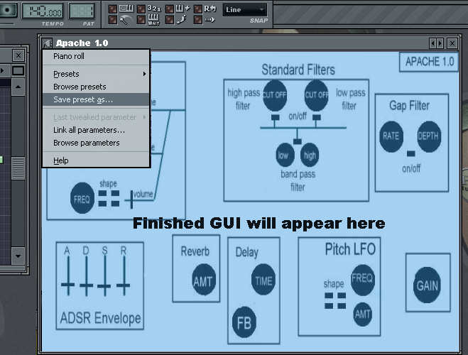

That was a typical everyday use of the proposed system. The steps described above will be repeated again and again in different combinations, and using other parameters of the plug-in by its users. There is also the option of having several instances of Apache open at the same time if a user wishes combine the generators of each to make more complex sounds. The user would simply route the midi data to all instances of Apache to achieve this. This type of use however, would be constrained by the CPU speed.

Preliminary Schedule

The following is a estimated schedule for the total completion of the Apache 1.0 project, including its testing, documentation and installer program.

January / February 2006: Begin design & implementation stage of project. Using this Functional Specification as a schematic, start work on the first major functional requirement outlined earlier: Handling MIDI and Parameter data.

13th February: Start implementation of the first functional requirement described above no later than this date.

20th February: Deadline for completion of functional requirement number one. Begin work on functional requirement number two: Waveform Generation

27th February: Start implementation of the waveform generation part of the project no later than this date.

13th March: Deadline for completion of the waveform generation. Start work on the ADSR Envelope function.

20th March: Start implementation of ADSR Envelope function no later than this date.

27th March: Deadline for completion of ADSR Envelope. Start work on the Filters, including the gap filter.

3rd April: Start implementation of the Filters no later than this date.

10th April: Deadline for completion of the Filters section. Start work on the Pitch LFO section.

17th April: Deadline for completion of the pitch LFO section. This section is only given one week from design to completion because we have already done the waveform generation so all we need to do is figure out how to apply the waveform across the pitch envelope of a signal. Start work on the delay and reverb section.

24th April: Start implementation of delay and reverb no later than this date. Begin designing the GUI to be used.

1st May: Deadline for completion of reverb and delay. The gain control is trivial. Have the GUI designed and start implementation of this aspect.

4th May: Deadline for submission of Project Documentation.

10th May: Deadline for completion and integration of GUI with the functional aspects. At this stage there will be a fully functioning vst plug-in as specified.

10th – 28th May: Testing of the plug-in, bug fixing, minor-tweaking and creation of an installer program, for easy deployment.

29th May 2006: Project Demonstration week. A VST compatible sequencer will need to be installed on the PC, which will be used to demo the project.

