[CA400]

Development of a Virtual Audio Synthesizer

By Cathal O’ Callaghan

50649775
CASE4

4th May 2006

Supervisor: Alistair Sutherland

Table of Contents

Section I – The User Manual

Introduction 4

Installation / Quick Start 5

Product Overview 7

Apache’s Controls 8

Factory Preset Guide 12

Section II – The Technical Manual

Introduction 14

System Architecture 16

High Level Design 18

Implementation 26

Problems & Resolutions 47

APACHE 1.0 VSTi

Additive Synthesizer

USER MANUAL

Introduction

Thank you for choosing Apache 1.0 – a versatile audio plug-in for the creation of high quality sounds.

The following pages explain how to install and use Apache.

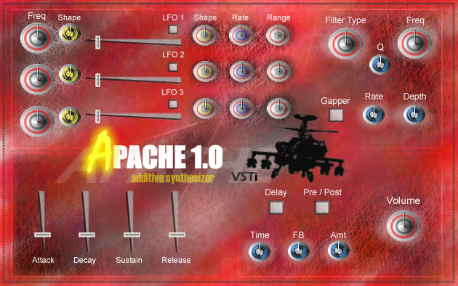

Apache 1.0 User Interface

Quick Start Guide

Apache 1.0 requires a (VST 2.0 compatible) host audio program to run. Examples of programs like this are FLStudio or Cubase. Please obtain a host audio sequencer/editor before attempting to run Apache.

The installation of Apache 1.0 is straightforward. Please use the following steps as a guide:

- Run the setup file entitled “apache1.0_setup.exe”.

- Follow the instructions on the installation dialog. You will be asked to locate your vst plug-in directory. Apache needs to be installed into you host audio programs vst plug-in directory. Please see your audio program’s manual if not sure where this directory is.

- Once you have located/selected the directory, click OK.

- Apache 1.0 will now be installed.

- Once the installer wizard has finished, your host audio program may have to re-scan its vst plug-in directory, in order to detect Apache. Please refer to the audio programs user manual, if unsure of how to do this.

- Now that Apache is installed, you may use it by opening your host audio program, and choosing Apache from the list of available plug-ins.

When you first open Apache in your host audio sequencer, it will be set at the default preset, a smooth bass-line. The easiest way to quickly start making original sounds is to change the shape and pitch of the oscillators. Initially, only the first oscillator is active. You may activate the other two oscillators by increasing the position of the volume slider for each one respectively.

The LFO (Low Frequency Oscillator) for each oscillator is another way to radically change the sound. Using the features of each standard oscillator in combination with each other is the best way to achieve a complex sound.
The filter section of the plug-in can be used to mould the output from the oscillators, into a more smooth or raw sound depending on what setting you choose to use. Initially, the filter section (along with all other sound effects) is turned off.

If you wish, you may start by selecting a different preset (see your host audio program’s manual for information on how to do this), and use that as a starting point for your own sounds. You may of course also use it just the way it is, for an even quicker start. Apache comes with 50 factory presets, spanning a wide variety of sounds, so feel free to browse!

For more information on all of Apache’s controls, please see section 4.

Overview

Apache 1.0 is a 16-voice additive audio synthesizer plug-in. It can be run with any VST 2.0 compatible audio program. Its intended platform is Windows NT/XP, and can only be guaranteed to run correctly on these operating systems.

This synthesizer plug-in is aimed at the amateur electronic music producer. It allows users to create good quality sounds easily and quickly. The variety of sounds that can be created with Apache is quite broad (see section 4/5 for more information). Using the features of the plug-in described below, you can create a sound and then modify it until satisfied. You may also save your own presets for future use (see host audio program’s manual for more information on how to do this).

Apache 1.0 generates sound by adding together waves of different forms and frequencies. This method of making sound is called additive synthesis. Apache only uses this method for generating sound, and so does not require excessive cpu power. This means that Apache can be run along with all your other favorite audio plug-ins without problems.
Once generated, Apache provides the option of applying various useful audio effects on the signal, in order to refine (or totally change) the sound. The effects are applied in series across the generated signal, in the following order: 1. Generation & pitch LFO(if active) - 2. ADSR Envelope – 3. Gap Filter – 4. Delay(pre) – 5. Regular Filters – 6. Delay(post) – 7. Volume.

Apache 1.0 has the following features:

- Three-oscillator synthesis engine; each oscillator capable of generating sounds in the waveforms of sine, square, saw-tooth and triangle.

- Three independent low frequency oscillators, which operate respectively on the pitch envelope of each of the standard oscillators.

- Low-pass, high-pass and band-pass filters, which can be applied on the generated signal.

- Gap Filter. This intermittently cuts and restores the generated signals volume at a rate and depth that you can specify.

- ADSR Envelope. This allows you to specify the volume of the generated signal over a period of time.

- Delay or echo effect, which can add one or more time-delayed versions of the original signal to the output.

- Capable of outputting up to 16 simultaneous notes at a time. This makes the creation of complex sound chords / textures possible.

Controls

1

A

B

C
2

D

E

F

G
3

H
I
J
K
L
M
4
N
O
P
Q
5
R
S
T
U
V
W

Apache is divided into 5 main sections in the diagram above, with each section containing the parameters which are closely related to each other.

Section 1 – This the audio synthesis engine. This contains the controls for the three oscillators :

A - This column of large dials is the frequency offset controls for oscillators 1-3 respectively. Twisting these dials will change the frequency of the signal being generated up or down, depending on which way they are turned (increase frequency: clockwise; decrease frequency: anti-clockwise).

B – This column of smaller dials is the shape controls for oscillators 1-3 respectively. Twisting these dials in a clockwise fashion will make the oscillators change the shape of the wave they’re generating. The order is sine, square, saw-tooth, triangle.

C – These three sliders are the volume controls for each respective oscillator. By sliding the control left to right, you increase the volume of a particular oscillator. You can use these volume controls to mix the various waveforms together (additive synthesis).
Section 2 – The pitch envelope LFO section. This part contains all the controls for making the pitch of a particular oscillator follow an envelope of shape sine or square:

D – Each of these three small square buttons activates a particular LFO. The top button is for LFO1, and will control the pitch envelope of the first oscillator. If the button is set at the off position (default), then the generated signal will not be affected.

E – This column of dials controls the shape parameter for the each respective LFO. At the extreme left position, the shape will be sine, otherwise the shape is square.

F – These dials control the rate of the LFO, that is, the frequency of sine/square waves, that are being applied across the pitch envelope of each oscillator. The lower the rate, the slower the pitch of the generated signal will change.

G – Each dial in this column controls the range of the LFO. They affect how big the difference is between the lowest and highest pitch during the oscillation. Like all other dials, the difference increases by turning it clockwise.

Section 3 – Filter Section. This section of the user interface contains the controls for the four filters. Filters change how much of certain frequencies are present in a signal. The Filter effects operate over the combined output from the three oscillators, pitch LFOs (if active) and ADSR Envelope:

H – This dial controls whether the filter is (1) turned off, (2) set at low-pass, (3) set at high-pass, (4) set at band-pass. Each of these four settings are, as always, accessed by turning the dial from left to right. The low-pass setting will cut off any frequency above cut-off frequency (control I), The high-pass will cut off any frequency below, while the band-pass will only allow through frequencies between a certain range.

I – This controls at what frequency the signal will begin to get cut off at. The speed (or gradient) of the cut-off depends on the third control (J). If the band-pass setting is chosen for control H, then this parameter is the middle frequency of the band of frequencies allowed through. In this case control J controls the width of the band.

J – The quantization control, or selectivity of the filter. This controls how strict the filter is when using the settings low-pass or high-pass. If set at a low setting, say 1, then the cut-off will be like a gentle ramp below/above the cut-off frequency. If set at a high frequency, say 10, then the cut-off will be much faster like a very steep ramp. If using the band-pass setting for control H, then this parameter simply controls the width of the band of frequencies allowed. There is a limit on how wide the band can be.
K – The Gap Filter on/off button. This simply activates / disables the Gap Filter effect described in section 3. This button is set in the off position by default.

L – This dial controls the rate of the gap filter, that is, how fast the volume is cut and restored. At fast rates a helicopter sounding effect can be achieved.

M – This dial controls the depth of the gap filter, that is, how much the volume is cut at each interval. This parameter can range from no cut in volume, right down to mute.

Section 4 – ADSR Envelope. This section comprises of the ADSR Envelope controls. There are only four vertical sliders, each of which control the four parameters needed to achieve the shaping of volume over time.

N – Attack. This slider controls how fast the sound fades- in after the reception of a note. That is, how fast the volume gets to a set peak level. This initial peak level helps to emulate a plucked or spiccato effect, but can be eliminated if control P is set to full.

O – Decay. This slider controls how fast the sound decreases from the initial peak level, down to the sustain level set by control P.

P – Sustain. This slider sets the sustain volume level. That is, the volume of the output for the duration of the note. (until you release the piano key, for example). For short quick sounds this control could be set to zero.

Q – Release. This slider sets how long the sound will take to fade away once a note has ended (after you release the key). This means that sounds don’t end abruptly (unless set to zero), and seem more naturally.

Section 5 – Delay and Volume. This part contains the two remaining effects, the delay and the overall volume of the synth.

R – Delay on/off button. This simply activates / disables the delay effect. The effect is applied on the combined output from the oscillators, pitch LFOs, ADSR envelope and filters (if active).

S – Delay pre/post button. This button controls whether the delay effect is applied before or after the filter effect. This would be useful if you wanted to put multiple delays on a signal but filter out the high frequency clicks that occur when doing this. In this case you would leave the button in the off position (default).

T – Delay time. This dial controls how long it takes before an echo sounds. The maximum length of delay is 2 seconds.

U – Delay Feedback. This dial controls how many echoes sound after the original sound.

V – Delay Amount – This dial controls how much of the echo/delay effect you hear. A setting of 75% is optimum in most cases.

W – Overall Volume – This dial simply controls the overall output volume of the synth. By turning anti-clockwise you can decrease volume, while turning it clockwise increases volume.

Factory Presets Guide

Apache 1.0 comes with 50 built in presets, which aim to give the user a wide range of sounds to use in may situations of electronic music production. Many of the presets are complex signals, while others are more simpler templates which are more for use as a starting point. This way the user doesn’t always have to start from some boring default setting. The sounds are separated into 5 sections :

[ 1-10 ] Bass Leads – These are designed to be low frequency sounds, used as the foundation of a track.

[11-20] Rave Leads – These are designed to be mid to high frequency sounds that should be prominent in a mix.

[21-30] Keyboards – These are mostly electric piano/keyboard style sounds, they can be used in many circumstances.

[31-40] Electro Hits – These are designed to be short mid to high frequency sounds. Ideal for use with the delay effect.

[41-50] Bizarre FX – These sounds are designed to sound strange, whatever frequency they are triggered at.

Technical Manual

Apache 1.0 VSTi

1. Introduction

1.1 Glossary

- VST – Virtual Studio Technology. The audio plugin standard created by Steinberg to allow any third party developers to create VST plug-ins for use within VST host applications.

- MIDI – Musical Instrument Digital Interface. An industry-standard communications protocol that precisely defines each musical note in an electronic or software musical instrument. It allows electronic and software instruments to exchange data with computers, or "talk", with each other. MIDI does not transmit audio - it simply transmits digital information about a musical performance.

- Audio Sequencer – Software which allows the user to record, edit and layout sound/MIDI data, in order to create a musical composition. An Example of an audio sequencer is Cubase SX, or FL Studio.

- Dll File – Stands For Dynamic Linked Library. Implements the concept of dynamic linking. For this project, the linking of a plug-in to a sequencer.

- Oscillator – Responsible for the creation of an audio signal.

- LFO – Low Frequency Oscillator.

- Polyphony – A musical texture consisting of several independent voices, as opposed to just one voice.

- VSTi – A virtual music instrument complying with the VST plug-in standard.

- Waveform – The shape of a signal, such as the vibration of a plucked string. Common waveforms include Sine, Square, Triangle and Saw-tooth.

- ADSR Envelope – A parameter used in synthesizers to control the volume of a sound over time.

- GoF - A computer science book entitled “Design Patterns” which proposes standard solutions and naming conventions to common problems in software design.

1.2 Overview

This document describes a technical manual for a 4th year project which was the design and implementation of a VST synthesizer plug-in. The manual will describe in detail all aspects of the application from a developers perspective. It will describe the different parts of the application and explain how they communicate, as well as providing an architectural overview of the system. It will also outline the core algorithms used in the implementation, and detail the ways that the different parts of the application were implemented.

Before any specifics are given about these aspects, the author feels it is necessary to inform the reader what a VST plug-in actually is. Like many kinds of plug-ins, a VST plug-in comes in the form of dll file, which in order to be used, needs a third party audio program (the host) to run it. The plug-in is loaded up from within the host application, and depending on what kind of VST plug-in it is (effect or instrument), it will be applied across an audio signal (for example a delay effect), or it will be sent information (MIDI data) on which notes to output as audio.
The VST standard is an open standard, created by Steinberg. The VST SDK was used to create this 4th year project application.

The VST instrument plug-in that this project has produced is a 16-voice additive sound synthesizer called ‘Apache 1.0’. The purpose of the synthesizer is to allow users to create a wide variety of original sounds, for use in music production or sound design. The plug-in includes three independent sound generators, which generate sound waves in a variety of shapes. These generators/oscillators are the engine behind the sound synthesis and initially allow the user to control exactly what kind of sound is produced (by adding together waves of differing frequencies and shapes). In addition to the 3 oscillators, the plug-in also has many effects that can be applied to the generated sound, such as delay and filters. Once created, the user will be able to save his or her unique sound using presets. This way a user can build up banks of original sounds for repeated use with the plug-in. To use Apache 1.0, one opens it in the host (VST 2.0 compatible) audio program. The host audio program sends Apache midi information, which is then interpreted by the plug-in. The appropriate audio data is then sent to the host program, which outputs this audio to the computers soundcard.

Overall, this application has three main parts :

- The interpretation of MIDI information sent from the host.
- The digital signal processing associated with synthesizing audio and applying processes on it.
- The user interface.

These could also be seen as the three main aspects associated with the project as a whole. The rest of the technical manual will document the various components and operations as members of one of these groups.

2. System Architecture

The Big Picture

This section gives a overall view of the whole application and shows how it interacts with the host audio sequencer.
Firstly the way that the plug-in operates in terms of the sequencer and Windows is best understood through the following diagram:

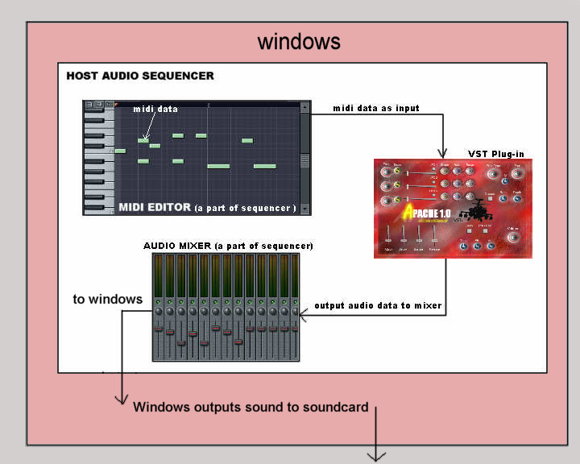
Figure 1: architectural overview of system

The nature of the VST Standard set out by Steinberg defines the relationship shown above between the VST plug-in and the sequencer. The sequencer must call the plug-in and send it information. The sequencer doesn’t know what the plug-in does. All it knows is that the plug-in is a black box with an arbitrary number of inputs, outputs and related parameters.

The way the plug-in works itself is quite simple. When the plug-in receives a midi note, the waveforms are generated, and then various effects that are currently activated are applied in series across the generated signal. The plug-in stops outputting when the midi note has ended*. The following diagram illustrates:
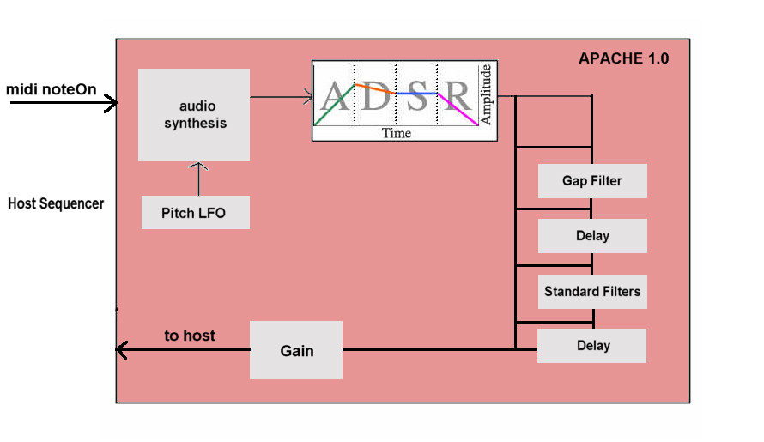Figure 2: Flow of audio data inside plug-in

During use, the plug-in will respond (in real-time) to any changes made to its parameters, as well as responding to midi messages sent by the host. There are 37 user parameters in total.

The host doesn’t just send the plug-in midi information, it can also send the plug-in initial setup information such as sample-rate and tempo. In the case of this plug-in, tempo information sent by the host is ignored (we have little use for it). The sample-rate however, is very important as the plug-in needs to generate the sounds at the same sample-rate as the host (otherwise audio distortions will occur).

The next section deals with the high level design of the system components.

* The output audio doesn’t always end immediately after the end of a midi note. If there are pending delays to sound, or if the release parameter of the ADSR envelope is active, then output persists according to the parameter values.

3. High Level Design

3.1 Introduction

The following is an outline of the ten different components present in the system, separated into the three overall aspects of the project:

Message Handler 3.2 MIDI Aspect
Voice Handler 3.3

An Individual Voice 3.4
The Volume Envelope 3.5
The Sound Generator 3.6
Effect Handler 3.7 DSP Aspect
The Sound Filter 3.8
The Gap Filter 3.9
The Sound Delay 3.10

The User Interface 3.11 UI Aspect

The high level design of the application loosely follows the observer design pattern, in that each component observes another for changes. The difference between the way the pattern is implemented in our case, and the traditional way (in GoF), is that communication is mostly one-way between the different components. For example, the sound generator observes the voice that its associated with for changes in its parameters. The voice observes the voice-handler for changes in its parameters. The voice-handler observes the message-handler for for changes, and so on.
The only exception is the two-way communication between the message handler and the user interface, and between a voice and its volume envelope. The following diagram illustrates the communication flow between the components:

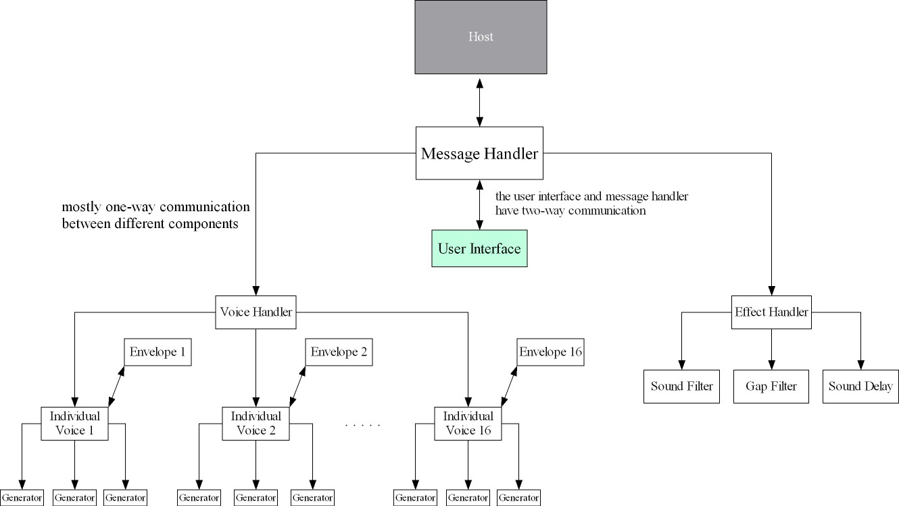

Figure 3: Communication between architectural components

3.2 Message Handler

The message handler is basically just a wrapper for the voice handler and effect handler components. It tells them what messages to deal with. It sends effect parameter messages to the effect handler, and all other user parameter / midi messages to the voice handler (most of the messages). The message handler also deals with changes in the user interface component. Unlike most other components, the message handler and user-interface have a two-way communication system, i.e. its not just one telling the other what to do all the time. The message handler knows first when a user changes a parameter, and informs the user-interface about it. The UI then asks the message handler for the new value of the parameter and updates itself appropriately.

3.3 Voice Handler

The voice handler is essentially ‘the brains of the system’, as it deals with most incoming messages, and allocates voices (tones of audio) to the incoming midi notes. The messages can be divided into two groups, MIDI and user parameter messages.
The MIDI messages that are dealt with are individual midi notes and pitch- bend messages. Most of the midi messages that voice handler deals with will be the note messages, however. Pitch-bend is not used nearly as much.
There is far more variety in the amount of user parameter messages that can be received, as there is 37 different parameters for the user to play around with. The voice handler receives parameter messages relating to the three oscillators, the LFO and the ADSR Envelope ( 24 possible messages ).

3.4 Individual Voice

As mentioned in section 1, Apache is a 16-voice audio synthesizer. This basically means that it can output up to 16 tones of audio at once. This component of the system encapsulates a single voice. It receives most of its messages from the voice handler, including what midi note it should be playing (or not), and what changes in user parameters it needs to deal with. It also receives messages from the volume envelope, relating to what stage of the ADSR envelope the voice should be at.
The voice is composed of three independent sound generators, and one volume envelope. The voice sends messages to the generators, to inform them of relevant changes in midi note or user parameters, and to the volume envelope relating to user parameter changes in the ADSR section. The voice component is also responsible for applying the volume envelope on the generated sound. The following diagrams illustrate:

The summed outputs from the three generators, into the individual voice, and subsequent enveloping of the signal (fig. 5).

The summed outputs of the individual voices into the voice–handler (fig. 6).

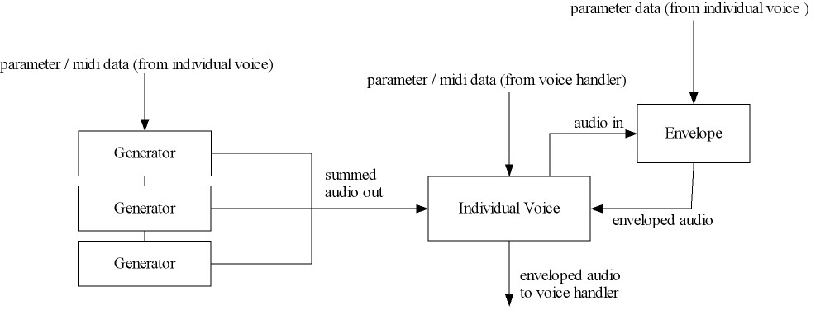

Figure 5: The sound generators output is the audio input for the voice

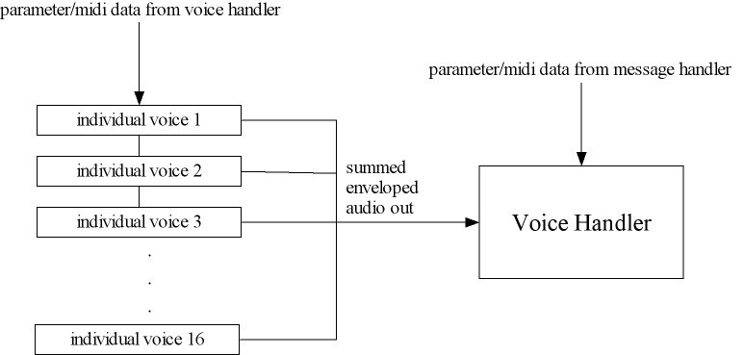
Figure 6: The output of up to 16 enveloped voices is the audio input to voice handler

3.5 Volume Envelope

This is composed of a four different parts: The attack section, the decay section, the sustain section and the release section. (please see user guide for more information on these parameters) The volume envelope component receives all its messages from the individual voice its associated with, relating to parameter changes. It also sends messages to its voice, telling it when to change from one section of the envelope to the next. The voice and volume envelope are designed in this way so as to keep them loosely coupled, to allow for ease of future extensibility. The relationship between the volume envelope and the voice is illustrated in figure 5.

3.6 Sound Generator

This is composed of a single oscillator and LFO, which are controlled by user parameters to allow the shaping of the output signal. The sound generator is the engine of the plug-in, as it synthesizes the signals that get processed by other components of the system. The generator also applies (if activated) a LFO on the pitch envelope of the generated waveform, to give a tremolo like effect. It receives all its messages from the individual voice that it is a part of. As described in the last section, each voice has three of these generator components and can mix their output together to generate a more complex sound.
This sound generator is the first link in the chain, so to speak, as it doesn’t communicate with any other components; it only receives messages and generates the
sound. The following diagram illustrates the structure of the sound generator:

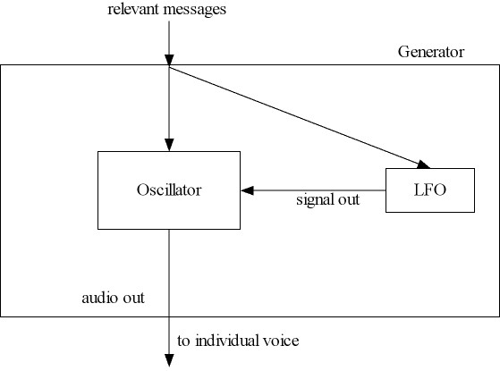
Figure 6: Internal structure of Generator

3.7 Effect Handler

The effect handler is a simplified version of the voice handler. It deals with user parameter messages only. The messages it deals with are of course only related to the audio effects (delay, filters and gain), and it doesn’t have to deal with allocating voices or any aspects of the generation of audio. It is also much simpler in that it only needs to send messages to at most one instance of sound-filter or sound-delay (voice-handler has to deal with multiple instances of the voice component).
The effect handler is the final link in the signal processing chain of the system. The output from the voice handler is routed into the effect handler so that any activated effects may be applied to the signal. The following diagram illustrates this relationship:

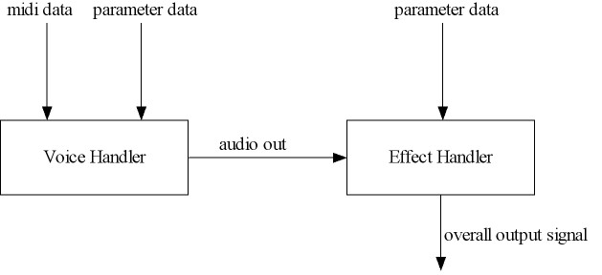
Figure 4: Output from voice handler is the audio input to effect handler

3.8 Sound Filter

The sound filter is the component of the system that applies standard filtering on the generated audio signal. It is composed of three types of filters, namely: Low-pass, High-pass, Band-pass (see user guide for information on these effects). Only one of the three standard filters can be used on the signal at once.
The filter component receives all its messages from the effect handler, and does not communicate with any components.

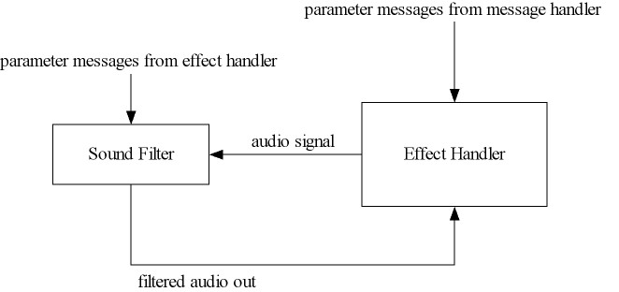

Figure 7: sound filter relationship with effect handler

3.9 Gap Filter

This component is the most simple component in the system. As with the sound filter it receives all its messages from the effect-handler, and does not communicate with any component in the system. It consists of a single gapper effect which can be applied on the input signal(or not).

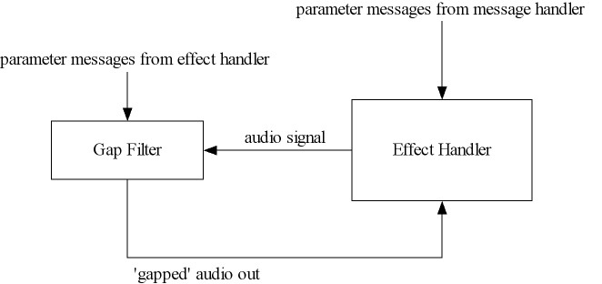

Figure 8: gap filter relationship with effect handler
3.10 Sound Delay

The sound delay consists of a single delay effect which can be applied on the input signal, if activated. It receives all its messages from the effect-handler and does not communicate with any component.

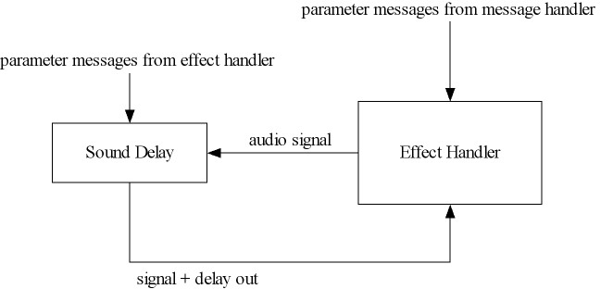

Figure 8: gap filter relationship with effect handler

3.11 User Interface

The user interface component is obviously much different from all the other components. Unlike the other components, the user interface has a two-way communication between the message handler. When a user changes a slider or a dial on the GUI, the message handler tells the user interface about what parameter has been changed. The user-interface, then updates itself based on the value of the parameter, which it asks the message-handler for. The advantage of this set-up is that message-handler is the only functional component of the system that knows about the user interface, and so the other components don’t need to be concerned about the user interface. The user interface only communicates with the message handler to receive parameter display values, it doesn’t communicate with any other component. The following diagram (Figure 9) illustrates the relationship between the two components:

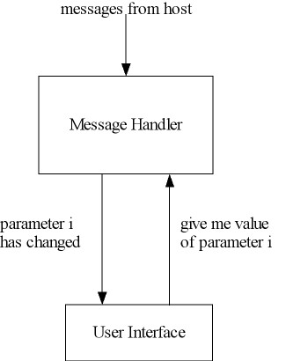

Figure 10: two-way communication between UI and message handler

4. Implementation

4.1 Introduction

This section gives a thorough description of how each component described (abstractly) in section 3 was implemented. Code snippets and mathematical algorithms are given throughout, to give the reader a more explicit understanding of how the various features work. As in section 3, the system will be described in terms of grouped components, but in this case each component is a class in the source code.

Apache() 4.2 MIDI Aspect
VoiceHandler() 4.3

Voice() 4.4
Envelope() 4.5
Oscillator() 4.6
EffectHandler() 4.7
Filter() 4.8 DSP Aspect
GapFilter() 4.9
Delay() 4.10

ApacheGUI() 4.11 UI Aspect

Before we go into the individual details of the implementation, the reader should be made aware of the basic project properties:

- The application was implemented using C++, and the functions from the VST standard development kit.

- Before the coding of the functionality of the plug-in, the VST base class AudioEffectX(), had to be extended by our plug-in class, Apache(). This is the only way to use the SDK, by inheriting from its base class, and then implementing the functions process() and processReplacing(). In the case of this project one other optional function was implemented, processEvents(), which deals with all messages sent from host. Otherwise the plug-in would not be able to receive midi events.

- In order for the plug-in to work correctly, strict naming conventions of the all functions implemented must be adhered to. There is a lot of small functions that the host expects to be made available (implemented) by the plug-in class, so all these needed to be set up initially.
- In general, only the mandatory functions were implemented, with the option of adding other functions if needed.

- Once the initial functions that the base classes/host use were implemented, the main functionality of the plug-in could be programmed.

The following diagram illustrates the structure of the program:

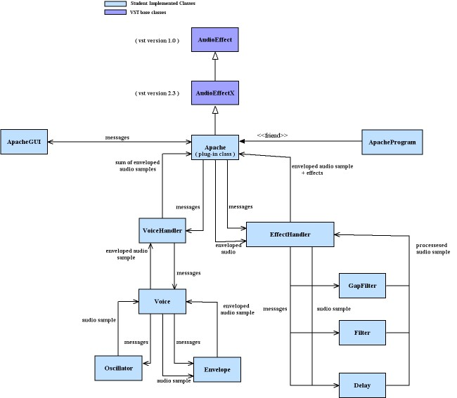

Figure 11: UML Abstract Class diagram of program

4.2 Apache, The plug-in class

This class is what gets constructed by the host program when the VST plug-in is first loaded up, and this class is as much the host can see of the plug-in. The host passes this class an object of the type audioMasterCallback, which handles the interaction between the host and the plug-in. This class then passes that object on to the VST base class that it inherits from (AudioEffectX), and the VST base code does the rest (we don’t have to deal with it):

Apache::Apache(audioMasterCallback audioMaster):
AudioEffectX(audioMaster, numProgs, numParam)

All the functions implemented in this class are made available to the host. The functions of the Apache() class that will be described here are process(), processReplacing(), processEvents(), processMIDI() and setParameter(). The first three of these classes can be called by the host, while the fouth is basically a utility function which filters the incoming midi messages, and prevents having to put too much code in the process loop. The fifth deals with changes in user parameters.

In the constructor of Apache, objects of type VoiceHandler and EffectHandler are instantiated. These objects will be used throughout the class to access the functions of both of these classes. Another thing worth mentioning about the constructor of Apache is the initialization of all of Apaches user parameters to a default value. The function setParameter() is used to set all the parameters, and is described later in this section:

voiceHandler = new VoiceHandler(); // declare our voice handler
effectHandler = new EffectHandler();

.
.
.

setParameter(freq1,0.5f); //set freqs to default -
setParameter(freq2,0.5f);
setParameter(freq3,0.5f);
setParameter(shape1,0.0f); //set waveforms to sine wave
setParameter(shape2,0.0f);
setParameter(shape3,0.0f);
.
.
.

Constructor of Apache, many parameters/objects initialized

Apache::Process() and Apache::ProcessReplacing()

The two most important functions in any VST plug-in is process() and processReplacing(). These two functions contain the process loop, where the both the voiceHandler() and effectHandler() are called continuously sample by sample, until the duration specified by the host elapses (the duration of a midi note, for example).
Any changes in (relevant) midi input will result in appropriate change in audio output, because before either effectHandler() or voiceHandler() are called, processMIDI() is called which in turn calls functions of voiceHandler which deals with midi notes.

Some hosts may use either process() or processReplacing() in different circumstances, but for our project it wouldn’t affect the output, whichever one was used. The process loop in each of these functions is almost identical, the only difference being that in process(), the output signal is added to the input, while in processReplacing() the output signal replaces the input. Since this plug-in doesn’t have any audio inputs (its not an effect), these two functions do the same thing:

for(i=0;i<sampleFrames;i++) // process loop
{
if(numEventsLeft > 0) while midi events remain
processMIDI(i);

temp = effectHandler->applyEffect(voiceHandler->getSample());
//generate next sample and apply any effect over it

outputs[0][i] += temp; //left channel
outputs[1][i] += temp; //right channel
//add sample to output buffer

}

The process loop, sampleFrames is a duration of samples passed by the
host to both process() and processReplacing().

Apache::ProcessEvents()

The third core function of the class Apache, is ProcessEvents() which is also called very frequently by the host. It will be called anytime the host sends a midi message to the plug-in. This function essentially captures all midi events and puts them into a queue. (The host can send events other than midi, but for this plug-in we ignore them) The queue that the function uses is an array of the inherited struct VstMidiEvent, which can hold all information about midi messages.

Apache::ProcessMIDI()

ProcessMIDI() is also a vital function, which is only called from within the process loop. It operates on the queue of midi events, that processEvents() keeps stacked, by making sense of the next midi event in the queue. It ignores all midi events except the type noteOn, noteOff and pitch-bend.

When processMIDI recognizes a relevant midi message it calls a relevant function of voiceHandler, passing the midi information as an argument. For example if a midi noteOn message is detected, then the noteOn() function of voiceHandler is called, with the note value passed as its only argument.

The following code snippet of processMIDI() shows how the different messages are detected, and passed on to voiceHandler().

switch(message)
{
case 144: //144 = NoteOn.
if(veloVal > 0)
voiceHandler->noteOn(noteVal, (float)veloVal/127.0f);
else
voiceHandler->noteOff(noteVal);
break;
case 128: //128 = NoteOff.
voiceHandler->noteOff(noteVal);
break;
case 224: //224 = Pitch Bend.
temp = (float)(veloVal * 128);
pitchbend = ((temp + (float)noteVal)/16384.0f);

voiceHandler->setPitchBend(pitchbend);
break;
}

processMIDI(), filters out non-relevant midi messages and informs VoiceHandler() of relevant onces.

Apache::SetParamter()

The only other method of class Apache that warrants attention in the technical manual is the setParameter() method. This function is used only for updating user parameters, for all the components of the system. The setParameter() function exists in this class as well as in the class VoiceHandler and EffectHandler.
The setParamter function is the key to how the predominately one-way communication system described in section 3, is maintained. When setParamter is called in Apache, this basically means that some user parameter needs to be updated. SetParameter in Apache, decides if the message should be sent to the effectHandler or to the voiceHandler based on what parameter it relates to. If for example, if it relates to one of the oscillator’s parameters, then setParameter in Apache will call the setParameter function in voiceHandler, which in turn will call the setParameter function in Voice. This then scans the message to decide what parameter it relates to and calls an appropriate function of Oscillator, to change the oscillators output accordingly. The following diagram illustrates :

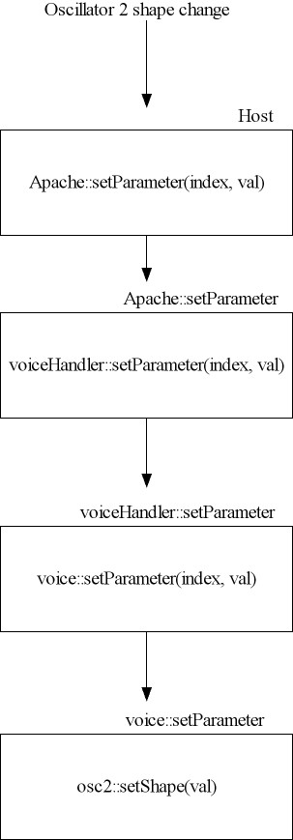

Figure 12

The remaining functions in class Apache deal with display of user parameters and parameter labels, and many other uninteresting procedural things that will not be described here.

4.3 VoiceHandler

Every time a midi noteOn signal is received, a separate tone is output. If 16 simultaneous noteOn messages are received (a complex chord, for example), then 16 separate audio tones at each notes respective frequency are summed together and output as one complete sound.
Therefore, each received midi noteOn has its own dedicated ‘voice’ which produces a sound at the notes frequency and volume for the duration of the note. Once the note has ended (midi noteOff) the ‘voice’ is released from that note, and can be allocated to another incoming midi note. The following diagram illustrates the reception of midi notes and how the voices are allocated to each incoming note:

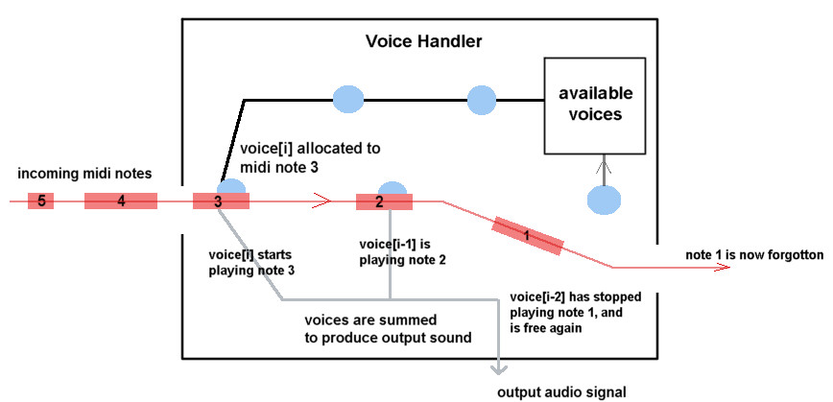
Figure 13 : Snapshot of VoiceHandler at some millisecond in time.

The VoiceHandler class represents audio data of up to 16 voices. The main functions of this class are noteOn(), noteOff() and getSample(). The first two take a midi note value and velocity as arguments, and are responsible for the allocation/de-allocation of voices to individual midi notes. They also ensure that the same note is not played more than once at the same time. The third function, getSample() adds together samples from all voices which are currently active (outputting samples). The maximum amount of voices that can be summed is of course 16, and most of the time its well below this figure. In the constructor of VoiceHandler an array of voice objects are instantiated to represent the 16 voices of sound that are possible:

voices = new Voice[maxPoly];

VoiceHandler::NoteOn()

The following code snippet shows how this function is implemented:

for(i=0;i<maxPoly;i++)
{

if(notes[i] == note) //dont repeat note that’s active
return;
}

for(i=0;i<maxPoly;i++)
{

if(!voices[i].getIsActive()) //If current voice is inactive, then give it the new note
{
voices[i].noteOn(note, velocity);
notes[i] = note;
break;
}
}

VoiceHandler::NoteOff()

for(i=0;i<maxPoly;i++)
{
if(notes[i] == note) //finds the voice this note corresponds to, and calls its noteOff() function
{
voices[i].noteOff();
notes[i] = -1;
break;
}
}

VoiceHandler::getSample()

for(i=0;i<maxPoly;i++) // up to 16 voices can be output simultaenously
{

if(voices[i].getIsActive()) //get samples for active voices
sample += ( voices[i].getSample() );
}

return sample;

The remaining functions in the VoiceHandler class are to do with passing on changes in user parameters (setParamater() ) and setting pitchbend for the voices.

4.4 Voice

This class represents a single tone of audio, or polyphony. It is one of the biggest classes of the program. In its constructor, three Oscillator objects and four objects of the base type Envelope are instantiated. The fifth Envelope type (curEnvSection) is just to hold the currently active section of the volume envelope:

osc1 = new Oscillator(); //3 oscillators
osc2 = new Oscillator();
osc3 = new Oscillator();

//adsr envelope objects
attack = new Attack(samplerate, this, true);
decay = new Decay(samplerate, this, true);
sustain = new Sustain(samplerate, this, true);
release = new Release(samplerate, this, true);
curEnvSection = attack;

This corresponds with the property that each voice uses three oscillators to generate a sound, and then applies a volume envelope over the sound.

The Voice class has three main functions which mirror the VoiceHandler class, noteOn(), noteOff and getSample().

Voice::noteOn()

This function is called from VoiceHandlers noteOn() function, and is far more functional that the latter. It takes two arguments, the note value and its velocity. The first thing the function does is enables the voice’s three oscillators. It then converts the midi note value (an integer between 0-127), to a float value which represents the frequency of that note (this value gets stored in the instance variable, midi_note). The function uses an array called note_Freqs, to look up the various frequencies for each possible midi note.
The Volume envelope is then reset (it will have been at a different value for the last note this voice dealt with), and the flag isActive is set to true, which indicates that this voice is no longer free, and therefore cant be allocated to a different midi note.

if(!isActive) // if voice is not active
{
. . .

osc1->enable();
osc2->enable();
osc3->enable();

frequency = note_Freqs[note];
this->note = note;
midi_note = frequency * ((2.0f * PI) / samplerate); // calculate freq needed for each relative to sample-rate
// note to be played
//--Envelope------
//Reset the attack sections of the envelope to have index = 0.
attack->reset();
currentEnvSection = attack;

isActive = true;

this->velocity = velo;

//Update midi_note appropriately if pitch bend needed.
if(pitchBend != 0.5f)
setPitchBend(pitchBend);
}

The noteOn function of Voice

Voice::noteOff()

This function is called from VoiceHandlers noteOff() function. It takes no arguments, and simply expedites the Volume Envelope into its release stage. This is done, so that if the release parameter is set above zero, then when the end of a note is reached, the sound will gradually fade off, and not do so abruptly:

if(isActive) //voice has to be active, to be turned off
{

//release's sustain amount should be set to the current level of the envelope to stop clicks, and give a smooth roll off.

release->reset();
release->setSustain (curEnvSection->getLevel());
curEnvSection = release;

}

The noteOn function of Voice

Voice::getSample()

This function is called from VoiceHandlers getSample() function. It takes no arguments, and returns the current audio sample of the voice. GetSample() works by firstly getting the current volume envelope value, then summing the outputs from the three oscillators, and then multiplying the envelope by the this sum, to get an overall enveloped sample value. This value is then returned to the calling function:

if(skipSamples >= freqSamples)
{
//get current envelope value
lastEnvVal = curEnvSection->getSample();
skipSamples = 0;
}
skipSamples ++;

sample = osc1->getSample(midi_note) + //additive synthesis
osc2->getSample(midi_note) +
osc3->getSample(midi_note);

//Evelope the oscillators output.
sample *= lastEnvVal;

return sample * (velocity/3); //scale to midi velocity and return.

The getSample() function of Voice

The remaining functions of Voice include the setParameter() function and setPitchBend function. There are also the functions moveToDecay() and moveToSustain(), which simply move the curEnvSection pointer to either of these sections. Note the noteOn() function will automatically move the envelope to the attack stage while the noteOff() function will move it to the release section.

4.5 Envelope

This class represents the volume envelope which voice applies on the oscillator outputs. The class is constructed a bit differently than the rest of the classes, in that it uses polymorphism to simplify how it is used by Voice. Essentially each part of the volume envelope (attack, decay, sustain, release), are separate classes, each of which inherit from a common base class (Envelope), which contains most of their functions. Each of the child classes, however, implement different versions of the getSample() method. This allows the voice that a particular section of the envelope belongs to to be notifed easily about what section it should move on to next. The particular section of the envelope will notify its voice, when it has come to its end, and the voice will then move the envelope onto its next section (by updating the member variable curEnvSection appropriately)
The parent class Envelope’s constructor takes three arguments. The first one is the samplerate, the second is a pointer to a Voice, and the third is a bool, isMain, which determines whether this particular envelope should tell voice when its finished. This parameter is really only if we want to have more than one ASDR envelope, so its redundant in this case, but its presence would streamline future extensibility.

Envelope::Enveleope(float samplerate, Voice *voice, bool isMain):
currentLevel(0.0f),
sustainLevel(0.5f),
index(0.0f),
increment(1.0f)
{
this->samplerate = samplerate;
this->voice = voice;
this->isMain = isMain;
}

Constructor of parent class Envelope

Attack::Attack(float samplerate, Voice *voice, bool isMain):
Envelope(samplerate, voice, isMain)
{

}

float Attack::getSample()
{
//currentLevel = 0 -> 1
currentLevel = index;

//Increment index => if we've reached the end of the table, tell voice to
//move to the next ADSR section.
index += increment;
if(index > 1.0f)
voice->moveToDelay(this);

return currentLevel;
}

getSample() method of child class Attack

Each Envelope section is essentially the same class, with just a different implementation of the getSample() function. The following diagram illustrates the four sub-classes of envelope:

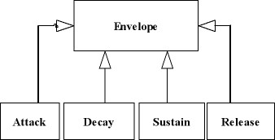

Figure 14

4.6 Oscillator

The class oscillator represents a single oscillator, and its associated parameters. Apart from the standard functions which set and return the parameters (instance variables), the main functions of the oscillator class are not surprisingly the functions which generate the four possible waveforms (sine, square, saw-tooth, triangle) and the getSample() method which returns these waveforms and any possible LFO that is applied on their pitch envelope.
As the oscillator class is the start of the chain, it does not need any other classes to do its work, and so there are no object declarations in its constructor:

Oscillator::Oscillator(): //constructor
shape(1),
LFO_shape(1),
freq(1.0f),
LFO_rate(0.5f * ((2.0f * PI) / samplerate) ),
wave_idx(0.0f),
lfo_idx(0.0f),
samplerate(44100.0f),
amplitude(0.5f),
LFO_range(1.0f),
counter(1),
counter2(1),
enabled(false),
LFO(false)
{
//no object to instantiate here!
}

Constructor of class Oscillator

The four functions that generate the four different shapes are genSine(), genSqr(), genSaw(), and genTri(). All of these functions take a frequency parameter which is equivalent to the current midi note that should be played . If you recall, the noteOn method of Voice, converts the midi note to a frequency, before Voice::getSample() passes it as an argument to Oscillator::getSample(), which in turn combines it with the LFO increment before passing it to either of these four methods.
The algorithms that were used to create the four waveforms are the following (in pseudocode):

Sine wave :

For each sample {

Output = sine(index);
Index += midi_frequency * oscillator_frequency ;

If( index > 2PI)
Index = index mod 2PI;

}

- index is the variable which loops continuously between 0 and 2PI, and which increments in values of sine, therefore producing a sine wave.

- midi_frequency is the input into the genSine() method, while the oscillator_frequency is the frequency offset of the oscillator (a user parameter).

- The higher the values of midi_frequency and oscillator_frequency, the bigger the value of sine(index), and therefore the quicker it will reach 2PI and start over again at zero (a full cycle). This means a higher the number of cycles per second of the sine wave (higher frequency wave).

Square wave:

For each sample {

temp1 = (samplerate / oscillator_frequency) / (midi_frequency * scale);

temp2 = temp1 / 2 ;

If(index <= temp2)
Out = 1.0;
Index++;
else
Out = -1.0;
Index++;

If(index > temp1)
Index = 0;

Return out;
}

-index is the variable which loops between zero and the (samplerate scaled by the oscillator_frequency and midi_frequency).

-Temp1 is the higher limit on the index variable, and its size is determined by the midi_frequency combined with the oscillator_frequency. If these two variables are big then temp1 will be smaller, thereby making the wavelengths shorter(frequency higher). If these two variables are smaller then the opposite will happen(lower frequency)

-Temp2 is the switch over limit, when the 1.0 changes to a –1.0 (this gives the on/off characteristic of a square wave). When the index reaches Temp1, it goes back to zero and starts another cycle.

Saw-tooth wave:

For each sample {

Output = index mod (samplerate/2);

Index += midi_frequency * oscillator_frequency;

If(index > 2PI)
Index = -5 + (index mod 2PI);

Return output;

}

-index, as in the sine wave algorithm

-in this algorithm the index continues to grow until it is is bigger than 2PI, it is then set back to a low figure and the cycle starts again.

-the size of the index at each iteration is determined by midi_frequency and oscillator_frequency will determine how fast or slow the index gets to the top of the ramp.

Triangle wave:

For each sample {

Do the same as for the saw-tooth wave;

And then:

If( output >= 0)
Output = 1 – (2 * output);
Else
Output = 1 + (2 * output);

Return output;

}

The triangle wave starts off the exact same as the saw-tooth, but the wave is transformed into the triangle by the above formula.

All of the algorithms shown, generate non-bandlimited waveforms, this means that aliasing occurs at high frequencies . This however is not a big problem for the plug-in as the aliasing can be eliminated by using the low-pass filters. Many electronic sounds work well with some aliasing.

Oscillator::getSample()

This function of Oscillator is quite simple as all it does it bring together the frequency that needs to be output by the oscillator, and the current LFO envelope value, and pass their product into either of the wave generator functions. They then output the audio sample and getSample() returns this back to the calling function (Voice). The following code snippet demonstrates:

switch(shape) //shape set by user parameters
{
case 1:
return genSine(midi_note * generateLFO() )...
break;
case 2:
return genSqr(midi_note * generateLFO() )...
break;
case 3:
return genSaw(midi_note * generateLFO() )...
break;
case 4:
return genTri(midi_note * generateLFO() )...
break;
default:
return genSine(midi_note * generateLFO() )...
break;
}

getSample() function of class Oscillator

The function generateLFO(), generates signals of sine and square in much the same way as genSine() and genSqr() do. The differences is that generateLFO signals are not output directly as audio, but instead slightly alter the midi frequency at each iteration (midi_note * generateLFO() ), so that the returned output from the shape generators will have a frequency that constantly oscillates between a cetain range, regardless of its shape.

4.7 EffectHandler

The effectHandler class is quite simple and really just passes on messages to the effect classes, and deals with the ordering of the effects. The effect handler instantiates three objects in its constructor:

filter = new Filter();
gapper = new GapFilter();
delay = new Delay();

These are the three effects that can be applied on the signal, so EffectHandler needs to use their functions.

In effectHandler itself, the only function worth mentioning here is the applyEffect() method which is analogous to the getSample method of VoiceHandler.
ApplyEffect() is a very simple method which applies the gap filter, standard filter and delay effect on the audio passed to it :

float EffectHandler::applyEffect(float s)
{
float sample;

sample = gapper->applyGapFilter(s); //first apply gap-filter

if(delay_pre)
sample = delay->applyDelay(sample);

sample = filter->applyFilter(sample); //apply filter

if(!delay_pre)
sample = delay->applyDelay(sample); //apply delay

sample *= gain; //apply overall gain to signal

return sample;
}

ApplyEffect() method of EffectHandler

As indicated in the code it can apply the delay effect before or after the application of the standard filter to the signal (not both ways though). In order to apply the various effects on th input signal, ApplyEffect() calls the equivalent lower-level functions of each of the effects classes and those functions actually do the work, and return the processed signal to the effects chain. The final process applied over the signal is the overall gain(volume). ApplyEffect() does do this small task itself!

4.8 Filter

The filter class represents the three standard filter effects that can be
applied over the signal. The filter implemented in this class is a second-order IIR(infinite impulse response) filter. IIR filters are suited to real time processing and give a natural frequency response.

This class is composed of the usual functions which set and retrieve parameters, as well as the function applyFilter(). This method takes audio as its input and outputs a filtered signal. The type of filter (low-pass, high-pass, band-pass) that gets applied to the signal depends on what the value of the member variable type Is. Type gets set by user parameter messages from EffectHandler.

In order to implement the IIR filter on the signal, four global variables which store the two previous inputs and outputs from the filter are needed. These variables are utilized along with five other local variables which act as the coefficients in the filtering process. The calculation of these coefficients is relatively complex, but they only need to be re-calculated when the user changes the filter parameters, otherwise the previous coefficients (from the last sample) are used. This saves a lot of cpu, and is a big advantage of IIR filters.

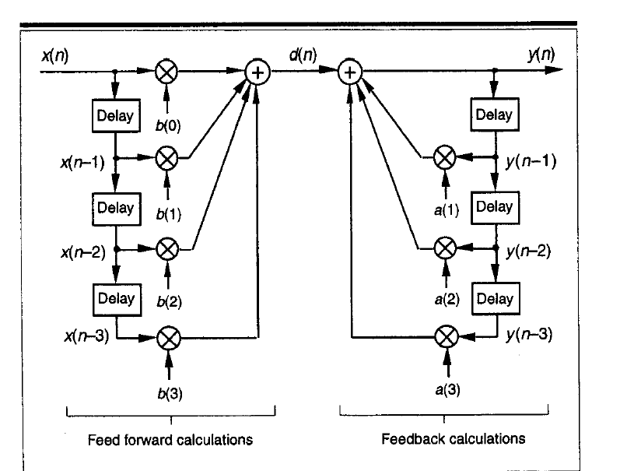
Figure 15. IIR digital filter structure

The implementation of the filters was accomplished by converting from a differential equation which defines the relationship between the input and output of the IIR filter :
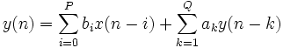

this equation yields the variables needed, and makes the implementation of the filter possible. The actual design of each of the three standard filters, is based on code examples in the article “Sound Filtering for the Masses”, by Fabio Bizzetti.

4.9 GapFilter

The gapFilter class is a small class which has only one interesting function, namely the applyGapFilter() function, which actually does the ‘gapping’ of the input signal. This method works by using a counter to count up to half the samplerate value, during which time the output is unchanged. Once the counter goes over samplerate / 2, the signal is reduced in volume by the depth parameter. The speed between the gaps can be increased or decreased by using the rate parameter of as a scalar for the samplerate. The following code demonstrates:

float GapFilter::applyGapFilter(float samp)
{
if(isActive)
{

float temp;
float temp2;

temp = (samplerate / GapFilter::getRate());

temp2 = temp/2;

if(counter <= (temp2) )
{
samp = samp;
++counter;
}
else
{
samp *= depth;
++counter;
}

if(counter > (temp ) )
{
counter = 0;
}

}

return samp; //scale output

}

4.10 Delay

This class, like the previous one, is quite small and only has one function that will be mentioned, applyDelay(). This function uses an array of size (samplerate * 2), to provide a maximum of two seconds of delay added to the input signal. Basically, every time a sample is read in, this sample gets stored in the next buffer slot, combined with the (last sample * feedback). The current sample is then summed with the (current buffer slot * amount) and is output. The location of the slots increment according to a counter variable which goes up to amount of samples of delay currently set by the delay parameter (maximum of two seconds). The following code demonstrates the function applyDelay():

float Delay::applyDelay(float sample)
{
float y = sample;

if(isActive) //if delay is turned on
{

float x = sample;
y = sample + (buffer[counter] * amount);

buffer[counter++] = x + y * feedback;

if (counter >= del)
counter = 0;
}

return y;
}

The function applyDelay() of class Delay

4.11 ApacheGUI

The ApacheGUI class deals with all aspects of user interface including the updating of its parameters and labels. In order to create a GUI for the plug-in, ApacheGUI needs to inherit from the VST SDK class AEffGUIEditor, in that same was as Apache inherits from AudioEffectX. The AEffGUIEditor contains all the functions necessary to help in creating a custom GUI. If this class is not implemented, the host program would automatically create a GUI for the plug-in but it would be a bare host themed GUI. This plug-in however, has its own custom GUI, and the ApacheGUI class begins by instantiating its parameters and resources (background images/graphics etc).

ApacheGUI::APacheGUI (AudioEffect *effect)
: AEffGUIEditor (effect)
{
bOpened = false;

.
.
.

hBackground = new CBitmap (IDB_BITMAP2);

// init the size of the plugin
rect.left = 0;
rect.top = 0;
rect.right = (short)hBackground->getWidth ();
rect.bottom = (short)hBackground->getHeight ();

.
.
.
}

Constructor of class ApacheGUI

The main function of ApacheGUI is Open(). This robust function initializes every user parameter, resource and label associated with the GUI. It is responsible for the initial appearance of the plug-in. Open() is expected to be implemented (as with all functions in this class), as the host calls it when creating the plug-in. Another important function of the ApacheGUI class is the setParameter() method. This method is called by the plug-in class to tell the GUI that something has changed. This parameter then in-turn calls the getParamter() function of the plug-in class to update its parameters and make the change in the GUI.
As described in section 3, the communication between the GUI and the plug-in class (analogous to message handler component), is two-way. This avoids any other classes, apart from Apache knowing about class ApacheGUI.

The only other functions in ApacheGUI are functions the close() and valueChanged().

5. Problems & Resolutions

5.1 Introduction

The development of this project was always going to be a big undertaking. As an avid musician, the author wanted to create an application that would be of good use to amateur musicians. Overall, this goal has been accomplished as the plug-in works just as designed. However, the development of Apache VSTi was a journey in which many problems were encountered and overcome. The following section gives a list of these problems in the order in they occurred.

5.2 The Problems

- The initial problem was the time it took to study the VST SDK and understand how things worked in this platform. VST programming is a very new standard in relative terms and there is still no book that can be obtained on the subject. So Internet articles and message boards were well utilized in this research stage, as well as the SDK documentation provided by Steinberg.

- The first major developmental problem that was encountered was choosing what the high level design of the application was going to be like. At one stage a design was in place but was scrapped (after the author began studying design patterns). This was for the best, as the original design lacked cohesion and was likely not to work very well. The high level design that was eventually chosen was based on the Observer design pattern. (described in detail in section 3). The components in this design are loosely coupled and once the author began implementing classes, it was quite easy to add extra classes (like effects) into the system.

- The next problem that was encountered was how to do the part of the program which dealt with midi events. After some more research on midi events and the way in which the VSTSDK deals with them, a solution was devised. The function ProcessMIDI() was created to sort out the midi events and relay them to the relevant classes. This is when it became obvious that a total separation of user parameter messages and midi message was needed.

- The actual synthesis of the waveforms was as much about trial and error , as about research on different synthesis methods. Initially, the problem was simply: how can a waveform of some shape be generated digitally? After research into different methods (inverse fourier series, bandlimited waveform generation, etc) it was decided that the synthesis would be kept as simple as possible (there were too many things to deal with apart from this aspect). So the simple algorithms which are described in section 4.6 were implemented.

- Now that a separate oscillator was capable of being implemented, the way in which the 16-voices were to work, needed to fill the gap between the Oscillator and voiceHandler classes. The solution was a class that represented a single voice, which could contain multiple oscillators and still output as a single tone of audio. The voiceHandler class was duly changed from an awkward attempted implementation to a functional class which allocated midi notes to individual voices.

- The implementation of the LFO section of the oscillator caused many more problems that originally thought (and ended up taking twice as long to do). Initially the LFO was supposed to be an effect on the input signal. After some more thought, it was realized that if we wanted an oscillating (wobbling) pitch sound, then the LFO would have to be applied at the very source of the signal, namely the oscillators. There were further problems relating to scaling of the signals produced by the LFO so that when applying them to the oscillators, the result would sound right. This scaling took quite a while to perfect.

- The implementation of the volume envelopes also posed quite a lot of difficulty. Initially the volume envelope was just one class (object), which simply had variables relating to its four parameters. This format generally caused the envelope and voice classes to become too interconnected, (big switch/case statements). The solution was to use polymorphism which improved the situation a great deal. Section 4.5 describes this.

- The choice of what kind of standard filters to use also posed a problem. The easier to implement FIR style filters were apparently very computational expensive, but the more difficult IIR filters were perfect for real-time processing. The IIR filters were chosen but their implantation took quite a while as understanding of IIR filters was not very easy at all

