A Guide to the Internet

By Tim Kennedy

Ok the first thing you should see when the computer is turned on is the screen below. Yours may not have the same icons on it as my one but that doesn’t matter. Just follow these few steps and we will soon have you connected!

- Connect to the Internet in the way that you have been shown. This may involve double-clicking on an icon that looks like a phone
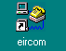Or it may be that you just have to click on the blue Internet explorer icon like this

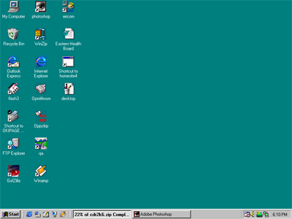
- Connect by clicking here
- or here

Doing this should bring up a screen like the one below.
At the top of the screen there is a white line with the “address” of the page written into it. All web sites have an address and if you want to get them you type in the address.

To type in the address by hand use the mouse to place the pointer in this box.

Click the left mouse button once so that the text that is written in the box already is highlighted.

Then type in the address of the page.
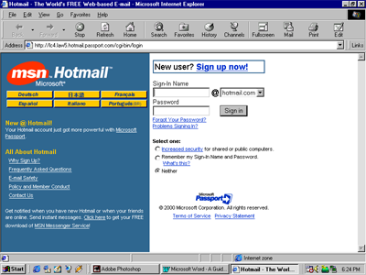
This is where you type in the address of the page if you know it, i.e. www.hotmail.com

If you don’t know the address of the page or if you just want to look up a word, you will need to use a “search engine”.
A search engine is a web page that lets you look up a word or words, and will bring up a list of web sites that contain the information that you need.

There are loads of search engines around but you will be better off as a beginner to use only two of the main ones. The first one is called “Yahoo”, and the other is called “AltaVista”.
To use either of these search engines you will need to type the address into the box like I showed you earlier.

The addresses are… www.yahoo.com and www.altavista.com
Notice that on the web there are no spaces between the words and there are no capital letters.
Below is an example of “yahoo”.

If you want to search for a subject like “dogs” you simply type in the word in the “search box”. You can see this in the picture.
This is where you type in the subject you want to look up.

Then you press search.
Use the back button to go to the previous page.
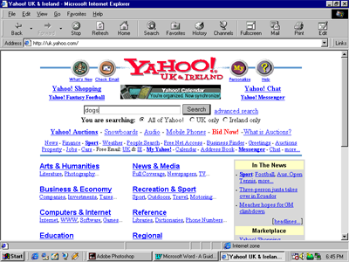
It should then bring up a list of sites that are about dogs or the subject that you chose.

You should now be ready to “surf” the net!

