T.S.P.R.C.

Tipperary small Pet Rescue centre

Tipperary Small Pet Rescue offers a safe haven for unwanted and neglected small pets.



We also provide advice on the basic care of many of the small pets available today like rabbits and guinea pigs.

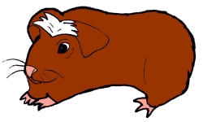

We can help with information on correct housing; T.S.P.R.C. has a strict no breeding policy
The centre also gratefully accept donations of supplies or equipment:

Housing/larger items:

Hutches / Runs / Small Kennels
Pet carriers
Bird cages (not round ones)
Aviary wire mesh (even left over rolls)
Sheets of wire mesh
Untreated plywood and Marine plywood
Untreated white pine
Felt for hutch roofs
Bags or square bales of good hay

Smaller items

Newspapers/shredded newspapers
Bottles of white vinegar
Plain white kitchen roll
Hamster/gerbil cages and tubes/toys etc
Drinking bottles
Other small animal items

For more information or if you know of a small pet in need, please contact TSPRC at:

Email: tsprcenter2003@yahoo.co.uk
Leave a message and we will get back to you very soon

